SEC Form 3
FORM 3 | UNITED STATES SECURITIES AND EXCHANGE COMMISSION  Washington, D.C. 20549  INITIAL STATEMENT OF BENEFICIAL OWNERSHIP OF SECURITIES  Filed pursuant to Section 16(a) of the Securities Exchange Act of 1934  or Section 30(h) of the Investment Company Act of 1940
  OMB APPROVAL
  OMB Number: | 3235-0104
  Estimated average burden
  hours per response: | 0.5
1. Name and Address of Reporting Person*  (Street) | 2. Date of Event Requiring Statement (Month/Day/Year)  04/02/2025 | 3. Issuer Name and Ticker or Trading Symbol  FEDERAL NATIONAL MORTGAGE ASSOCIATION FANNIE MAE [ FNMA ]
  ROSCOE JOHN MICHAEL
  (Last) | (First) | (Middle)
  C/O FANNIE MAE
  1100 15TH STREET
  WASHINGTON | DC | 20005
  (City) | (State) | (Zip)
 |  | 4. Relationship of Reporting Person(s) to Issuer  (Check all applicable) | 5. If Amendment, Date of Original Filed (Month/Day/Year)
   | Director |  | 10% Owner
   | Officer (give title below) |  | Other (specify below)
  EVP - Ops & Public Relations
6. Individual or Joint/Group Filing (Check Applicable Line)
Form filed by One Reporting Person
Form filed by More than One Reporting Person

Table I - Non-Derivative Securities Beneficially Owned
1. Title of Security (Instr. 4) | 2. Amount of Securities Beneficially Owned (Instr. 4) | 3. Ownership Form: Direct (D) or Indirect (I) (Instr. 5) | 4. Nature of Indirect Beneficial Ownership (Instr. 5)
No Securities Beneficially Owned | 0 | D
Table II - Derivative Securities Beneficially Owned
(e.g., puts, calls, warrants, options, convertible securities)
1. Title of Derivative Security (Instr. 4) | 2. Date Exercisable and Expiration Date (Month/Day/Year) |  | 3. Title and Amount of Securities Underlying Derivative Security (Instr. 4) |  | 4. Conversion or Exercise Price of Derivative Security | 5. Ownership Form: Direct (D) or Indirect (I) (Instr. 5) | 6. Nature of Indirect Beneficial Ownership (Instr. 5)
1. Title of Derivative Security (Instr. 4) | Date Exercisable | Expiration Date | Title | Amount or Number of Shares | 4. Conversion or Exercise Price of Derivative Security | 5. Ownership Form: Direct (D) or Indirect (I) (Instr. 5) | 6. Nature of Indirect Beneficial Ownership (Instr. 5)
Explanation of Responses:
Remarks:
 | /s/ John Roscoe | 04/10/2025
 | ** Signature of Reporting Person | Date
Reminder: Report on a separate line for each class of securities beneficially owned directly or indirectly.
* If the form is filed by more than one reporting person, see Instruction 5 (b)(v).
** Intentional misstatements or omissions of facts constitute Federal Criminal Violations See 18 U.S.C. 1001 and 15 U.S.C. 78ff(a).
Note: File three copies of this Form, one of which must be manually signed. If space is insufficient, see Instruction 6 for procedure.
Persons who respond to the collection of information contained in this form are not required to respond unless the form displays a currently valid OMB Number.
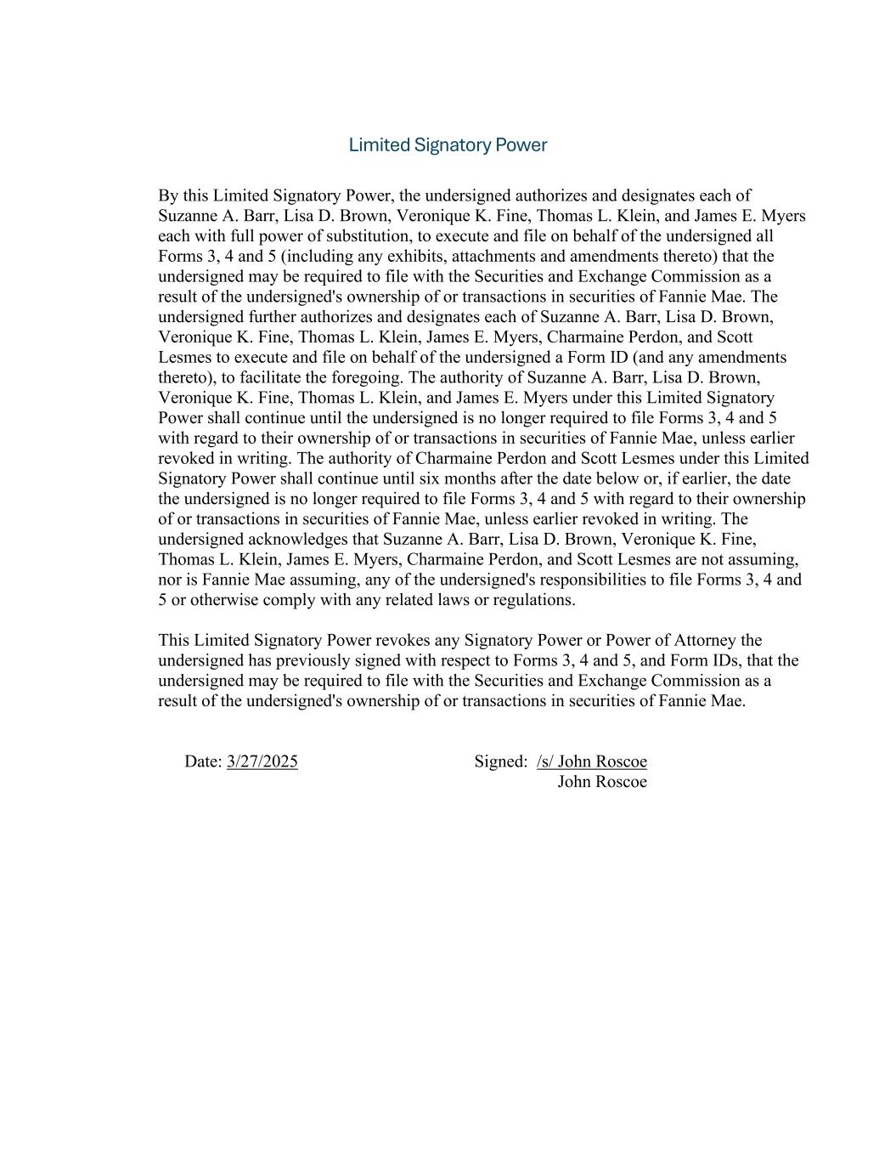
Limited Signatory Power By this Limited Signatory Power, the undersigned authorizes and designates each of Suzanne A. Barr, Lisa D. Brown, Veronique K. Fine, Thomas L. Klein, and James E. Myers each with full power of substitution, to execute and file on behalf of the undersigned all Forms 3, 4 and 5 (including any exhibits, attachments and amendments thereto) that the undersigned may be required to file with the Securities and Exchange Commission as a result of the undersigned's ownership of or transactions in securities of Fannie Mae. The undersigned further authorizes and designates each of Suzanne A. Barr, Lisa D. Brown, Veronique K. Fine, Thomas L. Klein, James E. Myers, Charmaine Perdon, and Scott Lesmes to execute and file on behalf of the undersigned a Form ID (and any amendments thereto), to facilitate the foregoing. The authority of Suzanne A. Barr, Lisa D. Brown, Veronique K. Fine, Thomas L. Klein, and James E. Myers under this Limited Signatory Power shall continue until the undersigned is no longer required to file Forms 3, 4 and 5 with regard to their ownership of or transactions in securities of Fannie Mae, unless earlier revoked in writing. The authority of Charmaine Perdon and Scott Lesmes under this Limited Signatory Power shall continue until six months after the date below or, if earlier, the date the undersigned is no longer required to file Forms 3, 4 and 5 with regard to their ownership of or transactions in securities of Fannie Mae, unless earlier revoked in writing. The undersigned acknowledges that Suzanne A. Barr, Lisa D. Brown, Veronique K. Fine, Thomas L. Klein, James E. Myers, Charmaine Perdon, and Scott Lesmes are not assuming, nor is Fannie Mae assuming, any of the undersigned's responsibilities to file Forms 3, 4 and 5 or otherwise comply with any related laws or regulations. This Limited Signatory Power revokes any Signatory Power or Power of Attorney the undersigned has previously signed with respect to Forms 3, 4 and 5, and Form IDs, that the undersigned may be required to file with the Securities and Exchange Commission as a result of the undersigned's ownership of or transactions in securities of Fannie Mae. Date: 3/27/2025 Signed: /s/ John Roscoe John Roscoe

