UNITED STATES
SECURITIES AND EXCHANGE COMMISSION
Washington, DC 20549

FORM 8-K

CURRENT REPORT
Pursuant to Section 13 or 15(d) of The Securities Exchange Act of 1934
Date of Report (Date of earliest event reported): July 29, 2026

Federal National Mortgage Association
(Exact name of registrant as specified in its charter)
Fannie Mae
Federally chartered corporation |  |  | 0-50231 |  |  | 52-0883107 |  |  |  |  |  | 1100 15th Street, NW |  |  |  |  |  |  |  |  |  |  |  | 800 |  |  |  |  |  | 232-6643
 |  |  |  |  |  |  |  |  |  |  |  | Washington, |  |  | DC |  |  | 20005
(State or other jurisdiction  of incorporation) |  |  | (Commission  File Number) |  |  | (IRS Employer  Identification No.) |  |  |  |  |  | (Address of principal executive offices, including zip code) |  |  |  |  |  |  |  |  |  |  |  | (Registrant’s telephone number, including area code)

Check the appropriate box below if the Form 8-K filing is intended to simultaneously satisfy the filing obligation of the registrant under any of the following provisions (see General Instruction A.2. below):
☐ |  |  | Written communications pursuant to Rule 425 under the Securities Act (17 CFR 230.425)
☐ |  |  | Soliciting material pursuant to Rule 14a-12 under the Exchange Act (17 CFR 240.14a-12)
☐ |  |  | Pre-commencement communications pursuant to Rule 14d-2(b) under the Exchange Act (17 CFR 240.14d-2(b))
☐ |  |  | Pre-commencement communications pursuant to Rule 13e-4(c) under the Exchange Act (17 CFR 240.13e-4(c))

Securities registered pursuant to Section 12(b) of the Act:
Title of each class |  |  | Trading Symbol(s) |  |  | Name of each exchange on which registered
None |  |  | N/A |  |  | N/A

Indicate by check mark whether the registrant is an emerging growth company as defined in Rule 405 of the Securities Act of 1933 (§230.405 of this chapter) or Rule 12b-2 of the Securities Exchange Act of 1934 (§240.12b-2 of this chapter).
 |  |  | Emerging growth company |  |  | ☐
If an emerging growth company, indicate by check mark if the registrant has elected not to use the extended transition period for complying with any new or revised financial accounting standards provided pursuant to Section 13(a) of the Exchange Act. ☐

The information in this report, including information contained in the exhibits submitted with this report, shall not be deemed “filed” for purposes of Section 18 of the Securities Exchange Act of 1934, or otherwise subject to the liabilities of Section 18, nor shall it be deemed incorporated by reference into any disclosure document relating to Fannie Mae (formally known as the Federal National Mortgage Association), except to the extent, if any, expressly incorporated by specific reference in that document.

Item 2.02 Results of Operations and Financial Condition.
On July 29, 2026, Fannie Mae filed its quarterly report on Form 10-Q for the quarter ended June 30, 2026, and is issuing a press release reporting its financial results for the periods covered by the Form 10-Q, as well as an earnings presentation and a financial supplement. Copies of the press release, earnings presentation, and financial supplement are furnished as Exhibits 99.1, 99.2, and 99.3, respectively, to this report and are incorporated herein by reference. Copies may also be found on Fannie Mae’s website, www.fanniemae.com, in the “About Us” section under “Investor Relations/Quarterly and Annual Results.” Information appearing on the company’s website is not incorporated into this report.
Item 9.01 Financial Statements and Exhibits.
(d) Exhibits. The following exhibits are being submitted with this report:

Exhibit Number |  |  |  |  |  | Description of Exhibit
99.1 |  |  |  |  |  | Press release, dated July 29, 2026
99.2 |  |  |  |  |  | 2Q 2026 Earnings Presentation, dated July 29, 2026
99.3 |  |  |  |  |  | Second Quarter 2026 Financial Supplement, dated July 29, 2026
104 |  |  |  |  |  | Cover Page Interactive Data File (embedded within the Inline XBRL document)

SIGNATURES
Pursuant to the requirements of the Securities Exchange Act of 1934, the registrant has duly caused this report to be signed on its behalf by the undersigned hereunto duly authorized.

 |  |  |  |  |  | FEDERAL NATIONAL MORTGAGE ASSOCIATION
 |  |  | By: |  |  | /s/ Chryssa C. Halley
 |  |  |  |  |  | Chryssa C. Halley
 |  |  |  |  |  | Executive Vice President and Chief Financial Officer
Date: July 29, 2026

Exhibit 99.1

Fannie Mae Earns $4.0 Billion in Second Quarter 2026
•Growth in earnings from prior quarter reflects increased net revenues(1), which more than offset higher credit loss provision
•34th consecutive quarterly profit pushed net worth to $116.5 billion, a $103.0 billion increase since the start of 2020
•Illustrative return on average required CET1(2) capital of 10.8%, up from 10.4% in the first quarter of 2026
WASHINGTON, DC – July 29, 2026 – Fannie Mae (FNMA/OTCQB) earned $4.0 billion in net income in the second quarter of 2026, compared with $3.7 billion in the first quarter of 2026, and increased its net worth to $116.5 billion as of June 30, 2026. Net revenues increased to $7.6 billion in the second quarter, compared with $7.3 billion in the first quarter of 2026. The increase in net income reflects increased net revenues driven by higher net interest income from portfolios and higher net deferred guaranty fees, a shift to investment gains, and lower non-interest expenses. These were partially offset by an increased credit loss provision and a shift to fair value losses.
William J. Pulte, Director, U.S. Federal Housing, and Chairman, Fannie Mae Board of Directors:
“Fannie Mae’s strong second quarter earnings of $4 billion are up 20% year-over-year, growing its net worth to more than $116 billion. This shows the company’s continued stability and growth, all while reaching $3 billion in estimated homeowner savings since 2018 through innovative appraisal alternatives.”
Peter Akwaboah, Acting Chief Executive Officer and Chief Operating Officer, Fannie Mae:
“The strength of our core guaranty business and financial discipline enabled us to deliver another quarter of solid earnings and real impact. We provided $125 billion in mortgage market liquidity, supporting 417,000 home purchases, refinances, and rental units, including helping almost 110,000 borrowers buy their first home. Our financial performance advances our mission to promote a stable, accessible, and affordable housing market across America.”
More information, including access to the webcast featuring our earnings presentation, our Second Quarter 2026 Form 10-Q, and other disclosures, can be found on our Quarterly and Annual Results webpage at fanniemae.com/financialresults.

Second Quarter 2026 Key Metrics
 |  |  | $4.0 billion |  |  |  |  |  |  |  |  |  |  |  | $116.5 billion |  |  |  |  |  |  |  |  |  |  |  | $7.6 billion
 |  |  | Net Income |  |  |  |  |  |  |  |  |  |  |  | Net Worth |  |  |  |  |  |  |  |  |  |  |  | Net Revenues(1)
 |  |  | ($3.7 billion in 1Q 2026) |  |  |  |  |  |  |  |  |  |  |  | ($112.7 billion in 1Q 2026) |  |  |  |  |  |  |  |  |  |  |  | ($7.3 billion in 1Q 2026)
 |  |  | $4.1 trillion |  |  |  |  |  |  |  |  |  |  |  | 10.7% |  |  |  |  |  |  |  |  |  |  |  | 10.8%
 |  |  | Guaranty Book of Business |  |  |  |  |  |  |  |  |  |  |  | Administrative Expense Ratio(3) |  |  |  |  |  |  |  |  |  |  |  | Illust. Return on Avg. Req. CET1(2)
 |  |  | ($4.1 trillion in 1Q 2026) |  |  |  |  |  |  |  |  |  |  |  | (10.2% in 1Q 2026) |  |  |  |  |  |  |  |  |  |  |  | (10.4% in 1Q 2026)
Business Impact and Quarterly Highlights
Mortgage Acquisitions
Enabled the financing of ~417,000 home purchases,
refinancings, and rental units in the second quarter of 2026

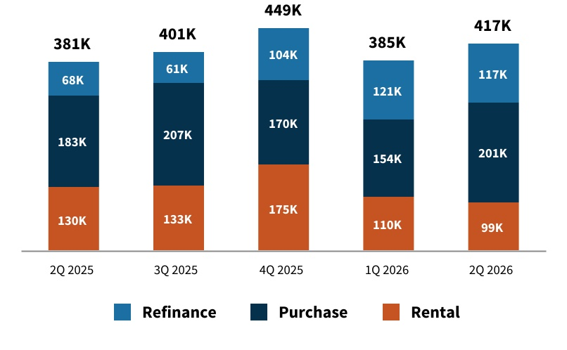
$125 billion in liquidity provided to mortgage market, supporting approximately 201,000 home purchases, 117,000 refinancings, and 99,000 rental units.
More than 80% of multifamily units financed were affordable to renters earning less than 100% of area median income.
Helped nearly 110,000 first-time homebuyers purchase a home, representing 55% of single-family purchase acquisitions.
Our foreclosure prevention solutions allowed more than 21,000 homeowners to remain in their homes.
Introduced new Purchase-Application Level Index (PALI) weekly data series, providing insights into future home sales and GSE MBS issuance activity.
Reached $3 billion in estimated borrower closing cost savings since 2018 from Fannie Mae-enabled appraisal alternatives.(4)
Endnotes are presented on page 5

Second Quarter 2026 |  |  |  |  |  | 1

Summary of Financial Results
Chryssa C. Halley, Chief Financial Officer, Fannie Mae:
“Our second quarter results highlight our large, stable revenue base and continued expense and capital discipline. Together, these strengths contributed to our highest level of quarterly net income in over a year, bringing our net worth to above $116 billion.”

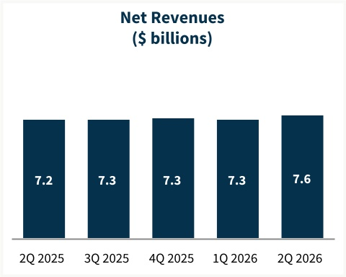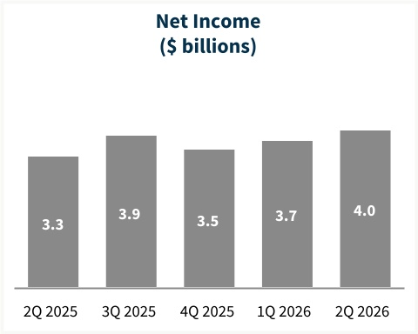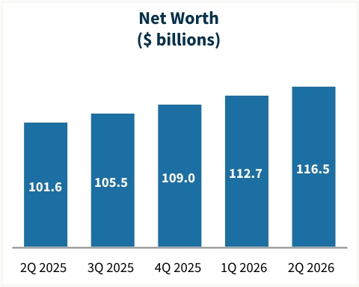
Key Highlights — Second Quarter 2026
• |  |  |  | Net revenues of $7.6 billion, primarily consisting of guaranty fee income on the company’s $4.1 trillion guaranty book of business. The increase in net revenues was primarily driven by higher net interest income from portfolios and higher net deferred guaranty fee income.
 |  |  |  | ◦Single-family net revenues of $6.3 billion from a $3.6 trillion conventional guaranty book with an average charged guaranty fee of 49.0 basis points.
 |  |  |  | ◦Multifamily net revenues of $1.3 billion from a $544.6 billion guaranty book with an average charged guaranty fee of 70.5 basis points.
• |  |  |  | Provision for credit losses of $485 million, compared with $277 million in 1Q 2026.
• |  |  |  | Non-interest expense of $2.1 billion, compared with $2.2 billion in 1Q 2026; decrease driven primarily by a shift from other expense to other income in the Multifamily segment, partially offset by higher administrative expenses.
• |  |  |  | Other losses decreased by $133 million compared with 1Q 2026, driven by a shift from investment losses to investment gains, which was partially offset by a shift from fair value gains to fair value losses.
Summary of Consolidated Financial Results
(Dollars in millions) |  |  |  |  |  | 2Q26 |  |  |  |  |  | 1Q26 |  |  |  |  |  | Variance |  |  |  |  |  | % Change |  |  |  |  |  | 2Q25 |  |  |  |  |  |  |  | Variance |  |  |  |  |  | % Change
Net interest income |  |  |  |  |  | $ | 7,493 |  |  |  |  | $ | 7,198 |  |  |  |  | $ | 295 |  |  |  |  | 4 |  | % |  |  |  | $ | 7,155 |  |  |  |  |  |  | $ | 338 |  |  |  |  | 5 |  | %
Fee and other income |  |  |  |  |  | 72 |  |  |  |  |  | 82 |  |  |  |  |  | (10) |  |  |  |  |  | (12) |  | % |  |  |  | 86 |  |  |  |  |  |  |  | (14) |  |  |  |  |  | (16) |  | %
Net revenues |  |  |  |  |  | 7,565 |  |  |  |  |  | 7,280 |  |  |  |  |  | 285 |  |  |  |  |  | 4 |  | % |  |  |  | 7,241 |  |  |  |  |  |  |  | 324 |  |  |  |  |  | 4 |  | %
Fair value gains (losses), net |  |  |  |  |  | (76) |  |  |  |  |  | 121 |  |  |  |  |  | (197) |  |  |  |  |  | NM |  |  |  |  |  | 211 |  |  |  |  |  |  |  | $ | (287) |  |  |  |  | NM
Investment gains (losses), net |  |  |  |  |  | 53 |  |  |  |  |  | (277) |  |  |  |  |  | 330 |  |  |  |  |  | NM |  |  |  |  |  | (19) |  |  |  |  |  |  |  | 72 |  |  |  |  |  | NM
Other gains (losses), net |  |  |  |  |  | (23) |  |  |  |  |  | (156) |  |  |  |  |  | 133 |  |  |  |  |  | 85 |  | % |  |  |  | 192 |  |  |  |  |  |  |  | (215) |  |  |  |  |  | NM
(Provision) benefit for credit losses |  |  |  |  |  | (485) |  |  |  |  |  | (277) |  |  |  |  |  | (208) |  |  |  |  |  | (75) |  | % |  |  |  | (946) |  |  |  |  |  |  |  | 461 |  |  |  |  |  | 49 |  | %
Non-interest expense:
Administrative expenses(5) |  |  |  |  |  | (811) |  |  |  |  |  | (745) |  |  |  |  |  | (66) |  |  |  |  |  | (9) |  | % |  |  |  | (847) |  |  |  |  |  |  |  | 36 |  |  |  |  |  | 4 |  | %
Legislative assessments(6) |  |  |  |  |  | (934) |  |  |  |  |  | (931) |  |  |  |  |  | (3) |  |  |  |  |  | — |  | %* |  |  |  | (939) |  |  |  |  |  |  |  | 5 |  |  |  |  |  | 1 |  | %
Credit enhancement expense(7) |  |  |  |  |  | (361) |  |  |  |  |  | (358) |  |  |  |  |  | (3) |  |  |  |  |  | (1) |  | % |  |  |  | (400) |  |  |  |  |  |  |  | 39 |  |  |  |  |  | 10 |  | %
Other income (expense), net(8) |  |  |  |  |  | 38 |  |  |  |  |  | (149) |  |  |  |  |  | 187 |  |  |  |  |  | NM |  |  |  |  |  | (147) |  |  |  |  |  |  |  | 185 |  |  |  |  |  | NM
Total non-interest expense |  |  |  |  |  | (2,068) |  |  |  |  |  | (2,183) |  |  |  |  |  | 115 |  |  |  |  |  | 5 |  | % |  |  |  | (2,333) |  |  |  |  |  |  |  | 265 |  |  |  |  |  | 11 |  | %
Income before federal income taxes |  |  |  |  |  | 4,989 |  |  |  |  |  | 4,664 |  |  |  |  |  | 325 |  |  |  |  |  | 7 |  | % |  |  |  | 4,154 |  |  |  |  |  |  |  | 835 |  |  |  |  |  | 20 |  | %
Provision for federal income taxes |  |  |  |  |  | (1,007) |  |  |  |  |  | (944) |  |  |  |  |  | (63) |  |  |  |  |  | (7) |  | % |  |  |  | (837) |  |  |  |  |  |  |  | (170) |  |  |  |  |  | (20) |  | %
Net income |  |  |  |  |  | $ | 3,982 |  |  |  |  | $ | 3,720 |  |  |  |  | $ | 262 |  |  |  |  | 7 |  | % |  |  |  | $ | 3,317 |  |  |  |  |  |  | $ | 665 |  |  |  |  | 20 |  | %
 |  |  |  |  |  |  |  |  |  |  |  | — |  |  |  |  |  |  |  |  |  |  |  |  |  |  |  |  |  |  |  |  |  |  |  |  |  | —
Total comprehensive income |  |  |  |  |  | $ | 3,830 |  |  |  |  | $ | 3,655 |  |  |  |  | $ | 175 |  |  |  |  | 5 |  | % |  |  |  | $ | 3,324 |  |  |  |  |  |  | $ | 506 |  |  |  |  | 15 |  | %
Net worth |  |  |  |  |  | $ | 116,497 |  |  |  |  | $ | 112,667 |  |  |  |  | $ | 3,830 |  |  |  |  | 3 |  | % |  |  |  | $ | 101,636 |  |  |  |  |  |  | $ | 14,861 |  |  |  |  | 15 |  | %
NM - Not meaningful
* Represents less than 0.5%

Second Quarter 2026 |  |  |  |  |  | 2

Single-Family Business
Jake Williamson, EVP, Head of Single-Family, Fannie Mae:
“Lenders are using our enhanced Desktop Underwriter services to drive speed, certainty, and a more seamless borrower experience. We are using technology with the goal of modernizing the lending process and lowering up-front mortgage costs, including building upon the estimated $3 billion that borrowers have saved since 2018 through Fannie Mae-enabled appraisal alternatives."

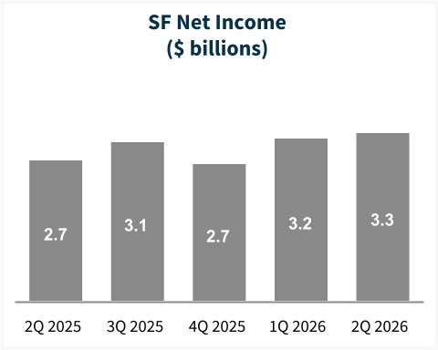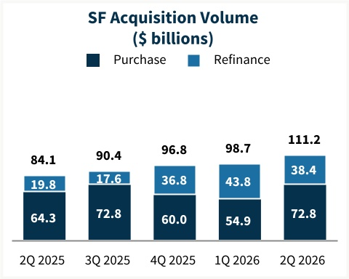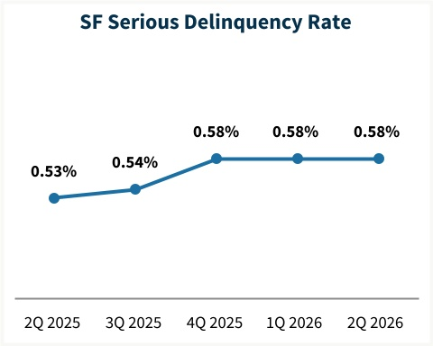
Single-Family Highlights — Second Quarter 2026
• |  |  | Single-family conventional acquisition volume increased to $111.2 billion, compared with $98.7 billion in 1Q 2026, driven by a $17.9 billion increase in purchase acquisition volume, partially offset by a $5.4 billion decrease in refinance acquisition volume.
• |  |  | Average single-family conventional guaranty book was largely unchanged at $3.56 trillion compared to 1Q 2026.
• |  |  | The average charged guaranty fee, net of TCCA fees, on the single-family conventional guaranty book increased to 49.0 basis points, compared with 48.8 basis points in 1Q 2026. The average charged guaranty fee on newly acquired conventional loans, net of TCCA fees, decreased to 53.5 basis points, compared with 55.1 basis points in 1Q 2026.
• |  |  | Overall credit characteristics of the single-family conventional guaranty book were largely unchanged compared with the prior quarter, with a weighted-average mark-to-market loan-to-value ratio of 51% and a weighted-average FICO credit score at origination(9) of 753 as of June 30, 2026.
• |  |  | Single-family serious delinquency rate remained unchanged at 0.58% as of June 30, 2026, compared with prior quarter end.(10)
• |  |  | Provision for single-family credit losses of $226 million, primarily associated with new acquisitions, newly delinquent loans, and the redesignation of certain loans to held for sale, partially offset by a benefit from actual home price growth. This compares with a provision of $103 million in 1Q 2026.
Single-Family Business Financial Results
(Dollars in millions) |  |  |  |  |  | 2Q26 |  |  |  |  |  | 1Q26 |  |  |  |  |  | Variance |  |  |  |  |  | % Change |  |  |  |  |  | 2Q25 |  |  |  |  |  |  |  | Variance |  |  |  |  |  | % Change
Net interest income |  |  |  |  |  | $ | 6,248 |  |  |  |  | $ | 5,978 |  |  |  |  | $ | 270 |  |  |  |  | 5 |  | % |  |  |  | $ | 5,992 |  |  |  |  |  |  | $ | 256 |  |  |  |  | 4 |  | %
Fee and other income |  |  |  |  |  | 53 |  |  |  |  |  | 61 |  |  |  |  |  | (8) |  |  |  |  |  | (13) |  | % |  |  |  | 69 |  |  |  |  |  |  |  | (16) |  |  |  |  |  | (23) |  | %
Net revenues |  |  |  |  |  | 6,301 |  |  |  |  |  | 6,039 |  |  |  |  |  | 262 |  |  |  |  |  | 4 |  | % |  |  |  | 6,061 |  |  |  |  |  |  |  | 240 |  |  |  |  |  | 4 |  | %
Fair value gains (losses), net |  |  |  |  |  | (35) |  |  |  |  |  | 204 |  |  |  |  |  | (239) |  |  |  |  |  | NM |  |  |  |  |  | 197 |  |  |  |  |  |  |  | (232) |  |  |  |  |  | NM
Investment gains (losses), net |  |  |  |  |  | 50 |  |  |  |  |  | (257) |  |  |  |  |  | 307 |  |  |  |  |  | NM |  |  |  |  |  | (20) |  |  |  |  |  |  |  | 70 |  |  |  |  |  | NM
Other gains (losses), net |  |  |  |  |  | 15 |  |  |  |  |  | (53) |  |  |  |  |  | 68 |  |  |  |  |  | NM |  |  |  |  |  | 177 |  |  |  |  |  |  |  | (162) |  |  |  |  |  | (92) |  | %
(Provision) benefit for credit losses |  |  |  |  |  | (226) |  |  |  |  |  | (103) |  |  |  |  |  | (123) |  |  |  |  |  | (119) |  | % |  |  |  | (737) |  |  |  |  |  |  |  | 511 |  |  |  |  |  | 69 |  | %
Non-interest expense:
Administrative expenses(5) |  |  |  |  |  | (650) |  |  |  |  |  | (601) |  |  |  |  |  | (49) |  |  |  |  |  | (8) |  | % |  |  |  | (687) |  |  |  |  |  |  |  | 37 |  |  |  |  |  | 5 |  | %
Legislative assessments(6) |  |  |  |  |  | (924) |  |  |  |  |  | (918) |  |  |  |  |  | (6) |  |  |  |  |  | (1) |  | % |  |  |  | (918) |  |  |  |  |  |  |  | (6) |  |  |  |  |  | (1) |  | %
Credit enhancement expense(7) |  |  |  |  |  | (278) |  |  |  |  |  | (280) |  |  |  |  |  | 2 |  |  |  |  |  | 1 |  | % |  |  |  | (318) |  |  |  |  |  |  |  | 40 |  |  |  |  |  | 13 |  | %
Other income (expense), net(8) |  |  |  |  |  | (87) |  |  |  |  |  | (90) |  |  |  |  |  | 3 |  |  |  |  |  | 3 |  | % |  |  |  | (131) |  |  |  |  |  |  |  | 44 |  |  |  |  |  | 34 |  | %
Total non-interest expense |  |  |  |  |  | (1,939) |  |  |  |  |  | (1,889) |  |  |  |  |  | (50) |  |  |  |  |  | (3) |  | % |  |  |  | (2,054) |  |  |  |  |  |  |  | 115 |  |  |  |  |  | 6 |  | %
Income before federal income taxes |  |  |  |  |  | 4,151 |  |  |  |  |  | 3,994 |  |  |  |  |  | 157 |  |  |  |  |  | 4 |  | % |  |  |  | 3,447 |  |  |  |  |  |  |  | 704 |  |  |  |  |  | 20 |  | %
Provision for federal income taxes |  |  |  |  |  | (873) |  |  |  |  |  | (820) |  |  |  |  |  | (53) |  |  |  |  |  | (6) |  | % |  |  |  | (711) |  |  |  |  |  |  |  | (162) |  |  |  |  |  | (23) |  | %
Net income |  |  |  |  |  | $ | 3,278 |  |  |  |  | $ | 3,174 |  |  |  |  | $ | 104 |  |  |  |  | 3 |  | % |  |  |  | $ | 2,736 |  |  |  |  |  |  | $ | 542 |  |  |  |  | 20 |  | %
Average charged guaranty fee on new conventional acquisitions, net of TCCA fees |  |  |  |  |  | 53.5 bps |  |  |  |  |  | 55.1 bps |  |  |  |  |  | (1.6) bps |  |  |  |  |  | (3) |  | % |  |  |  | 57.3 bps |  |  |  |  |  |  |  | (3.8) bps |  |  |  |  |  | (7) |  | %
Average charged guaranty fee on conventional guaranty book of business, net of TCCA fees |  |  |  |  |  | 49.0 bps |  |  |  |  |  | 48.8 bps |  |  |  |  |  | 0.2 bps |  |  |  |  |  | — |  | %* |  |  |  | 48.3 bps |  |  |  |  |  |  |  | 0.7 bps |  |  |  |  |  | 1 |  | %

Second Quarter 2026 |  |  |  |  |  | 3

Multifamily Business
Kelly Follain, EVP, Head of Multifamily, Fannie Mae:
“In a dynamic multifamily market, we remain focused on disciplined growth, working with our lenders to provide reliable liquidity for borrowers and support the demand for affordable rental housing across the country.”

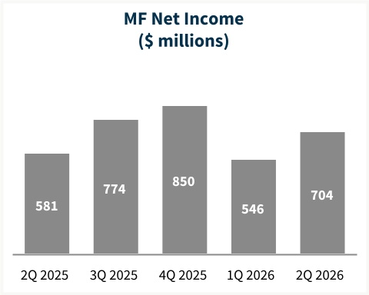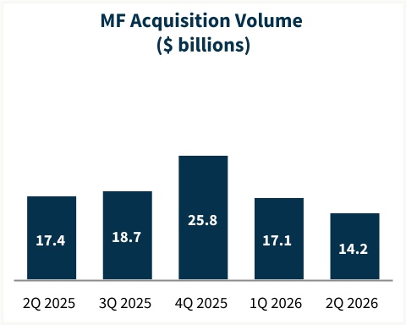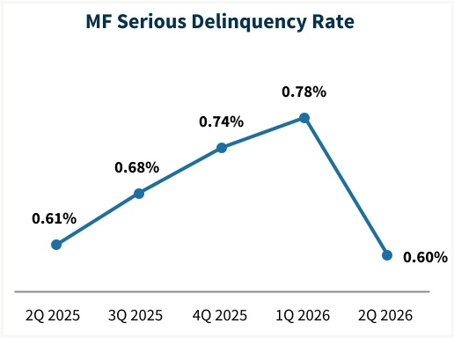
Multifamily Highlights — Second Quarter 2026
• |  |  | Multifamily acquisition volume declined to $14.2 billion, compared with $17.1 billion in 1Q 2026.
• |  |  | Multifamily book of business grew to $544.6 billion as of June 30, 2026, a $2.1 billion increase from March 31, 2026.
• |  |  | Average charged guaranty fees on overall multifamily book decreased by 0.6 basis points to 70.5 basis points as of June 30, 2026, compared with 71.1 basis points as of March 31, 2026.
• |  |  | Overall credit characteristics of the multifamily guaranty book were largely unchanged compared with the prior quarter, with weighted-average original loan-to-value ratio of 63% and a weighted-average debt service coverage ratio of 1.9 as of June 30, 2026.
• |  |  | Multifamily serious delinquency rate decreased to 0.60% as of June 30, 2026, compared with 0.78% as of prior quarter end, primarily as a result of the modification of a loan portfolio previously in forbearance and foreclosure activity, partially offset by additional loans that became seriously delinquent due to sustained market challenges in recent periods.(11)
• |  |  | Provision for multifamily credit losses of $259 million, primarily associated with weaker property valuations and slower net operating income growth in our multifamily guaranty book and by provision for loans that became seriously delinquent. This compares to a provision of $174 million in 1Q 2026.
Multifamily Business Financial Results
(Dollars in millions) |  |  |  |  |  | 2Q26 |  |  |  |  |  | 1Q26 |  |  |  |  |  | Variance |  |  |  |  |  | % Change |  |  |  |  |  |  |  | 2Q25 |  |  |  |  |  |  |  | Variance |  |  |  |  |  | % Change
Net interest income |  |  |  |  |  | $ | 1,245 |  |  |  |  | $ | 1,220 |  |  |  |  | $ | 25 |  |  |  |  | 2 |  | % |  |  |  |  |  | $ | 1,163 |  |  |  |  |  |  | $ | 82 |  |  |  |  | 7 |  | %
Fee and other income |  |  |  |  |  | 19 |  |  |  |  |  | 21 |  |  |  |  |  | (2) |  |  |  |  |  | (10) |  | % |  |  |  |  |  | 17 |  |  |  |  |  |  |  | 2 |  |  |  |  |  | 12 |  | %
Net revenues |  |  |  |  |  | 1,264 |  |  |  |  |  | 1,241 |  |  |  |  |  | 23 |  |  |  |  |  | 2 |  | % |  |  |  |  |  | 1,180 |  |  |  |  |  |  |  | 84 |  |  |  |  |  | 7 |  | %
Fair value gains (losses), net |  |  |  |  |  | (41) |  |  |  |  |  | (83) |  |  |  |  |  | 42 |  |  |  |  |  | 51 |  | % |  |  |  |  |  | 14 |  |  |  |  |  |  |  | (55) |  |  |  |  |  | NM
Investment gains (losses), net |  |  |  |  |  | 3 |  |  |  |  |  | (20) |  |  |  |  |  | 23 |  |  |  |  |  | NM |  |  |  |  |  |  |  | 1 |  |  |  |  |  |  |  | 2 |  |  |  |  |  | 200 |  | %
Other gains (losses), net |  |  |  |  |  | (38) |  |  |  |  |  | (103) |  |  |  |  |  | 65 |  |  |  |  |  | 63 |  | % |  |  |  |  |  | 15 |  |  |  |  |  |  |  | (53) |  |  |  |  |  | NM
(Provision) benefit for credit losses |  |  |  |  |  | (259) |  |  |  |  |  | (174) |  |  |  |  |  | (85) |  |  |  |  |  | (49) |  | % |  |  |  |  |  | (209) |  |  |  |  |  |  |  | (50) |  |  |  |  |  | (24) |  | %
Non-interest expense:
Administrative expenses(5) |  |  |  |  |  | (161) |  |  |  |  |  | (144) |  |  |  |  |  | (17) |  |  |  |  |  | (12) |  | % |  |  |  |  |  | (160) |  |  |  |  |  |  |  | (1) |  |  |  |  |  | (1) |  | %
Legislative assessments(6) |  |  |  |  |  | (10) |  |  |  |  |  | (13) |  |  |  |  |  | 3 |  |  |  |  |  | 23 |  | % |  |  |  |  |  | (21) |  |  |  |  |  |  |  | 11 |  |  |  |  |  | 52 |  | %
Credit enhancement expense(7) |  |  |  |  |  | (83) |  |  |  |  |  | (78) |  |  |  |  |  | (5) |  |  |  |  |  | (6) |  | % |  |  |  |  |  | (82) |  |  |  |  |  |  |  | (1) |  |  |  |  |  | (1) |  | %
Other income (expense), net(8) |  |  |  |  |  | 125 |  |  |  |  |  | (59) |  |  |  |  |  | 184 |  |  |  |  |  | NM |  |  |  |  |  |  |  | (16) |  |  |  |  |  |  |  | 141 |  |  |  |  |  | NM
Total non-interest expense |  |  |  |  |  | (129) |  |  |  |  |  | (294) |  |  |  |  |  | 165 |  |  |  |  |  | 56 |  | % |  |  |  |  |  | (279) |  |  |  |  |  |  |  | 150 |  |  |  |  |  | 54 |  | %
Income before federal income taxes |  |  |  |  |  | 838 |  |  |  |  |  | 670 |  |  |  |  |  | 168 |  |  |  |  |  | 25 |  | % |  |  |  |  |  | 707 |  |  |  |  |  |  |  | 131 |  |  |  |  |  | 19 |  | %
Provision for federal income taxes |  |  |  |  |  | (134) |  |  |  |  |  | (124) |  |  |  |  |  | (10) |  |  |  |  |  | (8) |  | % |  |  |  |  |  | (126) |  |  |  |  |  |  |  | (8) |  |  |  |  |  | (6) |  | %
Net income |  |  |  |  |  | $ | 704 |  |  |  |  | $ | 546 |  |  |  |  | $ | 158 |  |  |  |  | 29 |  | % |  |  |  |  |  | $ | 581 |  |  |  |  |  |  | $ | 123 |  |  |  |  | 21 |  | %
Average charged guaranty fee rate on multifamily guaranty book of business, at period end |  |  |  |  |  | 70.5 bps |  |  |  |  |  | 71.1 bps |  |  |  |  |  | (0.6) bps |  |  |  |  |  | (1) |  | % |  |  |  |  |  | 73.3 bps |  |  |  |  |  |  |  | (2.8) bps |  |  |  |  |  | (4) |  | %

Second Quarter 2026 |  |  |  |  |  | 4

Additional Matters
Fannie Mae’s Condensed Consolidated Statements of Operations and Comprehensive Income and Condensed Consolidated Balance Sheets for the second quarter of 2026 are available in the accompanying Annex; however, investors and interested parties should read the company’s quarterly report on Form 10-Q for the quarter ended June 30, 2026 (“Second Quarter 2026 Form 10-Q”), which was filed today with the Securities and Exchange Commission and is available on Fannie Mae’s website, www.fanniemae.com. The company provides further discussion of its financial results and condition, credit performance, and other matters in its Second Quarter 2026 Form 10-Q. Additional information about the company’s financial and credit performance is contained in Fannie Mae’s “2Q 2026 Earnings Presentation” and “Second Quarter 2026 Financial Supplement” at www.fanniemae.com.

# # #

This release includes forward-looking statements regarding the company's future financial and mission performance and financial condition, as well as the company’s future plans, and their impact. Actual outcomes could be materially different from what is set forth in these forward-looking statements due to a variety of factors, including those described in “Forward-Looking Statements” in the company’s Second Quarter 2026 Form 10-Q and in “Forward-Looking Statements,” “Risk Factors,” and elsewhere in the company’s annual report on Form 10-K for the year ended December 31, 2025.

Fannie Mae provides website addresses in its news releases solely for readers’ information. Information contained on or accessible through our website is not incorporated into, and does not as a result of references to the company’s website form a part of, this release or any other report or document the company files with or furnishes to the Securities and Exchange Commission, and any references to the company’s website are intended to be inactive textual references only.

To learn more, visit fanniemae.com.

Endnotes
NM |  |  | Not meaningful
* |  |  | Represents less than 0.5%
(1) |  |  | As presented in our Form 10-Q, net revenues consists of net interest income, and fee and other income.
(2) |  |  | Illustrative return on average required Common Equity Tier 1 (CET1) is designed to show what our return on capital would have been if our actual CET1 available capital had been equal to the CET1 capital requirement for the applicable periods. CET1 requirement as presented represents the company's average CET1 capital requirement including prescribed capital conservation buffer amount under the enterprise regulatory capital framework (which is not currently in effect while the company is in conservatorship) for the period as described below and not the amount of the company's actual available CET1 capital. As of June 30, 2026, the company's actual available CET1 capital was a deficit of $33 billion. For each applicable period, the illustrative return on average required CET1 ratio is calculated based on annualized year-to-date net income for the period divided by the average CET1 capital requirement for each quarter to date during the applicable year plus the fourth quarter of the previous year.
(3) |  |  | Administrative expense ratio is calculated as administrative expenses divided by net revenues during the period. Administrative expenses consist of salaries and employee benefits and professional services, technology and occupancy expenses.
(4) |  |  | Based on Fannie Mae analysis of loan delivery data from January 2018 through June 2026 using $550 as the approximate weighted average appraisal cost savings per loan.
(5) |  |  | Consists of salaries and employee benefits and professional services, technology and occupancy expenses.
(6) |  |  | For single-family, consists of the portion of our single-family guaranty fees that is paid to Treasury pursuant to the TCCA, affordable housing allocations and FHFA assessments. For multifamily, consists of affordable housing allocations and FHFA assessments.
(7) |  |  | Consists of costs associated with freestanding credit enhancements, which primarily include the company’s Connecticut Avenue Securities® (“CAS”) and Credit Insurance Risk TransferTM programs, enterprise-paid mortgage insurance, and certain lender risk-sharing programs.
(8) |  |  | Primarily consists of foreclosed property income (expense), change in the expected benefits from our freestanding credit enhancements, and gains (losses) from partnership investments.
(9) |  |  | Weighted-average FICO credit score at origination excludes loans for which FICO credit scores were unavailable and also excludes loans delivered with a VantageScore 4.0 credit score. Collectively these loans represented less than 0.5% of single-family conventional guaranty book of business.
(10) |  |  | Single-family seriously delinquent loans are loans that are 90 days or more past due or in the foreclosure process. Our single-family serious delinquency rate is expressed as a percentage of our single-family conventional guaranty book of business based on loan count.
(11) |  |  | Multifamily serious delinquency rate consists of multifamily loans that were 60 days or more past due based on unpaid principal balance, expressed as a percentage of our multifamily guaranty book of business.

Investor Contact: Yasaman Hekmat (yasaman_hekmat@fanniemae.com)
Media Contact: Matthew Classick (matthew_t_classick@fanniemae.com)

Second Quarter 2026 |  |  |  |  |  | 5

ANNEX
FANNIE MAE
(In conservatorship)
Condensed Consolidated Statements of Operations and Comprehensive Income — (Unaudited)
(Dollars and shares in millions, except per share amounts)

 |  |  | For the Three Months Ended June 30, |  |  |  |  |  |  |  |  |  |  |  |  |  |  |  |  |  |  |  |  |  |  |  | For the Six Months Ended June 30,
 |  |  | 2026 |  |  |  |  |  |  |  |  |  |  |  | 2025 |  |  |  |  |  |  |  |  |  |  |  | 2026 |  |  |  |  |  |  |  |  |  |  |  | 2025
Interest income:
Mortgage loans |  |  |  |  |  | $ | 39,294 |  |  |  |  |  |  |  |  |  |  | $ | 37,693 |  |  |  |  |  |  |  |  |  |  | $ | 78,199 |  |  |  |  |  |  |  |  |  |  | $ | 75,092
Securities purchased under agreements to resell |  |  |  |  |  | 548 |  |  |  |  |  |  |  |  |  |  |  | 924 |  |  |  |  |  |  |  |  |  |  |  | 1,178 |  |  |  |  |  |  |  |  |  |  |  | 1,796
Investments in securities and other |  |  |  |  |  | 966 |  |  |  |  |  |  |  |  |  |  |  | 794 |  |  |  |  |  |  |  |  |  |  |  | 1,653 |  |  |  |  |  |  |  |  |  |  |  | 1,539
Total interest income |  |  |  |  |  | 40,808 |  |  |  |  |  |  |  |  |  |  |  | 39,411 |  |  |  |  |  |  |  |  |  |  |  | 81,030 |  |  |  |  |  |  |  |  |  |  |  | 78,427
Interest expense:
Short-term debt |  |  |  |  |  | (254) |  |  |  |  |  |  |  |  |  |  |  | (103) |  |  |  |  |  |  |  |  |  |  |  | (448) |  |  |  |  |  |  |  |  |  |  |  | (208)
Long-term debt |  |  |  |  |  | (33,061) |  |  |  |  |  |  |  |  |  |  |  | (32,153) |  |  |  |  |  |  |  |  |  |  |  | (65,891) |  |  |  |  |  |  |  |  |  |  |  | (64,063)
Total interest expense |  |  |  |  |  | (33,315) |  |  |  |  |  |  |  |  |  |  |  | (32,256) |  |  |  |  |  |  |  |  |  |  |  | (66,339) |  |  |  |  |  |  |  |  |  |  |  | (64,271)
Net interest income |  |  |  |  |  | 7,493 |  |  |  |  |  |  |  |  |  |  |  | 7,155 |  |  |  |  |  |  |  |  |  |  |  | 14,691 |  |  |  |  |  |  |  |  |  |  |  | 14,156
Non-interest income:
Fair value gains (losses), net |  |  |  |  |  | (76) |  |  |  |  |  |  |  |  |  |  |  | 211 |  |  |  |  |  |  |  |  |  |  |  | 45 |  |  |  |  |  |  |  |  |  |  |  | 334
Fee and other income |  |  |  |  |  | 72 |  |  |  |  |  |  |  |  |  |  |  | 86 |  |  |  |  |  |  |  |  |  |  |  | 154 |  |  |  |  |  |  |  |  |  |  |  | 170
Investment gains (losses), net |  |  |  |  |  | 53 |  |  |  |  |  |  |  |  |  |  |  | (19) |  |  |  |  |  |  |  |  |  |  |  | (224) |  |  |  |  |  |  |  |  |  |  |  | (20)
Total non-interest income |  |  |  |  |  | 49 |  |  |  |  |  |  |  |  |  |  |  | 278 |  |  |  |  |  |  |  |  |  |  |  | (25) |  |  |  |  |  |  |  |  |  |  |  | 484
(Provision) benefit for credit losses |  |  |  |  |  | (485) |  |  |  |  |  |  |  |  |  |  |  | (946) |  |  |  |  |  |  |  |  |  |  |  | (762) |  |  |  |  |  |  |  |  |  |  |  | (970)
Non-interest expense:
Salaries and employee benefits |  |  |  |  |  | (463) |  |  |  |  |  |  |  |  |  |  |  | (492) |  |  |  |  |  |  |  |  |  |  |  | (926) |  |  |  |  |  |  |  |  |  |  |  | (1,103)
Professional services, technology, and occupancy |  |  |  |  |  | (348) |  |  |  |  |  |  |  |  |  |  |  | (355) |  |  |  |  |  |  |  |  |  |  |  | (630) |  |  |  |  |  |  |  |  |  |  |  | (736)
Legislative assessments |  |  |  |  |  | (934) |  |  |  |  |  |  |  |  |  |  |  | (939) |  |  |  |  |  |  |  |  |  |  |  | (1,865) |  |  |  |  |  |  |  |  |  |  |  | (1,870)
Credit enhancement expense |  |  |  |  |  | (361) |  |  |  |  |  |  |  |  |  |  |  | (400) |  |  |  |  |  |  |  |  |  |  |  | (719) |  |  |  |  |  |  |  |  |  |  |  | (879)
Other income (expense), net |  |  |  |  |  | 38 |  |  |  |  |  |  |  |  |  |  |  | (147) |  |  |  |  |  |  |  |  |  |  |  | (111) |  |  |  |  |  |  |  |  |  |  |  | (344)
Total non-interest expense |  |  |  |  |  | (2,068) |  |  |  |  |  |  |  |  |  |  |  | (2,333) |  |  |  |  |  |  |  |  |  |  |  | (4,251) |  |  |  |  |  |  |  |  |  |  |  | (4,932)
Income before federal income taxes |  |  |  |  |  | 4,989 |  |  |  |  |  |  |  |  |  |  |  | 4,154 |  |  |  |  |  |  |  |  |  |  |  | 9,653 |  |  |  |  |  |  |  |  |  |  |  | 8,738
Provision for federal income taxes |  |  |  |  |  | (1,007) |  |  |  |  |  |  |  |  |  |  |  | (837) |  |  |  |  |  |  |  |  |  |  |  | (1,951) |  |  |  |  |  |  |  |  |  |  |  | (1,760)
Net income |  |  |  |  |  | 3,982 |  |  |  |  |  |  |  |  |  |  |  | 3,317 |  |  |  |  |  |  |  |  |  |  |  | 7,702 |  |  |  |  |  |  |  |  |  |  |  | 6,978
Other comprehensive income (loss) |  |  |  |  |  | (152) |  |  |  |  |  |  |  |  |  |  |  | 7 |  |  |  |  |  |  |  |  |  |  |  | (217) |  |  |  |  |  |  |  |  |  |  |  | 1
Total comprehensive income |  |  |  |  |  | $ | 3,830 |  |  |  |  |  |  |  |  |  |  | $ | 3,324 |  |  |  |  |  |  |  |  |  |  | $ | 7,485 |  |  |  |  |  |  |  |  |  |  | $ | 6,979
Net income |  |  |  |  |  | $ | 3,982 |  |  |  |  |  |  |  |  |  |  | $ | 3,317 |  |  |  |  |  |  |  |  |  |  | $ | 7,702 |  |  |  |  |  |  |  |  |  |  | $ | 6,978
Dividends distributed or amounts attributable to senior preferred stock |  |  |  |  |  | (3,830) |  |  |  |  |  |  |  |  |  |  |  | (3,324) |  |  |  |  |  |  |  |  |  |  |  | (7,485) |  |  |  |  |  |  |  |  |  |  |  | (6,979)
Net income (loss) attributable to common stockholders |  |  |  |  |  | $ | 152 |  |  |  |  |  |  |  |  |  |  | $ | (7) |  |  |  |  |  |  |  |  |  |  | $ | 217 |  |  |  |  |  |  |  |  |  |  | $ | (1)
Earnings per share:
Basic |  |  |  |  |  | $ | 0.03 |  |  |  |  |  |  |  |  |  |  | $ | 0.00 |  |  |  |  |  |  |  |  |  |  | $ | 0.04 |  |  |  |  |  |  |  |  |  |  | $ | 0.00
Diluted |  |  |  |  |  | 0.03 |  |  |  |  |  |  |  |  |  |  |  | 0.00 |  |  |  |  |  |  |  |  |  |  |  | 0.04 |  |  |  |  |  |  |  |  |  |  |  | 0.00
Weighted-average common shares outstanding:
Basic |  |  |  |  |  | 5,867 |  |  |  |  |  |  |  |  |  |  |  | 5,867 |  |  |  |  |  |  |  |  |  |  |  | 5,867 |  |  |  |  |  |  |  |  |  |  |  | 5,867
Diluted |  |  |  |  |  | 5,893 |  |  |  |  |  |  |  |  |  |  |  | 5,867 |  |  |  |  |  |  |  |  |  |  |  | 5,893 |  |  |  |  |  |  |  |  |  |  |  | 5,867

See Notes to Condensed Consolidated Financial Statements in the Second Quarter 2026 Form 10-Q

Second Quarter 2026 |  |  |  |  |  | 6

FANNIE MAE
(In conservatorship)
Condensed Consolidated Balance Sheets — (Unaudited)
(Dollars in millions)
 |  |  | As of
 |  |  | June 30, 2026 |  |  |  |  |  |  |  |  |  |  |  | December 31, 2025
ASSETS
Cash |  |  |  |  |  | $ | 11,413 |  |  |  |  |  |  |  |  |  |  | $ | 11,452
Restricted cash (includes $22,143 and $22,848, respectively, related to consolidated trusts) |  |  |  |  |  | 29,401 |  |  |  |  |  |  |  |  |  |  |  | 31,131
Securities purchased under agreements to resell (includes $17,900 and $18,425, respectively, related to consolidated trusts) |  |  |  |  |  | 37,874 |  |  |  |  |  |  |  |  |  |  |  | 45,650
Investments in securities, at fair value |  |  |  |  |  | 94,769 |  |  |  |  |  |  |  |  |  |  |  | 69,889
Mortgage loans:
Loans held for sale, at lower of cost or fair value |  |  |  |  |  | 648 |  |  |  |  |  |  |  |  |  |  |  | 209
Loans held for investment, at amortized cost:
Of Fannie Mae |  |  |  |  |  | 66,761 |  |  |  |  |  |  |  |  |  |  |  | 57,970
Of consolidated trusts |  |  |  |  |  | 4,060,757 |  |  |  |  |  |  |  |  |  |  |  | 4,069,498
Total loans held for investment (includes $5,983 and $5,464, respectively, at fair value) |  |  |  |  |  | 4,127,518 |  |  |  |  |  |  |  |  |  |  |  | 4,127,468
Allowance for loan losses |  |  |  |  |  | (8,513) |  |  |  |  |  |  |  |  |  |  |  | (8,364)
Total loans held for investment, net of allowance |  |  |  |  |  | 4,119,005 |  |  |  |  |  |  |  |  |  |  |  | 4,119,104
Total mortgage loans |  |  |  |  |  | 4,119,653 |  |  |  |  |  |  |  |  |  |  |  | 4,119,313
Advances to lenders |  |  |  |  |  | 1,380 |  |  |  |  |  |  |  |  |  |  |  | 3,595
Deferred tax assets, net |  |  |  |  |  | 9,185 |  |  |  |  |  |  |  |  |  |  |  | 9,828
Accrued interest receivable (includes $11,477 and $11,129, respectively, related to consolidated trusts) |  |  |  |  |  | 12,287 |  |  |  |  |  |  |  |  |  |  |  | 11,689
Other assets |  |  |  |  |  | 16,381 |  |  |  |  |  |  |  |  |  |  |  | 14,991
Total assets |  |  |  |  |  | $ | 4,332,343 |  |  |  |  |  |  |  |  |  |  | $ | 4,317,538
LIABILITIES AND EQUITY
Liabilities:
Accrued interest payable (includes $11,321 and $11,320, respectively, related to consolidated trusts) |  |  |  |  |  | $ | 12,423 |  |  |  |  |  |  |  |  |  |  | $ | 12,035
Debt:
Of Fannie Mae (includes $264 and $256, respectively, at fair value) |  |  |  |  |  | 175,435 |  |  |  |  |  |  |  |  |  |  |  | 127,289
Of consolidated trusts (includes $14,557 and $15,060, respectively, at fair value) |  |  |  |  |  | 4,012,823 |  |  |  |  |  |  |  |  |  |  |  | 4,053,140
Other liabilities (includes $1,701 and $1,719, respectively, related to consolidated trusts) |  |  |  |  |  | 15,165 |  |  |  |  |  |  |  |  |  |  |  | 16,062
Total liabilities |  |  |  |  |  | 4,215,846 |  |  |  |  |  |  |  |  |  |  |  | 4,208,526
Commitments and contingencies (Note 14) |  |  |  |  |  | — |  |  |  |  |  |  |  |  |  |  |  | —
Fannie Mae stockholders’ equity:
Senior preferred stock (liquidation preference of $234,166 and $226,984, respectively) |  |  |  |  |  | 120,836 |  |  |  |  |  |  |  |  |  |  |  | 120,836
Preferred stock, 700,000,000 shares are authorized—555,374,922 shares issued and outstanding |  |  |  |  |  | 19,130 |  |  |  |  |  |  |  |  |  |  |  | 19,130
Common stock, no par value, no maximum authorization—1,308,762,703 shares issued and 1,158,087,567 shares outstanding |  |  |  |  |  | 687 |  |  |  |  |  |  |  |  |  |  |  | 687
Accumulated deficit |  |  |  |  |  | (16,559) |  |  |  |  |  |  |  |  |  |  |  | (24,261)
Accumulated other comprehensive income (loss) |  |  |  |  |  | (197) |  |  |  |  |  |  |  |  |  |  |  | 20
Treasury stock, at cost, 150,675,136 shares |  |  |  |  |  | (7,400) |  |  |  |  |  |  |  |  |  |  |  | (7,400)
Total stockholders’ equity |  |  |  |  |  | 116,497 |  |  |  |  |  |  |  |  |  |  |  | 109,012
Total liabilities and equity |  |  |  |  |  | $ | 4,332,343 |  |  |  |  |  |  |  |  |  |  | $ | 4,317,538

See Notes to Condensed Consolidated Financial Statements in the Second Quarter 2026 Form 10-Q
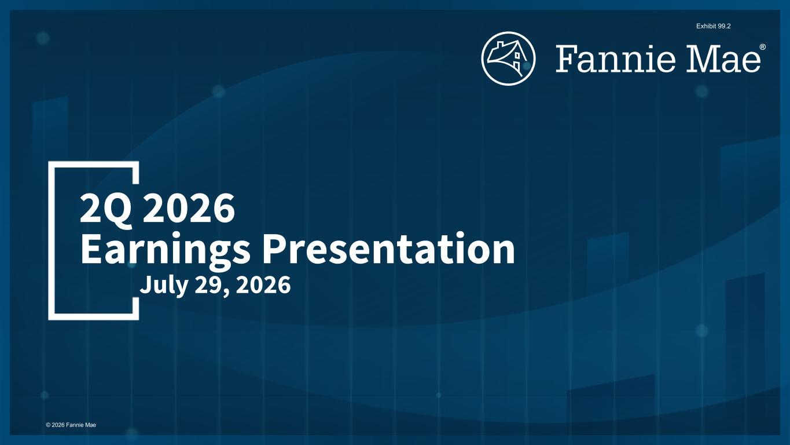

Second Quarter 2026 |  |  |  |  |  | 7

July 29, 2026 2Q 2026 Earnings Presentation © 2026 Fannie Mae Exhibit 99.2

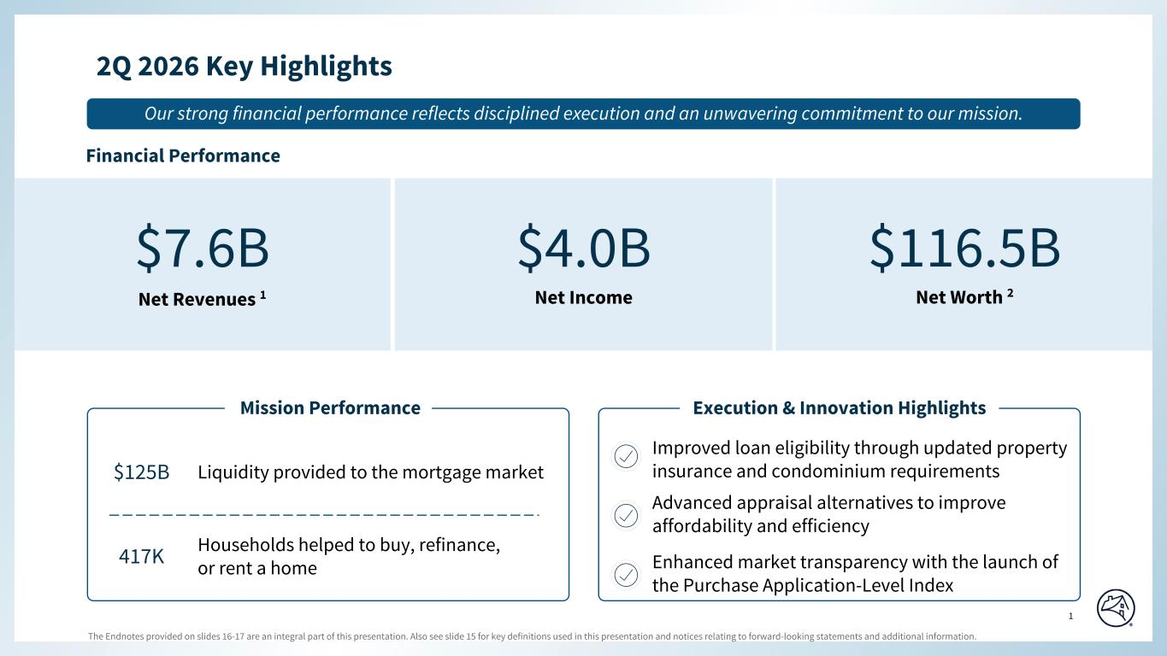
The Endnotes provided on slides 16-17 are an integral part of this presentation. Also see slide 15 for key definitions used in this presentation and notices relating to forward-looking statements and additional information. 1 Special Colors #edebe9 #898989 #cff2f2 Categorical Color Palette #05314d #1c6fa3 #898989 #4d4d4d #5dc7d0 #c55422 #2c6937 For callout boxes Use in rounded shape Sequential Color Palette #121212 #05314d #085280 #1c6fa3 #509ed5 #98c6e6 Line graph Color Palette #c44786 (refrain from using) #085280 #5dc7d0 #898989 #e66e39 #418152 #ffb400 2Q 2026 Key Highlights Page align Top align Advanced appraisal alternatives to improve affordability and efficiency Improved loan eligibility through updated property insurance and condominium requirements Our strong financial performance reflects disciplined execution and an unwavering commitment to our mission. $7.6B Net Revenues 1 $4.0B Net Income $116.5B Net Worth 2 Financial Performance Mission Performance $125B Liquidity provided to the mortgage market 417K Households helped to buy, refinance, or rent a home Execution & Innovation Highlights Enhanced market transparency with the launch of the Purchase Application-Level Index Bottom

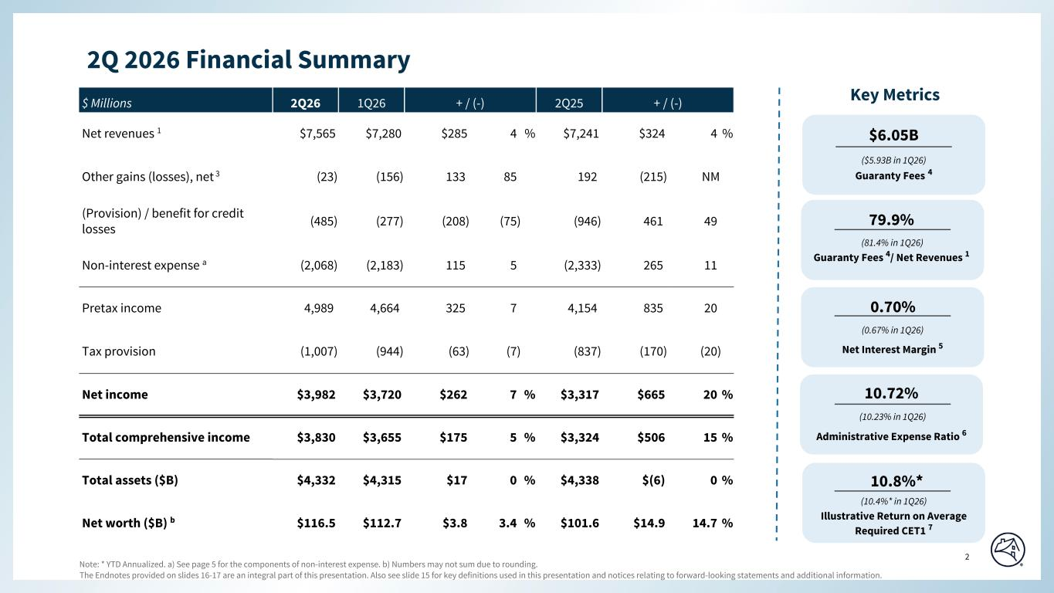
The Endnotes provided on slides 16-17 are an integral part of this presentation. Also see slide 15 for key definitions used in this presentation and notices relating to forward-looking statements and additional information. 2 Special Colors #edebe9 #898989 #cff2f2 Categorical Color Palette #05314d #1c6fa3 #898989 #4d4d4d #5dc7d0 #c55422 #2c6937 For callout boxes Use in rounded shape Sequential Color Palette #121212 #05314d #085280 #1c6fa3 #509ed5 #98c6e6 Line graph Color Palette #c44786 (refrain from using) #085280 #5dc7d0 #898989 #e66e39 #418152 #ffb400 $ Millions 2Q26 1Q26 + / (-) 2Q25 + / (-) Net revenues 1 $7,565 $7,280 $285 4 % $7,241 $324 4 % Other gains (losses), net 3 (23) (156) 133 85 192 (215) NM (Provision) / benefit for credit losses (485) (277) (208) (75) (946) 461 49 Non-interest expense a (2,068) (2,183) 115 5 (2,333) 265 11 Pretax income 4,989 4,664 325 7 4,154 835 20 Tax provision (1,007) (944) (63) (7) (837) (170) (20) Net income $3,982 $3,720 $262 7 % $3,317 $665 20 % Total comprehensive income $3,830 $3,655 $175 5 % $3,324 $506 15 % Total assets ($B) $4,332 $4,315 $17 0 % $4,338 $(6) 0 % Net worth ($B) b $116.5 $112.7 $3.8 3.4 % $101.6 $14.9 14.7 % 2Q 2026 Financial Summary Key Metrics Guaranty Fees 4/ Net Revenues 1 0.70% Net Interest Margin 5 10.72% Administrative Expense Ratio 6 10.8%* Illustrative Return on Average Required CET1 7 (81.4% in 1Q26) (10.4%* in 1Q26) (0.67% in 1Q26) (10.23% in 1Q26) 79.9% $6.05B Guaranty Fees 4 ($5.93B in 1Q26) Page align Note: * YTD Annualized. a) See page 5 for the components of non-interest expense. b) Numbers may not sum due to rounding. Bottom

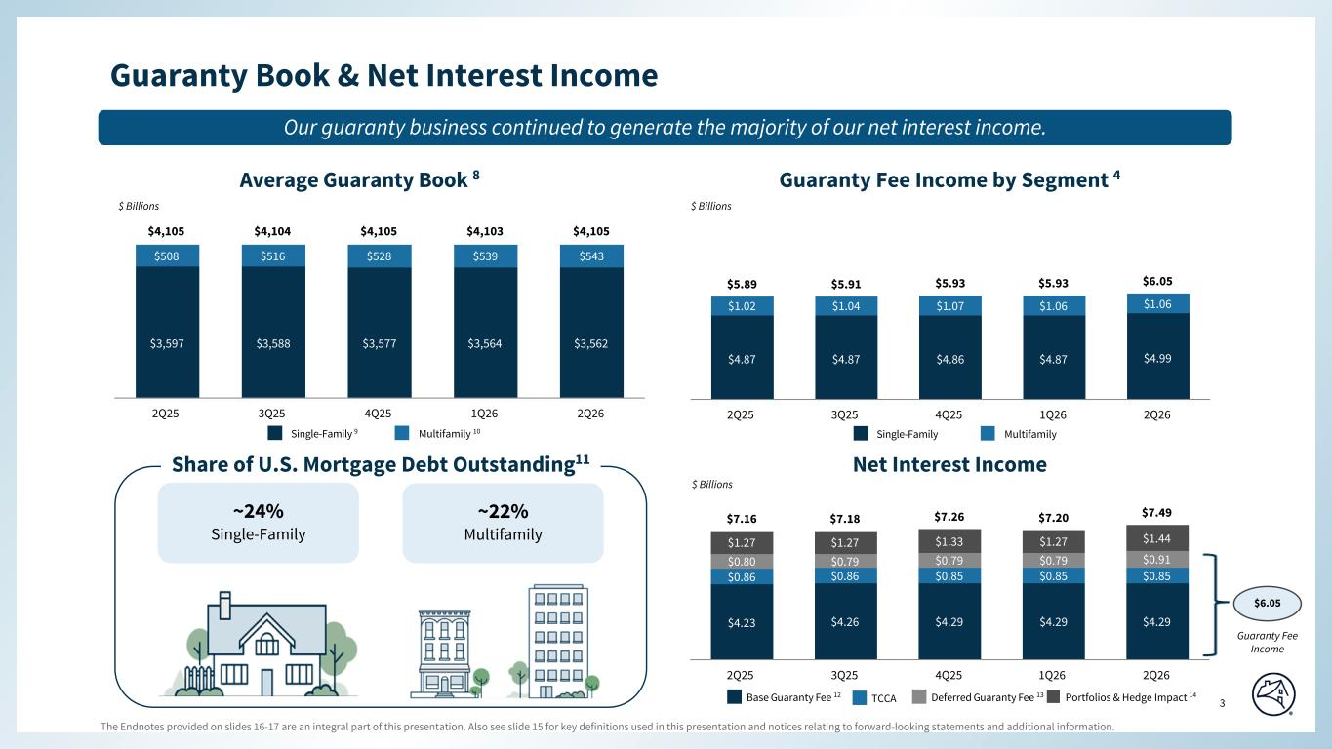
The Endnotes provided on slides 16-17 are an integral part of this presentation. Also see slide 15 for key definitions used in this presentation and notices relating to forward-looking statements and additional information. 3 Special Colors #edebe9 #898989 #cff2f2 Categorical Color Palette #05314d #1c6fa3 #898989 #4d4d4d #5dc7d0 #c55422 #2c6937 For callout boxes Use in rounded shape Sequential Color Palette #121212 #05314d #085280 #1c6fa3 #509ed5 #98c6e6 Line graph Color Palette #c44786 (refrain from using) #085280 #5dc7d0 #898989 #e66e39 #418152 #ffb400 $4.87 $4.87 $4.86 $4.87 $4.99 $1.02 $1.04 $1.07 $1.06 $1.06 $5.89 $5.91 $5.93 $5.93 $6.05 2Q25 3Q25 4Q25 1Q26 2Q26 $4.23 $4.26 $4.29 $4.29 $4.29 $0.86 $0.86 $0.85 $0.85 $0.85 $0.80 $0.79 $0.79 $0.79 $0.91 $1.27 $1.27 $1.33 $1.27 $1.44 $7.16 $7.18 $7.26 $7.20 $7.49 2Q25 3Q25 4Q25 1Q26 2Q26 Guaranty Book & Net Interest Income Average Guaranty Book 8 Page align Our guaranty business continued to generate the majority of our net interest income. $2.7 $1.7 $1.7 $8.5 Guaranty Fee Income $ Billions ~24% Single-Family ~22% Multifamily Share of U.S. Mortgage Debt Outstanding11 Net Interest Income Guaranty Fee Income by Segment 4 $ Billions $ Billions Single-Family 9 Multifamily 10 Single-Family Multifamily Base Guaranty Fee 12 Deferred Guaranty Fee 13 Portfolios & Hedge Impact 14TCCA $4,105 $4,104 $4,105 $4,103 $4,105 $3,597 $3,588 $3,577 $3,564 $3,562 $508 $516 $528 $539 $543 2Q25 3Q25 4Q25 1Q26 2Q26 $6.05

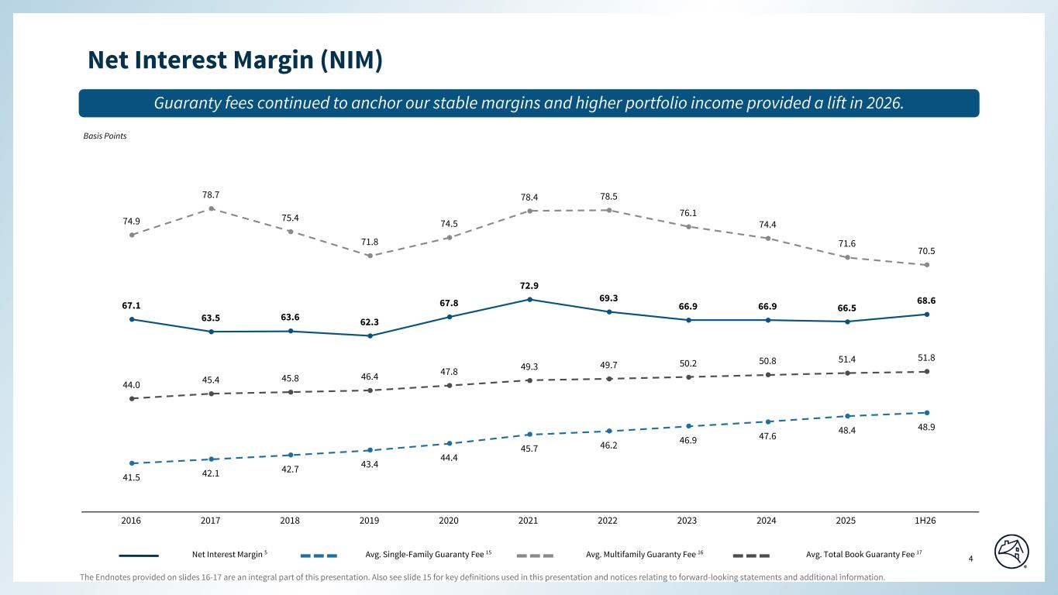
The Endnotes provided on slides 16-17 are an integral part of this presentation. Also see slide 15 for key definitions used in this presentation and notices relating to forward-looking statements and additional information. 4 Special Colors #edebe9 #898989 #cff2f2 Categorical Color Palette #05314d #1c6fa3 #898989 #4d4d4d #5dc7d0 #c55422 #2c6937 For callout boxes Use in rounded shape Sequential Color Palette #121212 #05314d #085280 #1c6fa3 #509ed5 #98c6e6 Line graph Color Palette #c44786 (refrain from using) #085280 #5dc7d0 #898989 #e66e39 #418152 #ffb400 67.1 63.5 63.6 62.3 67.8 72.9 69.3 66.9 66.9 66.5 68.6 44.0 45.4 45.8 46.4 47.8 49.3 49.7 50.2 50.8 51.4 51.8 41.5 42.1 42.7 43.4 44.4 45.7 46.2 46.9 47.6 48.4 48.9 74.9 78.7 75.4 71.8 74.5 78.4 78.5 76.1 74.4 71.6 70.5 2016 2017 2018 2019 2020 2021 2022 2023 2024 2025 1H26 Net Interest Margin (NIM) Guaranty fees continued to anchor our stable margins and higher portfolio income provided a lift in 2026. Basis Points Net Interest Margin 5 Avg. Single-Family Guaranty Fee 15 Avg. Multifamily Guaranty Fee 16 Avg. Total Book Guaranty Fee 17 Page align

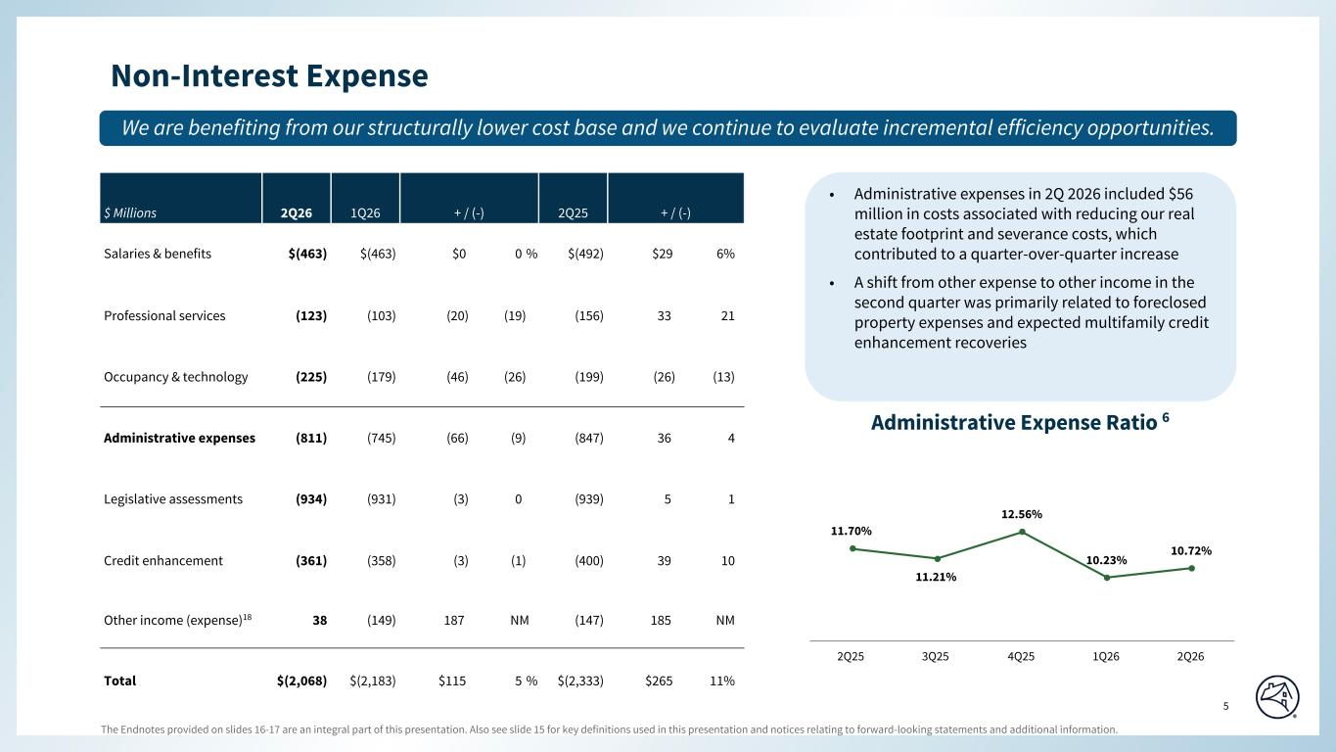
The Endnotes provided on slides 16-17 are an integral part of this presentation. Also see slide 15 for key definitions used in this presentation and notices relating to forward-looking statements and additional information. 5 Special Colors #edebe9 #898989 #cff2f2 Categorical Color Palette #05314d #1c6fa3 #898989 #4d4d4d #5dc7d0 #c55422 #2c6937 For callout boxes Use in rounded shape Sequential Color Palette #121212 #05314d #085280 #1c6fa3 #509ed5 #98c6e6 Line graph Color Palette #c44786 (refrain from using) #085280 #5dc7d0 #898989 #e66e39 #418152 #ffb400 • Administrative expenses in 2Q 2026 included $56 million in costs associated with reducing our real estate footprint and severance costs, which contributed to a quarter-over-quarter increase • A shift from other expense to other income in the second quarter was primarily related to foreclosed property expenses and expected multifamily credit enhancement recoveries Non-Interest Expense We are benefiting from our structurally lower cost base and we continue to evaluate incremental efficiency opportunities. $ Millions 2Q26 1Q26 + / (-) 2Q25 + / (-) Salaries & benefits $(463) $(463) $0 0 % $(492) $29 6 % Professional services (123) (103) (20) (19) (156) 33 21 Occupancy & technology (225) (179) (46) (26) (199) (26) (13) Administrative expenses (811) (745) (66) (9) (847) 36 4 Legislative assessments (934) (931) (3) 0 (939) 5 1 Credit enhancement (361) (358) (3) (1) (400) 39 10 Other income (expense)18 38 (149) 187 NM (147) 185 NM Total $(2,068) $(2,183) $115 5 % $(2,333) $265 11 % Administrative Expense Ratio 6 11.70% 11.21% 12.56% 10.23% 10.72% 2Q25 3Q25 4Q25 1Q26 2Q26 Page align

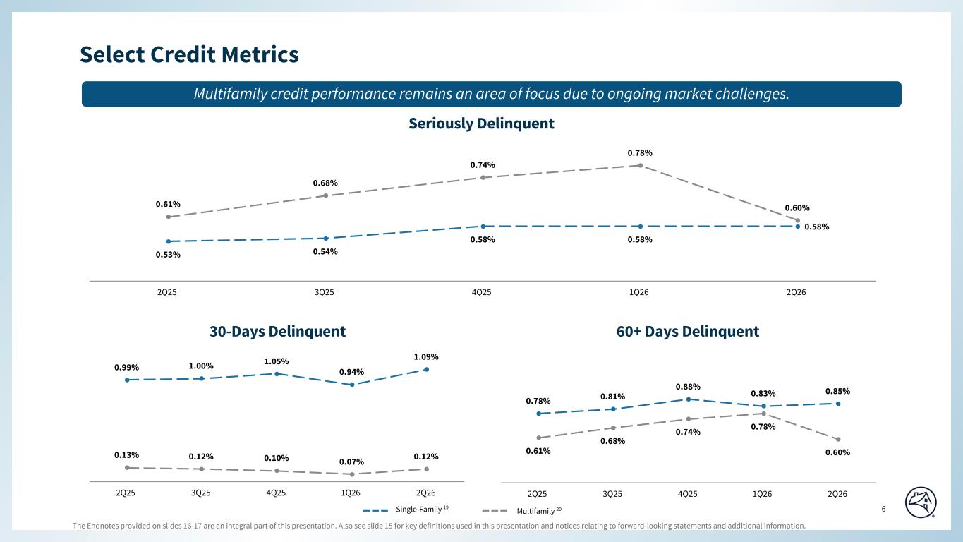
The Endnotes provided on slides 16-17 are an integral part of this presentation. Also see slide 15 for key definitions used in this presentation and notices relating to forward-looking statements and additional information. 6 Special Colors #edebe9 #898989 #cff2f2 Categorical Color Palette #05314d #1c6fa3 #898989 #4d4d4d #5dc7d0 #c55422 #2c6937 For callout boxes Use in rounded shape Sequential Color Palette #121212 #05314d #085280 #1c6fa3 #509ed5 #98c6e6 Line graph Color Palette #c44786 (refrain from using) #085280 #5dc7d0 #898989 #e66e39 #418152 #ffb400 0.99% 1.00% 1.05% 0.94% 1.09% 0.13% 0.12% 0.10% 0.07% 0.12% 2Q25 3Q25 4Q25 1Q26 2Q26 0.78% 0.81% 0.88% 0.83% 0.85% 0.61% 0.68% 0.74% 0.78% 0.60% 2Q25 3Q25 4Q25 1Q26 2Q26 Select Credit Metrics 30-Days Delinquent Seriously Delinquent 60+ Days Delinquent 0.53% 0.54% 0.58% 0.58% 0.58% 0.61% 0.68% 0.74% 0.78% 0.60% 2Q25 3Q25 4Q25 1Q26 2Q26 Multifamily credit performance remains an area of focus due to ongoing market challenges. Page align Single-Family 19 Multifamily 20

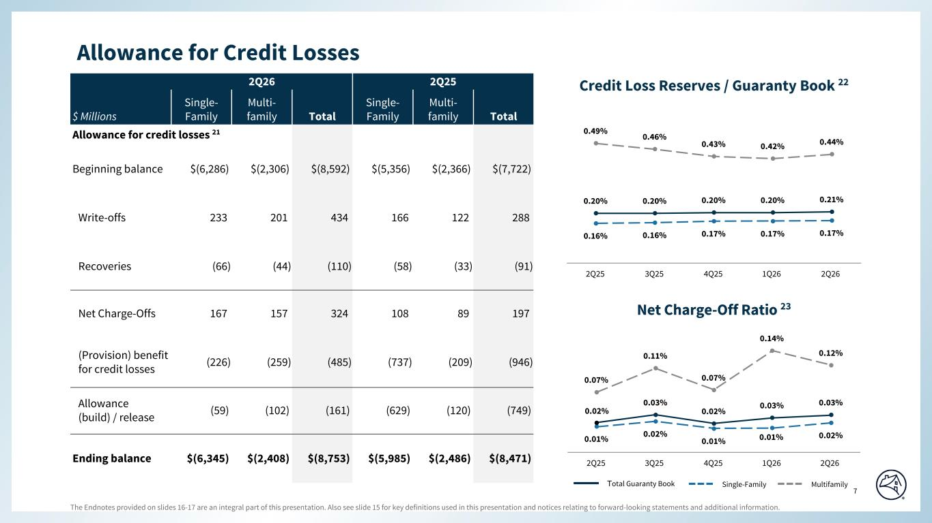
The Endnotes provided on slides 16-17 are an integral part of this presentation. Also see slide 15 for key definitions used in this presentation and notices relating to forward-looking statements and additional information. 7 Special Colors #edebe9 #898989 #cff2f2 Categorical Color Palette #05314d #1c6fa3 #898989 #4d4d4d #5dc7d0 #c55422 #2c6937 For callout boxes Use in rounded shape Sequential Color Palette #121212 #05314d #085280 #1c6fa3 #509ed5 #98c6e6 Line graph Color Palette #c44786 (refrain from using) #085280 #5dc7d0 #898989 #e66e39 #418152 #ffb400 0.16% 0.16% 0.17% 0.17% 0.17% 0.49% 0.46% 0.43% 0.42% 0.44% 0.20% 0.20% 0.20% 0.20% 0.21% 2Q25 3Q25 4Q25 1Q26 2Q26 0.01% 0.02% 0.01% 0.02% 0.07% 0.11% 0.07% 0.14% 0.12% 0.03% 0.02% 0.03% 0.03% 2Q25 3Q25 4Q25 1Q26 2Q26 Allowance for Credit Losses Net Charge-Off Ratio 23 Credit Loss Reserves / Guaranty Book 22 Total Guaranty Book Single-Family Multifamily 0.01% Page align Top 0.02% Bottom 2Q26 2Q25 $ Millions Single- Family Multi- family Total Single- Family Multi- family Total Allowance for credit losses 21 Beginning balance $(6,286) $(2,306) $(8,592) $(5,356) $(2,366) $(7,722) Write-offs 233 201 434 166 122 288 Recoveries (66) (44) (110) (58) (33) (91) Net Charge-Offs 167 157 324 108 89 197 (Provision) benefit for credit losses (226) (259) (485) (737) (209) (946) Allowance (build) / release (59) (102) (161) (629) (120) (749) Ending balance $(6,345) $(2,408) $(8,753) $(5,985) $(2,486) $(8,471)

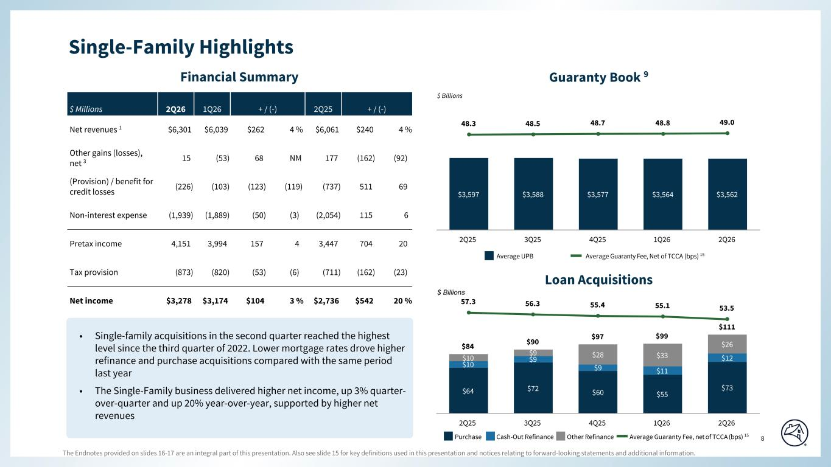
The Endnotes provided on slides 16-17 are an integral part of this presentation. Also see slide 15 for key definitions used in this presentation and notices relating to forward-looking statements and additional information. 8 Special Colors #edebe9 #898989 #cff2f2 Categorical Color Palette #05314d #1c6fa3 #898989 #4d4d4d #5dc7d0 #c55422 #2c6937 For callout boxes Use in rounded shape Sequential Color Palette #121212 #05314d #085280 #1c6fa3 #509ed5 #98c6e6 Line graph Color Palette #c44786 (refrain from using) #085280 #5dc7d0 #898989 #e66e39 #418152 #ffb400 $3,597 $3,588 $3,577 $3,564 $3,562 48.3 48.5 48.7 48.8 49.0 2Q25 3Q25 4Q25 1Q26 2Q26 $64 $72 $60 $55 $73 $10 $9 $9 $11 $12$10 $9 $28 $33 $26$84 $90 $97 $99 $111 57.3 56.3 55.4 55.1 53.5 2Q25 3Q25 4Q25 1Q26 2Q26 $ Billions Financial Summary Purchase Average Guaranty Fee, net of TCCA (bps) 15Cash-Out Refinance Other Refinance Average UPB Average Guaranty Fee, Net of TCCA (bps) 15 Guaranty Book 9 Loan Acquisitions $ Billions $ Millions 2Q26 1Q26 + / (-) 2Q25 + / (-) Net revenues 1 $6,301 $6,039 $262 4 % $6,061 $240 4 % Other gains (losses), net 3 15 (53) 68 NM 177 (162) (92) (Provision) / benefit for credit losses (226) (103) (123) (119) (737) 511 69 Non-interest expense (1,939) (1,889) (50) (3) (2,054) 115 6 Pretax income 4,151 3,994 157 4 3,447 704 20 Tax provision (873) (820) (53) (6) (711) (162) (23) Net income $3,278 $3,174 $104 3 % $2,736 $542 20 % Single-Family Highlights Page align • Single-family acquisitions in the second quarter reached the highest level since the third quarter of 2022. Lower mortgage rates drove higher refinance and purchase acquisitions compared with the same period last year • The Single-Family business delivered higher net income, up 3% quarter- over-quarter and up 20% year-over-year, supported by higher net revenues

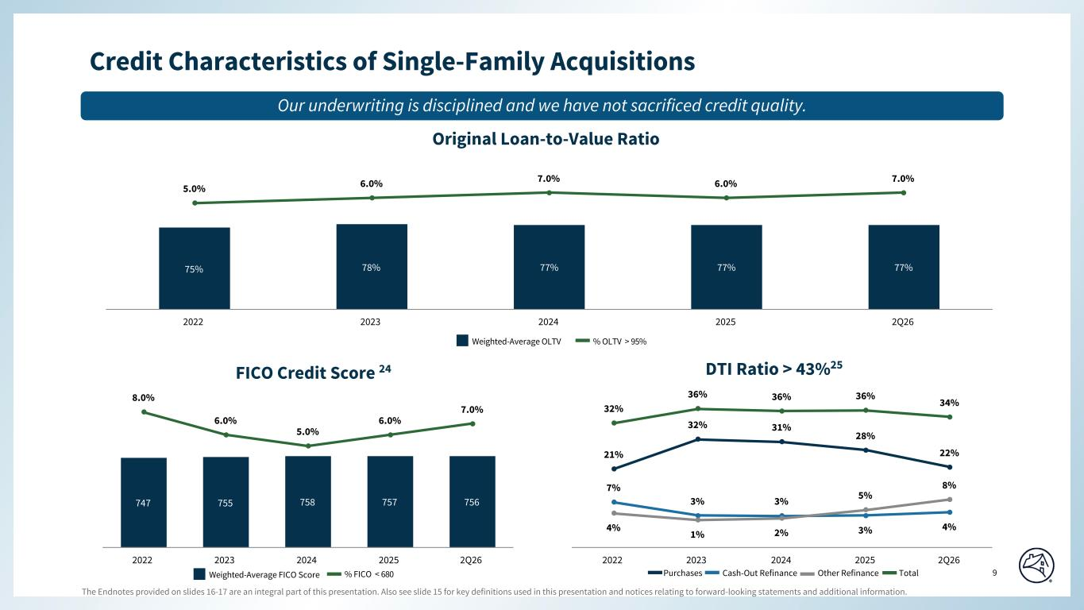
The Endnotes provided on slides 16-17 are an integral part of this presentation. Also see slide 15 for key definitions used in this presentation and notices relating to forward-looking statements and additional information. 9 Special Colors #edebe9 #898989 #cff2f2 Categorical Color Palette #05314d #1c6fa3 #898989 #4d4d4d #5dc7d0 #c55422 #2c6937 For callout boxes Use in rounded shape Sequential Color Palette #121212 #05314d #085280 #1c6fa3 #509ed5 #98c6e6 Line graph Color Palette #c44786 (refrain from using) #085280 #5dc7d0 #898989 #e66e39 #418152 #ffb400 21% 32% 31% 28% 22% 7% 3% 3% 3% 4%4% 1% 2% 5% 8% 32% 36% 36% 36% 34% 2022 2023 2024 2025 2Q26 75% 78% 77% 77% 77% 5.0% 6.0% 7.0% 6.0% 7.0% 2022 2023 2024 2025 2Q26 747 755 758 757 756 8.0% 6.0% 5.0% 6.0% 7.0% 2022 2023 2024 2025 2Q26 FICO Credit Score 24 Original Loan-to-Value Ratio DTI Ratio > 43%25 % FICO < 680Weighted-Average FICO Score % OLTV > 95%Weighted-Average OLTV Credit Characteristics of Single-Family Acquisitions Purchases Cash-Out Refinance Other Refinance Total Page align Our underwriting is disciplined and we have not sacrificed credit quality.

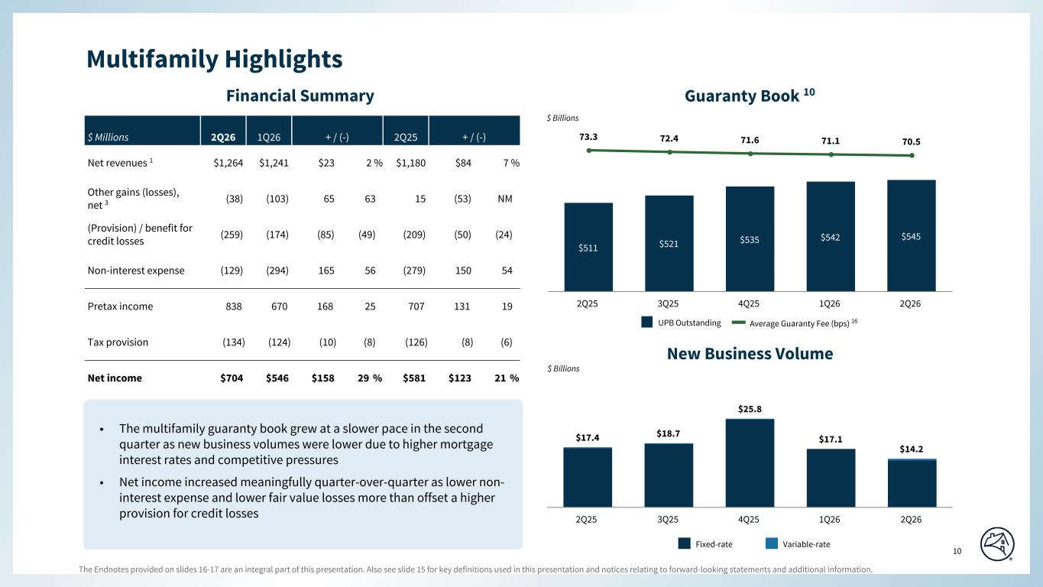
The Endnotes provided on slides 16-17 are an integral part of this presentation. Also see slide 15 for key definitions used in this presentation and notices relating to forward-looking statements and additional information. 10 Special Colors #edebe9 #898989 #cff2f2 Categorical Color Palette #05314d #1c6fa3 #898989 #4d4d4d #5dc7d0 #c55422 #2c6937 For callout boxes Use in rounded shape Sequential Color Palette #121212 #05314d #085280 #1c6fa3 #509ed5 #98c6e6 Line graph Color Palette #c44786 (refrain from using) #085280 #5dc7d0 #898989 #e66e39 #418152 #ffb400 $511 $521 $535 $542 $545 73.3 72.4 71.6 71.1 70.5 2Q25 3Q25 4Q25 1Q26 2Q26 Financial Summary Guaranty Book 10 $ Millions 2Q26 1Q26 + / (-) 2Q25 + / (-) Net revenues 1 $1,264 $1,241 $23 2 % $1,180 $84 7 % Other gains (losses), net 3 (38) (103) 65 63 15 (53) NM (Provision) / benefit for credit losses (259) (174) (85) (49) (209) (50) (24) Non-interest expense (129) (294) 165 56 (279) 150 54 Pretax income 838 670 168 25 707 131 19 Tax provision (134) (124) (10) (8) (126) (8) (6) Net income $704 $546 $158 29 % $581 $123 21 % $17.4 $18.7 $25.8 $17.1 $14.2 2Q25 3Q25 4Q25 1Q26 2Q26 Fixed-rate New Business Volume Variable-rate $ Billions $ Billions UPB Outstanding Average Guaranty Fee (bps) 16 Multifamily Highlights Page align • The multifamily guaranty book grew at a slower pace in the second quarter as new business volumes were lower due to higher mortgage interest rates and competitive pressures • Net income increased meaningfully quarter-over-quarter as lower non- interest expense and lower fair value losses more than offset a higher provision for credit losses

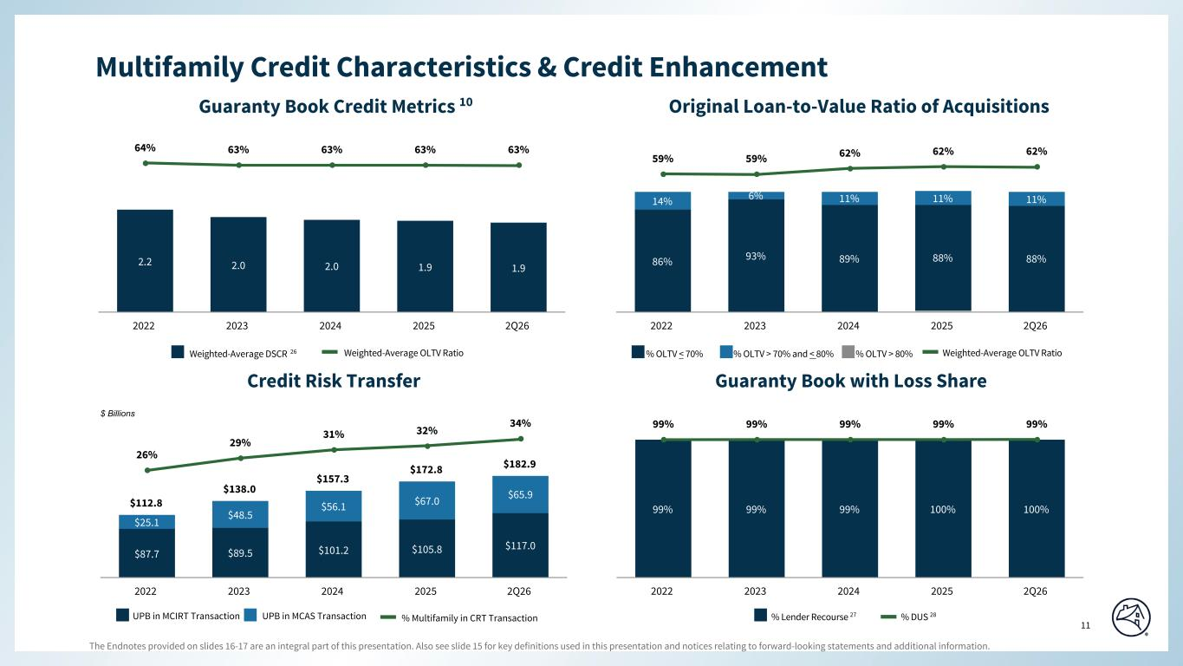
The Endnotes provided on slides 16-17 are an integral part of this presentation. Also see slide 15 for key definitions used in this presentation and notices relating to forward-looking statements and additional information. 11 Special Colors #edebe9 #898989 #cff2f2 Categorical Color Palette #05314d #1c6fa3 #898989 #4d4d4d #5dc7d0 #c55422 #2c6937 For callout boxes Use in rounded shape Sequential Color Palette #121212 #05314d #085280 #1c6fa3 #509ed5 #98c6e6 Line graph Color Palette #c44786 (refrain from using) #085280 #5dc7d0 #898989 #e66e39 #418152 #ffb400 Multifamily Credit Characteristics & Credit Enhancement 86% 93% 89% 88% 88% 14% 6% 11% 11% 11% 59% 59% 62% 62% 62% 2022 2023 2024 2025 2Q26 2.2 2.0 2.0 1.9 1.9 64% 63% 63% 63% 63% 2022 2023 2024 2025 2Q26 Original Loan-to-Value Ratio of Acquisitions Guaranty Book Credit Metrics 10 $112.8 $138.0 $157.3 $172.8 $182.9 $87.7 $89.5 $101.2 $105.8 $117.0 $25.1 $48.5 $56.1 $67.0 $65.9 26% 29% 31% 32% 34% 2022 2023 2024 2025 2Q26 Guaranty Book with Loss ShareCredit Risk Transfer 99% 99% 99% 100% 100% 99% 99% 99% 99% 99% 2022 2023 2024 2025 2Q26 Weighted-Average DSCR 26 Weighted-Average OLTV Ratio % OLTV > 80% Weighted-Average OLTV Ratio% OLTV < 70% % OLTV > 70% and < 80% % Multifamily in CRT TransactionUPB in MCIRT Transaction UPB in MCAS Transaction % Lender Recourse 27 % DUS 28 $ Billions Page align

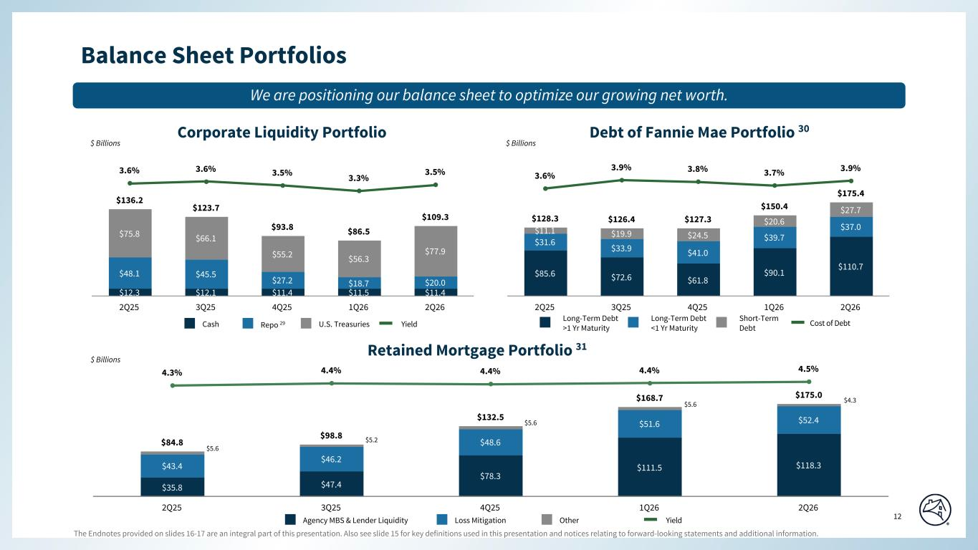
The Endnotes provided on slides 16-17 are an integral part of this presentation. Also see slide 15 for key definitions used in this presentation and notices relating to forward-looking statements and additional information. 12 Special Colors #edebe9 #898989 #cff2f2 Categorical Color Palette #05314d #1c6fa3 #898989 #4d4d4d #5dc7d0 #c55422 #2c6937 For callout boxes Use in rounded shape Sequential Color Palette #121212 #05314d #085280 #1c6fa3 #509ed5 #98c6e6 Line graph Color Palette #c44786 (refrain from using) #085280 #5dc7d0 #898989 #e66e39 #418152 #ffb400 $12.3 $12.1 $11.4 $11.5 $11.4 $48.1 $45.5 $27.2 $18.7 $20.0 $75.8 $66.1 $55.2 $56.3 $77.9 $136.2 $123.7 $93.8 $86.5 $109.3 3.6% 3.6% 3.5% 3.3% 3.5% 2Q25 3Q25 4Q25 1Q26 2Q26 $85.6 $72.6 $61.8 $90.1 $110.7 $31.6 $33.9 $41.0 $39.7 $37.0$11.1 $19.9 $24.5 $20.6 $27.7 $128.3 $126.4 $127.3 $150.4 $175.4 3.6% 3.9% 3.8% 3.7% 3.9% 2Q25 3Q25 4Q25 1Q26 2Q26 Cash Repo 29 U.S. Treasuries Debt of Fannie Mae Portfolio 30 Long-Term Debt >1 Yr Maturity Long-Term Debt <1 Yr Maturity Short-Term Debt Corporate Liquidity Portfolio Cost of DebtYield $ Billions $ Billions $35.8 $47.4 $78.3 $111.5 $118.3$43.4 $46.2 $48.6 $51.6 $52.4 $84.8 $98.8 $132.5 $168.7 $175.0 4.3% 4.4% 4.4% 4.4% 4.5% 2Q25 3Q25 4Q25 1Q26 2Q26 $ Billions Agency MBS & Lender Liquidity Loss Mitigation Other Retained Mortgage Portfolio 31 Yield Balance Sheet Portfolios Page align We are positioning our balance sheet to optimize our growing net worth. $5.6 $5.2 $5.6 $5.6 $4.3

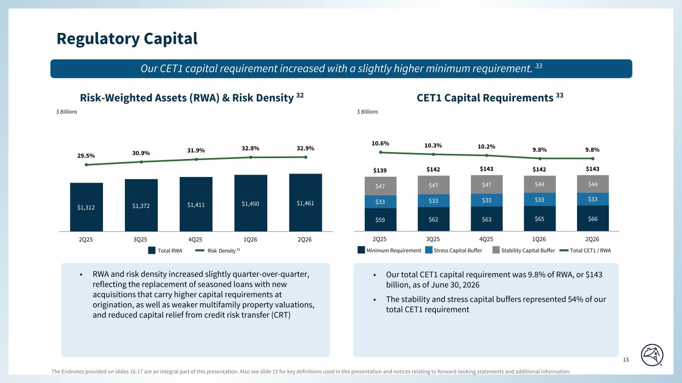
The Endnotes provided on slides 16-17 are an integral part of this presentation. Also see slide 15 for key definitions used in this presentation and notices relating to forward-looking statements and additional information. 13 Special Colors #edebe9 #898989 #cff2f2 Categorical Color Palette #05314d #1c6fa3 #898989 #4d4d4d #5dc7d0 #c55422 #2c6937 For callout boxes Use in rounded shape Sequential Color Palette #121212 #05314d #085280 #1c6fa3 #509ed5 #98c6e6 Line graph Color Palette #c44786 (refrain from using) #085280 #5dc7d0 #898989 #e66e39 #418152 #ffb400 Regulatory Capital Risk-Weighted Assets (RWA) & Risk Density 32 $ Billions $ Billions CET1 Capital Requirements 33 Our CET1 capital requirement increased with a slightly higher minimum requirement. 33 Minimum Requirement Total CET1 / RWAStress Capital Buffer Stability Capital Buffer $59 $62 $63 $65 $66 $33 $33 $33 $33 $33 $47 $47 $47 $44 $44 $139 $142 $143 $142 $143 10.6% 10.3% 10.2% 9.8% 9.8% 2Q25 3Q25 4Q25 1Q26 2Q26 $1,312 $1,372 $1,411 $1,450 $1,461 29.5% 30.9% 31.9% 32.8% 32.9% 2Q25 3Q25 4Q25 1Q26 2Q26 Total RWA Risk Density 32 • RWA and risk density increased slightly quarter-over-quarter, reflecting the replacement of seasoned loans with new acquisitions that carry higher capital requirements at origination, as well as weaker multifamily property valuations, and reduced capital relief from credit risk transfer (CRT) • Our total CET1 capital requirement was 9.8% of RWA, or $143 billion, as of June 30, 2026 • The stability and stress capital buffers represented 54% of our total CET1 requirement Page align

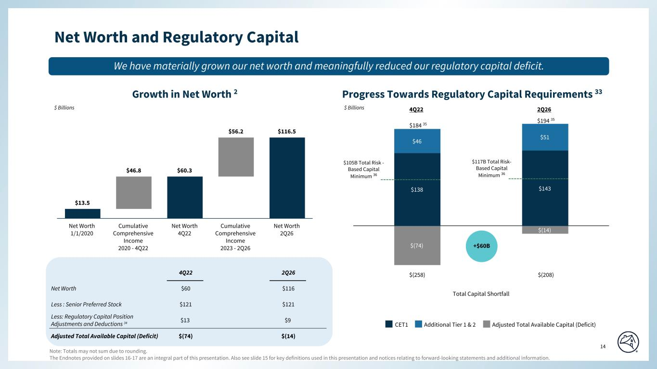
The Endnotes provided on slides 16-17 are an integral part of this presentation. Also see slide 15 for key definitions used in this presentation and notices relating to forward-looking statements and additional information. 14 Special Colors #edebe9 #898989 #cff2f2 Categorical Color Palette #05314d #1c6fa3 #898989 #4d4d4d #5dc7d0 #c55422 #2c6937 For callout boxes Use in rounded shape Sequential Color Palette #121212 #05314d #085280 #1c6fa3 #509ed5 #98c6e6 Line graph Color Palette #c44786 (refrain from using) #085280 #5dc7d0 #898989 #e66e39 #418152 #ffb400 $138 $143 $46 $51 $(74) $(14) 4Q22 2Q26 Net Worth $60 $116 Less : Senior Preferred Stock $121 $121 Less: Regulatory Capital Position Adjustments and Deductions 34 $13 $9 Adjusted Total Available Capital (Deficit) $(74) $(14) Net Worth and Regulatory Capital Growth in Net Worth 2 $13.5 $46.8 $60.3 $56.2 $116.5 Net Worth 1/1/2020 Cumulative Comprehensive Income 2020 - 4Q22 Net Worth 4Q22 Cumulative Comprehensive Income 2023 - 2Q26 Net Worth 2Q26 $ Billions $ Billions Progress Towards Regulatory Capital Requirements 33 CET1 Additional Tier 1 & 2 $105B Total Risk - Based Capital Minimum 36 $117B Total Risk- Based Capital Minimum 36 We have materially grown our net worth and meaningfully reduced our regulatory capital deficit. Adjusted Total Available Capital (Deficit) 4Q22 2Q26 $(258) $(208) Total Capital Shortfall $184 35 $194 35 Note: Totals may not sum due to rounding. +$60B Page align

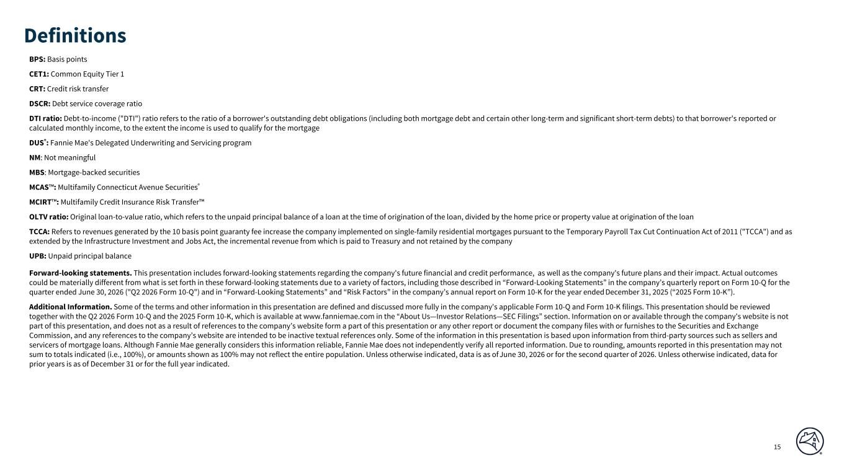
15 BPS: Basis points CET1: Common Equity Tier 1 CRT: Credit risk transfer DSCR: Debt service coverage ratio DTI ratio: Debt-to-income ("DTI") ratio refers to the ratio of a borrower's outstanding debt obligations (including both mortgage debt and certain other long-term and significant short-term debts) to that borrower's reported or calculated monthly income, to the extent the income is used to qualify for the mortgage DUS®: Fannie Mae's Delegated Underwriting and Servicing program NM: Not meaningful MBS: Mortgage-backed securities MCAS™: Multifamily Connecticut Avenue Securities® MCIRT™: Multifamily Credit Insurance Risk Transfer™ OLTV ratio: Original loan-to-value ratio, which refers to the unpaid principal balance of a loan at the time of origination of the loan, divided by the home price or property value at origination of the loan TCCA: Refers to revenues generated by the 10 basis point guaranty fee increase the company implemented on single-family residential mortgages pursuant to the Temporary Payroll Tax Cut Continuation Act of 2011 ("TCCA") and as extended by the Infrastructure Investment and Jobs Act, the incremental revenue from which is paid to Treasury and not retained by the company UPB: Unpaid principal balance Definitions Forward-looking statements. This presentation includes forward-looking statements regarding the company's future financial and credit performance, as well as the company's future plans and their impact. Actual outcomes could be materially different from what is set forth in these forward-looking statements due to a variety of factors, including those described in “Forward-Looking Statements” in the company’s quarterly report on Form 10-Q for the quarter ended June 30, 2026 ("Q2 2026 Form 10-Q") and in “Forward-Looking Statements” and “Risk Factors” in the company’s annual report on Form 10-K for the year ended December 31, 2025 (“2025 Form 10-K”). Additional Information. Some of the terms and other information in this presentation are defined and discussed more fully in the company's applicable Form 10-Q and Form 10-K filings. This presentation should be reviewed together with the Q2 2026 Form 10-Q and the 2025 Form 10-K, which is available at www.fanniemae.com in the “About Us—Investor Relations—SEC Filings” section. Information on or available through the company's website is not part of this presentation, and does not as a result of references to the company’s website form a part of this presentation or any other report or document the company files with or furnishes to the Securities and Exchange Commission, and any references to the company’s website are intended to be inactive textual references only. Some of the information in this presentation is based upon information from third-party sources such as sellers and servicers of mortgage loans. Although Fannie Mae generally considers this information reliable, Fannie Mae does not independently verify all reported information. Due to rounding, amounts reported in this presentation may not sum to totals indicated (i.e., 100%), or amounts shown as 100% may not reflect the entire population. Unless otherwise indicated, data is as of June 30, 2026 or for the second quarter of 2026. Unless otherwise indicated, data for prior years is as of December 31 or for the full year indicated.

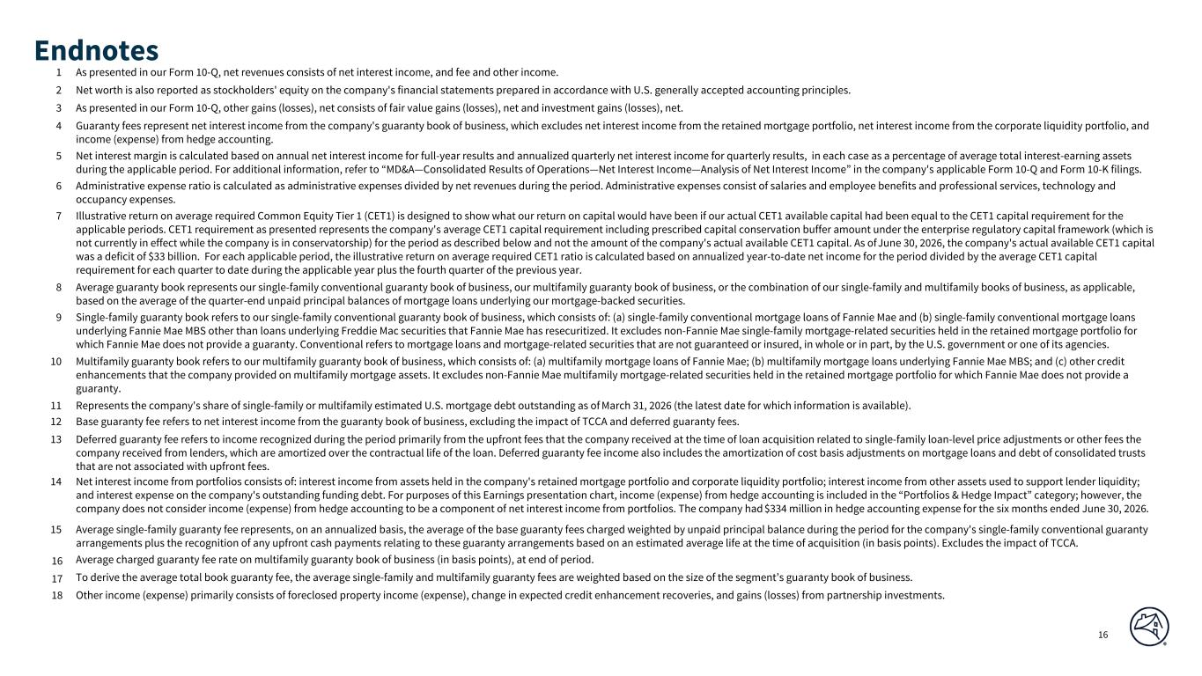
16 1 As presented in our Form 10-Q, net revenues consists of net interest income, and fee and other income. 2 Net worth is also reported as stockholders' equity on the company's financial statements prepared in accordance with U.S. generally accepted accounting principles. 3 As presented in our Form 10-Q, other gains (losses), net consists of fair value gains (losses), net and investment gains (losses), net. 4 Guaranty fees represent net interest income from the company's guaranty book of business, which excludes net interest income from the retained mortgage portfolio, net interest income from the corporate liquidity portfolio, and income (expense) from hedge accounting. 5 Net interest margin is calculated based on annual net interest income for full-year results and annualized quarterly net interest income for quarterly results, in each case as a percentage of average total interest-earning assets during the applicable period. For additional information, refer to “MD&A—Consolidated Results of Operations—Net Interest Income—Analysis of Net Interest Income” in the company's applicable Form 10-Q and Form 10-K filings. 6 Administrative expense ratio is calculated as administrative expenses divided by net revenues during the period. Administrative expenses consist of salaries and employee benefits and professional services, technology and occupancy expenses. 7 Illustrative return on average required Common Equity Tier 1 (CET1) is designed to show what our return on capital would have been if our actual CET1 available capital had been equal to the CET1 capital requirement for the applicable periods. CET1 requirement as presented represents the company's average CET1 capital requirement including prescribed capital conservation buffer amount under the enterprise regulatory capital framework (which is not currently in effect while the company is in conservatorship) for the period as described below and not the amount of the company's actual available CET1 capital. As of June 30, 2026, the company's actual available CET1 capital was a deficit of $33 billion. For each applicable period, the illustrative return on average required CET1 ratio is calculated based on annualized year-to-date net income for the period divided by the average CET1 capital requirement for each quarter to date during the applicable year plus the fourth quarter of the previous year. 8 Average guaranty book represents our single-family conventional guaranty book of business, our multifamily guaranty book of business, or the combination of our single-family and multifamily books of business, as applicable, based on the average of the quarter-end unpaid principal balances of mortgage loans underlying our mortgage-backed securities. 9 Single-family guaranty book refers to our single-family conventional guaranty book of business, which consists of: (a) single-family conventional mortgage loans of Fannie Mae and (b) single-family conventional mortgage loans underlying Fannie Mae MBS other than loans underlying Freddie Mac securities that Fannie Mae has resecuritized. It excludes non-Fannie Mae single-family mortgage-related securities held in the retained mortgage portfolio for which Fannie Mae does not provide a guaranty. Conventional refers to mortgage loans and mortgage-related securities that are not guaranteed or insured, in whole or in part, by the U.S. government or one of its agencies. 10 Multifamily guaranty book refers to our multifamily guaranty book of business, which consists of: (a) multifamily mortgage loans of Fannie Mae; (b) multifamily mortgage loans underlying Fannie Mae MBS; and (c) other credit enhancements that the company provided on multifamily mortgage assets. It excludes non-Fannie Mae multifamily mortgage-related securities held in the retained mortgage portfolio for which Fannie Mae does not provide a guaranty. 11 Represents the company's share of single-family or multifamily estimated U.S. mortgage debt outstanding as of March 31, 2026 (the latest date for which information is available). 12 Base guaranty fee refers to net interest income from the guaranty book of business, excluding the impact of TCCA and deferred guaranty fees. 13 Deferred guaranty fee refers to income recognized during the period primarily from the upfront fees that the company received at the time of loan acquisition related to single-family loan-level price adjustments or other fees the company received from lenders, which are amortized over the contractual life of the loan. Deferred guaranty fee income also includes the amortization of cost basis adjustments on mortgage loans and debt of consolidated trusts that are not associated with upfront fees. 14 Net interest income from portfolios consists of: interest income from assets held in the company's retained mortgage portfolio and corporate liquidity portfolio; interest income from other assets used to support lender liquidity; and interest expense on the company's outstanding funding debt. For purposes of this Earnings presentation chart, income (expense) from hedge accounting is included in the “Portfolios & Hedge Impact” category; however, the company does not consider income (expense) from hedge accounting to be a component of net interest income from portfolios. The company had $334 million in hedge accounting expense for the six months ended June 30, 2026. 15 Average single-family guaranty fee represents, on an annualized basis, the average of the base guaranty fees charged weighted by unpaid principal balance during the period for the company's single-family conventional guaranty arrangements plus the recognition of any upfront cash payments relating to these guaranty arrangements based on an estimated average life at the time of acquisition (in basis points). Excludes the impact of TCCA. 16 Average charged guaranty fee rate on multifamily guaranty book of business (in basis points), at end of period. 17 To derive the average total book guaranty fee, the average single-family and multifamily guaranty fees are weighted based on the size of the segment’s guaranty book of business. 18 Other income (expense) primarily consists of foreclosed property income (expense), change in expected credit enhancement recoveries, and gains (losses) from partnership investments. Endnotes

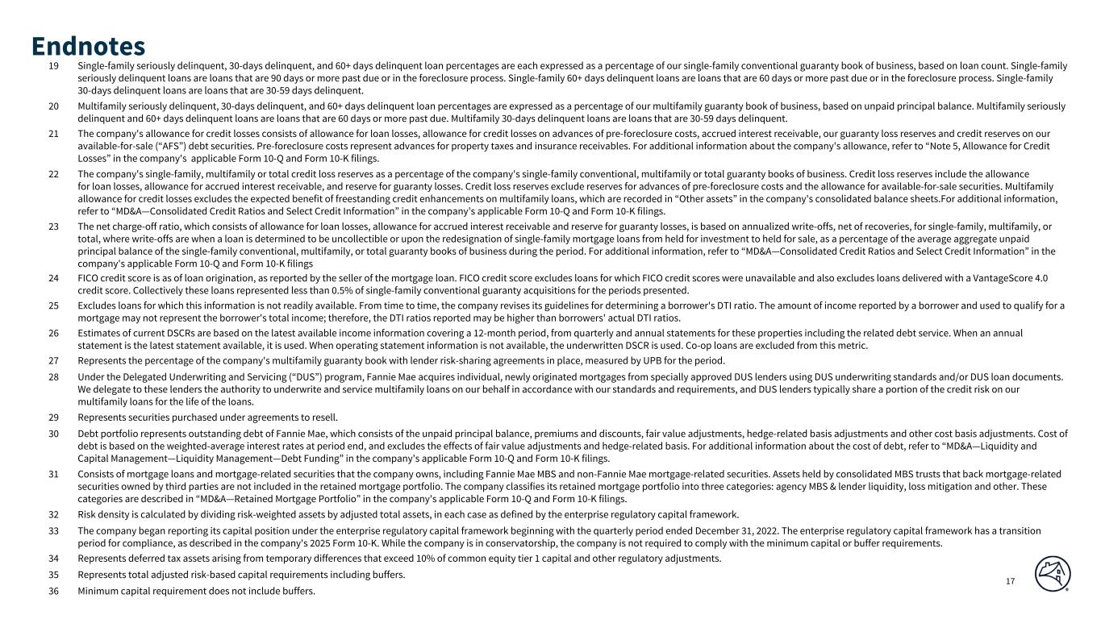
17 19 Single-family seriously delinquent, 30-days delinquent, and 60+ days delinquent loan percentages are each expressed as a percentage of our single-family conventional guaranty book of business, based on loan count. Single-family seriously delinquent loans are loans that are 90 days or more past due or in the foreclosure process. Single-family 60+ days delinquent loans are loans that are 60 days or more past due or in the foreclosure process. Single-family 30-days delinquent loans are loans that are 30-59 days delinquent. 20 Multifamily seriously delinquent, 30-days delinquent, and 60+ days delinquent loan percentages are expressed as a percentage of our multifamily guaranty book of business, based on unpaid principal balance. Multifamily seriously delinquent and 60+ days delinquent loans are loans that are 60 days or more past due. Multifamily 30-days delinquent loans are loans that are 30-59 days delinquent. 21 The company's allowance for credit losses consists of allowance for loan losses, allowance for credit losses on advances of pre-foreclosure costs, accrued interest receivable, our guaranty loss reserves and credit reserves on our available-for-sale (“AFS”) debt securities. Pre-foreclosure costs represent advances for property taxes and insurance receivables. For additional information about the company's allowance, refer to “Note 5, Allowance for Credit Losses” in the company's applicable Form 10-Q and Form 10-K filings. 22 The company's single-family, multifamily or total credit loss reserves as a percentage of the company's single-family conventional, multifamily or total guaranty books of business. Credit loss reserves include the allowance for loan losses, allowance for accrued interest receivable, and reserve for guaranty losses. Credit loss reserves exclude reserves for advances of pre-foreclosure costs and the allowance for available-for-sale securities. Multifamily allowance for credit losses excludes the expected benefit of freestanding credit enhancements on multifamily loans, which are recorded in “Other assets” in the company's consolidated balance sheets.For additional information, refer to “MD&A—Consolidated Credit Ratios and Select Credit Information” in the company’s applicable Form 10-Q and Form 10-K filings. 23 The net charge-off ratio, which consists of allowance for loan losses, allowance for accrued interest receivable and reserve for guaranty losses, is based on annualized write-offs, net of recoveries, for single-family, multifamily, or total, where write-offs are when a loan is determined to be uncollectible or upon the redesignation of single-family mortgage loans from held for investment to held for sale, as a percentage of the average aggregate unpaid principal balance of the single-family conventional, multifamily, or total guaranty books of business during the period. For additional information, refer to “MD&A—Consolidated Credit Ratios and Select Credit Information” in the company's applicable Form 10-Q and Form 10-K filings 24 FICO credit score is as of loan origination, as reported by the seller of the mortgage loan. FICO credit score excludes loans for which FICO credit scores were unavailable and also excludes loans delivered with a VantageScore 4.0 credit score. Collectively these loans represented less than 0.5% of single-family conventional guaranty acquisitions for the periods presented. 25 Excludes loans for which this information is not readily available. From time to time, the company revises its guidelines for determining a borrower's DTI ratio. The amount of income reported by a borrower and used to qualify for a mortgage may not represent the borrower's total income; therefore, the DTI ratios reported may be higher than borrowers' actual DTI ratios. 26 Estimates of current DSCRs are based on the latest available income information covering a 12-month period, from quarterly and annual statements for these properties including the related debt service. When an annual statement is the latest statement available, it is used. When operating statement information is not available, the underwritten DSCR is used. Co-op loans are excluded from this metric. 27 Represents the percentage of the company's multifamily guaranty book with lender risk-sharing agreements in place, measured by UPB for the period. 28 Under the Delegated Underwriting and Servicing (“DUS”) program, Fannie Mae acquires individual, newly originated mortgages from specially approved DUS lenders using DUS underwriting standards and/or DUS loan documents. We delegate to these lenders the authority to underwrite and service multifamily loans on our behalf in accordance with our standards and requirements, and DUS lenders typically share a portion of the credit risk on our multifamily loans for the life of the loans. 29 Represents securities purchased under agreements to resell. 30 Debt portfolio represents outstanding debt of Fannie Mae, which consists of the unpaid principal balance, premiums and discounts, fair value adjustments, hedge-related basis adjustments and other cost basis adjustments. Cost of debt is based on the weighted-average interest rates at period end, and excludes the effects of fair value adjustments and hedge-related basis. For additional information about the cost of debt, refer to “MD&A—Liquidity and Capital Management—Liquidity Management—Debt Funding” in the company's applicable Form 10-Q and Form 10-K filings. 31 Consists of mortgage loans and mortgage-related securities that the company owns, including Fannie Mae MBS and non-Fannie Mae mortgage-related securities. Assets held by consolidated MBS trusts that back mortgage-related securities owned by third parties are not included in the retained mortgage portfolio. The company classifies its retained mortgage portfolio into three categories: agency MBS & lender liquidity, loss mitigation and other. These categories are described in “MD&A—Retained Mortgage Portfolio” in the company's applicable Form 10-Q and Form 10-K filings. 32 Risk density is calculated by dividing risk-weighted assets by adjusted total assets, in each case as defined by the enterprise regulatory capital framework. 33 The company began reporting its capital position under the enterprise regulatory capital framework beginning with the quarterly period ended December 31, 2022. The enterprise regulatory capital framework has a transition period for compliance, as described in the company's 2025 Form 10-K. While the company is in conservatorship, the company is not required to comply with the minimum capital or buffer requirements. 34 Represents deferred tax assets arising from temporary differences that exceed 10% of common equity tier 1 capital and other regulatory adjustments. 35 Represents total adjusted risk-based capital requirements including buffers. 36 Minimum capital requirement does not include buffers. Endnotes



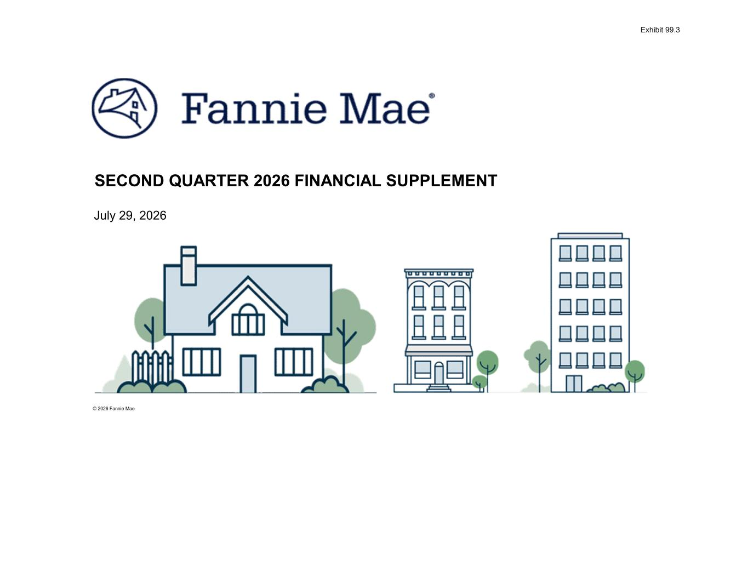
© 2026 Fannie Mae July 29, 2026 SECOND QUARTER 2026 FINANCIAL SUPPLEMENT Exhibit 99.3

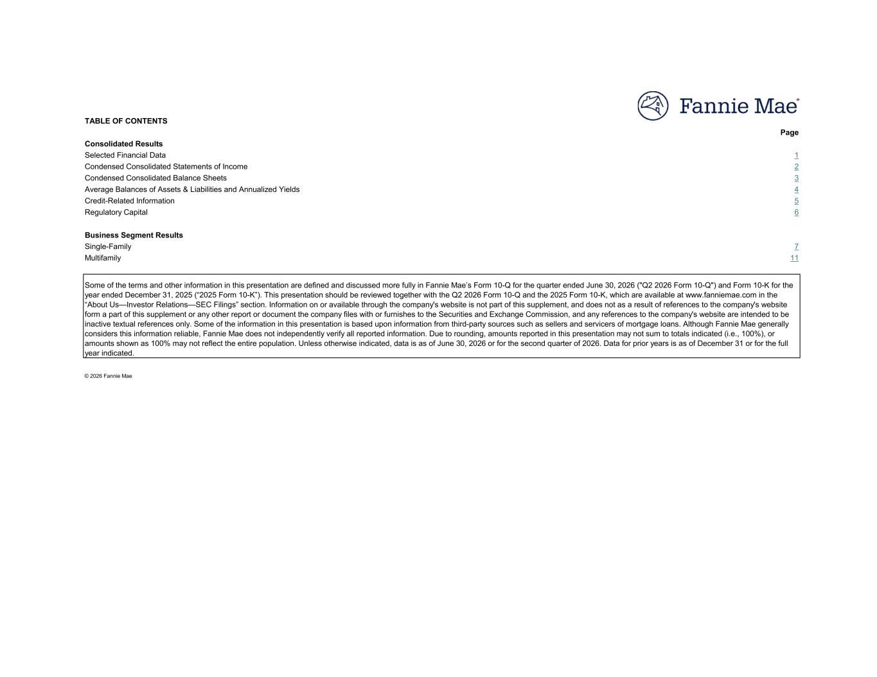
TABLE OF CONTENTS Page Consolidated Results Selected Financial Data 1 Condensed Consolidated Statements of Income 2 Condensed Consolidated Balance Sheets 3 Average Balances of Assets & Liabilities and Annualized Yields 4 Credit-Related Information 5 Regulatory Capital 6 Business Segment Results Single-Family 7 Multifamily 11 © 2026 Fannie Mae Some of the terms and other information in this presentation are defined and discussed more fully in Fannie Mae’s Form 10-Q for the quarter ended June 30, 2026 ("Q2 2026 Form 10-Q") and Form 10-K for the year ended December 31, 2025 (“2025 Form 10-K”). This presentation should be reviewed together with the Q2 2026 Form 10-Q and the 2025 Form 10-K, which are available at www.fanniemae.com in the “About Us—Investor Relations—SEC Filings” section. Information on or available through the company's website is not part of this supplement, and does not as a result of references to the company's website form a part of this supplement or any other report or document the company files with or furnishes to the Securities and Exchange Commission, and any references to the company's website are intended to be inactive textual references only. Some of the information in this presentation is based upon information from third-party sources such as sellers and servicers of mortgage loans. Although Fannie Mae generally considers this information reliable, Fannie Mae does not independently verify all reported information. Due to rounding, amounts reported in this presentation may not sum to totals indicated (i.e., 100%), or amounts shown as 100% may not reflect the entire population. Unless otherwise indicated, data is as of June 30, 2026 or for the second quarter of 2026. Data for prior years is as of December 31 or for the full year indicated.

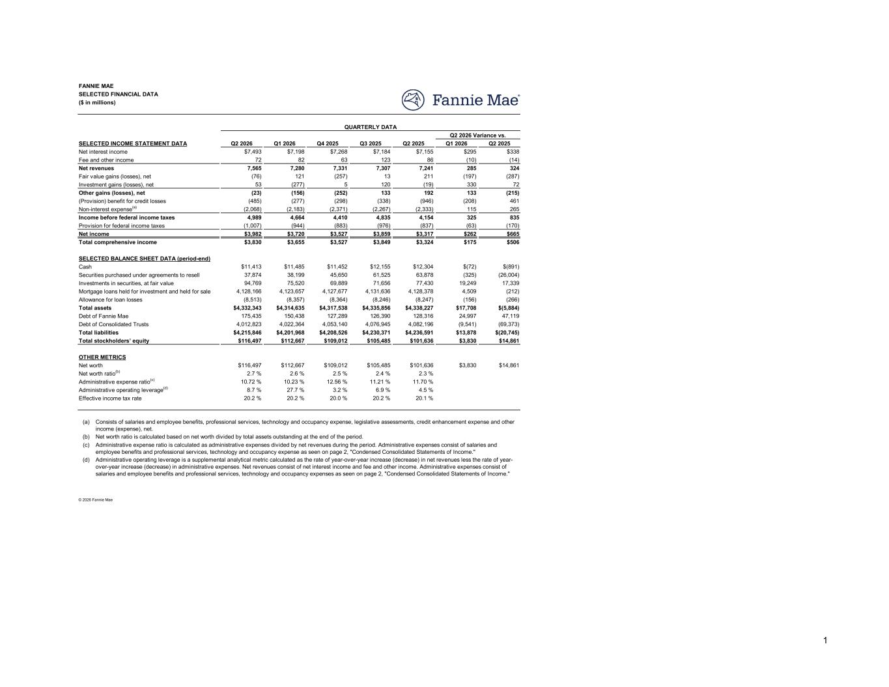
Q2 2026 Q1 2026 Q4 2025 Q3 2025 Q2 2025 Q1 2026 Q2 2025 $7,493 $7,198 $7,268 $7,184 $7,155 $295 $338 72 82 63 123 86 (10) (14) 7,565 7,280 7,331 7,307 7,241 285 324 (76) 121 (257) 13 211 (197) (287) 53 (277) 5 120 (19) 330 72 (23) (156) (252) 133 192 133 (215) (485) (277) (298) (338) (946) (208) 461 (2,068) (2,183) (2,371) (2,267) (2,333) 115 265 4,989 4,664 4,410 4,835 4,154 325 835 (1,007) (944) (883) (976) (837) (63) (170) $3,982 $3,720 $3,527 $3,859 $3,317 $262 $665 $3,830 $3,655 $3,527 $3,849 $3,324 $175 $506 $11,413 $11,485 $11,452 $12,155 $12,304 $(72) $(891) 37,874 38,199 45,650 61,525 63,878 (325) (26,004) 94,769 75,520 69,889 71,656 77,430 19,249 17,339 4,128,166 4,123,657 4,127,677 4,131,636 4,128,378 4,509 (212) (8,513) (8,357) (8,364) (8,246) (8,247) (156) (266) $4,332,343 $4,314,635 $4,317,538 $4,335,856 $4,338,227 $17,708 $(5,884) 175,435 150,438 127,289 126,390 128,316 24,997 47,119 4,012,823 4,022,364 4,053,140 4,076,945 4,082,196 (9,541) (69,373) $4,215,846 $4,201,968 $4,208,526 $4,230,371 $4,236,591 $13,878 $(20,745) $116,497 $112,667 $109,012 $105,485 $101,636 $3,830 $14,861 $116,497 $112,667 $109,012 $105,485 $101,636 $3,830 $14,861 2.7 % 2.6 % 2.5 % 2.4 % 2.3 % 10.72 % 10.23 % 12.56 % 11.21 % 11.70 % 8.7 % 27.7 % 3.2 % 6.9 % 4.5 % 20.2 % 20.2 % 20.0 % 20.2 % 20.1 % (a) (b) (c) (d) © 2026 Fannie Mae Net worth ratio(b) Net worth OTHER METRICS Administrative expense ratio(c) Effective income tax rate Administrative operating leverage(d) Administrative operating leverage is a supplemental analytical metric calculated as the rate of year-over-year increase (decrease) in net revenues less the rate of year- over-year increase (decrease) in administrative expenses. Net revenues consist of net interest income and fee and other income. Administrative expenses consist of salaries and employee benefits and professional services, technology and occupancy expenses as seen on page 2, "Condensed Consolidated Statements of Income." Administrative expense ratio is calculated as administrative expenses divided by net revenues during the period. Administrative expenses consist of salaries and employee benefits and professional services, technology and occupancy expense as seen on page 2, "Condensed Consolidated Statements of Income." Consists of salaries and employee benefits, professional services, technology and occupancy expense, legislative assessments, credit enhancement expense and other income (expense), net. Net worth ratio is calculated based on net worth divided by total assets outstanding at the end of the period. Allowance for loan losses Total assets Total liabilities Total stockholders’ equity Debt of Consolidated Trusts Debt of Fannie Mae Securities purchased under agreements to resell Cash SELECTED BALANCE SHEET DATA (period-end) Investments in securities, at fair value Mortgage loans held for investment and held for sale Other gains (losses), net (Provision) benefit for credit losses Non-interest expense(a) Net income Total comprehensive income Provision for federal income taxes Income before federal income taxes Fair value gains (losses), net Net revenues Net interest income Fee and other income Investment gains (losses), net FANNIE MAE SELECTED FINANCIAL DATA ($ in millions) SELECTED INCOME STATEMENT DATA QUARTERLY DATA Q2 2026 Variance vs. 1

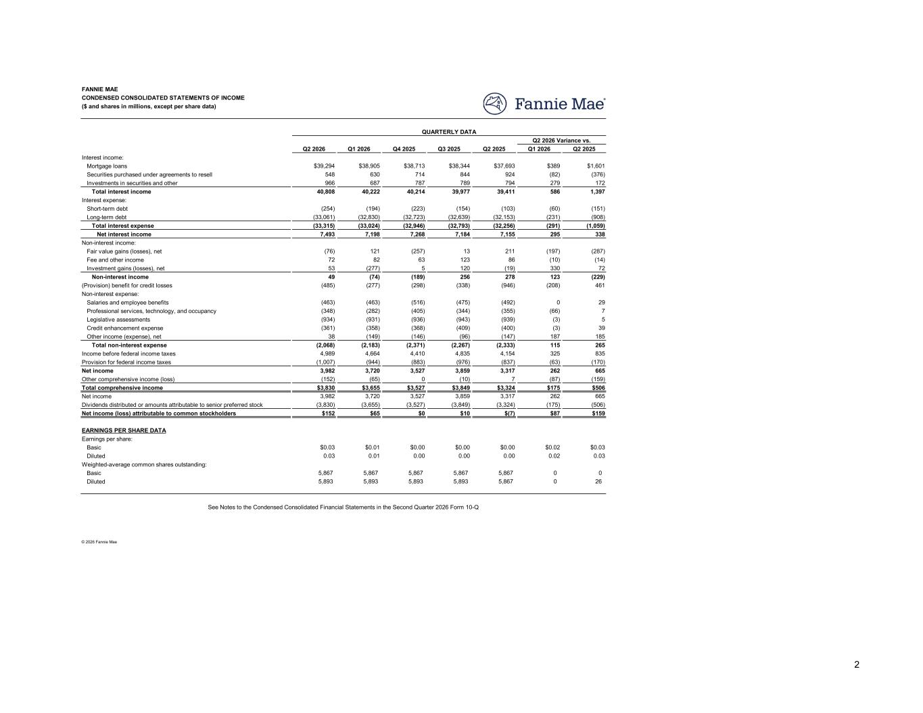
Q2 2026 Q1 2026 Q4 2025 Q3 2025 Q2 2025 Q1 2026 Q2 2025 $39,294 $38,905 $38,713 $38,344 $37,693 $389 $1,601 548 630 714 844 924 (82) (376) 966 687 787 789 794 279 172 40,808 40,222 40,214 39,977 39,411 586 1,397 (254) (194) (223) (154) (103) (60) (151) (33,061) (32,830) (32,723) (32,639) (32,153) (231) (908) (33,315) (33,024) (32,946) (32,793) (32,256) (291) (1,059) 7,493 7,198 7,268 7,184 7,155 295 338 (76) 121 (257) 13 211 (197) (287) 72 82 63 123 86 (10) (14) 53 (277) 5 120 (19) 330 72 49 (74) (189) 256 278 123 (229) (485) (277) (298) (338) (946) (208) 461 (463) (463) (516) (475) (492) 0 29 (348) (282) (405) (344) (355) (66) 7 (934) (931) (936) (943) (939) (3) 5 (361) (358) (368) (409) (400) (3) 39 38 (149) (146) (96) (147) 187 185 (2,068) (2,183) (2,371) (2,267) (2,333) 115 265 4,989 4,664 4,410 4,835 4,154 325 835 (1,007) (944) (883) (976) (837) (63) (170) 3,982 3,720 3,527 3,859 3,317 262 665 (152) (65) 0 (10) 7 (87) (159) $3,830 $3,655 $3,527 $3,849 $3,324 $175 $506 3,982 3,720 3,527 3,859 3,317 262 665 (3,830) (3,655) (3,527) (3,849) (3,324) (175) (506) $152 $65 $0 $10 $(7) $87 $159 $0.03 $0.01 $0.00 $0.00 $0.00 $0.02 $0.03 0.03 0.01 0.00 0.00 0.00 0.02 0.03 5,867 5,867 5,867 5,867 5,867 0 0 5,893 5,893 5,893 5,893 5,867 0 26 Basic Weighted-average common shares outstanding: Diluted © 2026 Fannie Mae See Notes to the Condensed Consolidated Financial Statements in the Second Quarter 2026 Form 10-Q Net income (loss) attributable to common stockholders EARNINGS PER SHARE DATA Earnings per share: Diluted Basic Net income Provision for federal income taxes Other comprehensive income (loss) Total comprehensive income Dividends distributed or amounts attributable to senior preferred stock Net income Legislative assessments Professional services, technology, and occupancy Credit enhancement expense Other income (expense), net Income before federal income taxes Total non-interest expense Investment gains (losses), net Fee and other income Non-interest income (Provision) benefit for credit losses Salaries and employee benefits Non-interest expense: Long-term debt Short-term debt Total interest expense Net interest income Fair value gains (losses), net Non-interest income: Mortgage loans Interest income: Securities purchased under agreements to resell Investments in securities and other Interest expense: Total interest income CONDENSED CONSOLIDATED STATEMENTS OF INCOME FANNIE MAE ($ and shares in millions, except per share data) Q2 2026 Variance vs. QUARTERLY DATA 2

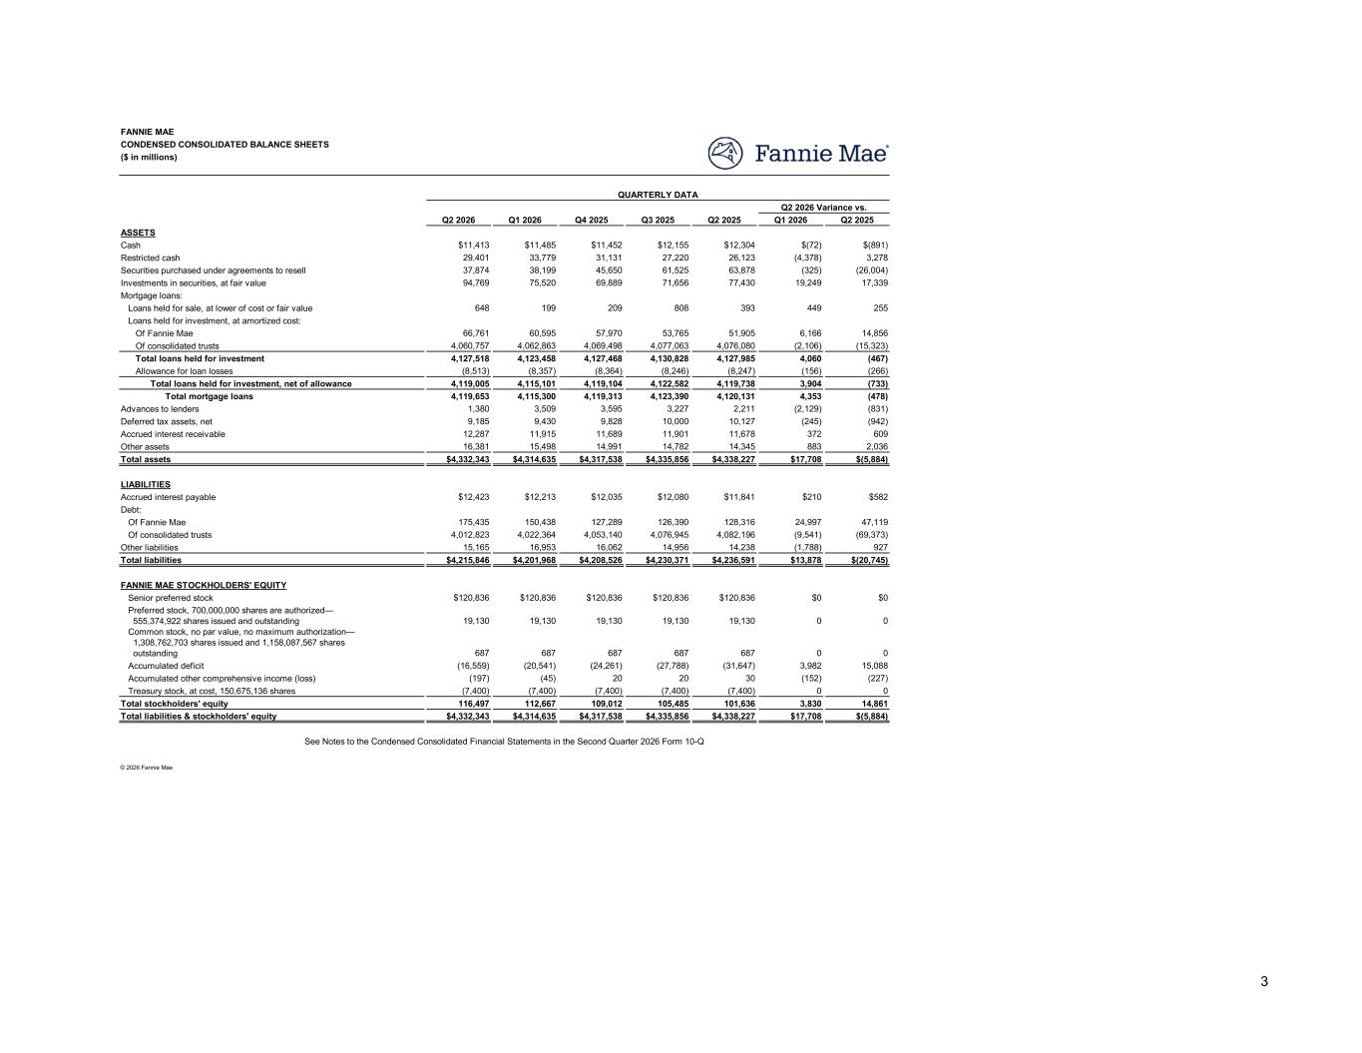
Q2 2026 Q1 2026 Q4 2025 Q3 2025 Q2 2025 Q1 2026 Q2 2025 $11,413 $11,485 $11,452 $12,155 $12,304 $(72) $(891) 29,401 33,779 31,131 27,220 26,123 (4,378) 3,278 37,874 38,199 45,650 61,525 63,878 (325) (26,004) 94,769 75,520 69,889 71,656 77,430 19,249 17,339 648 199 209 808 393 449 255 66,761 60,595 57,970 53,765 51,905 6,166 14,856 4,060,757 4,062,863 4,069,498 4,077,063 4,076,080 (2,106) (15,323) 4,127,518 4,123,458 4,127,468 4,130,828 4,127,985 4,060 (467) (8,513) (8,357) (8,364) (8,246) (8,247) (156) (266) 4,119,005 4,115,101 4,119,104 4,122,582 4,119,738 3,904 (733) 4,119,653 4,115,300 4,119,313 4,123,390 4,120,131 4,353 (478) 1,380 3,509 3,595 3,227 2,211 (2,129) (831) 9,185 9,430 9,828 10,000 10,127 (245) (942) 12,287 11,915 11,689 11,901 11,678 372 609 16,381 15,498 14,991 14,782 14,345 883 2,036 Total assets $4,332,343 $4,314,635 $4,317,538 $4,335,856 $4,338,227 $17,708 $(5,884) $12,423 $12,213 $12,035 $12,080 $11,841 $210 $582 175,435 150,438 127,289 126,390 128,316 24,997 47,119 4,012,823 4,022,364 4,053,140 4,076,945 4,082,196 (9,541) (69,373) 15,165 16,953 16,062 14,956 14,238 (1,788) 927 Total liabilities $4,215,846 $4,201,968 $4,208,526 $4,230,371 $4,236,591 $13,878 $(20,745) $120,836 $120,836 $120,836 $120,836 $120,836 $0 $0 19,130 19,130 19,130 19,130 19,130 0 0 687 687 687 687 687 0 0 (16,559) (20,541) (24,261) (27,788) (31,647) 3,982 15,088 (197) (45) 20 20 30 (152) (227) (7,400) (7,400) (7,400) (7,400) (7,400) 0 0 Total stockholders' equity 116,497 112,667 109,012 105,485 101,636 3,830 14,861 Total liabilities & stockholders' equity $4,332,343 $4,314,635 $4,317,538 $4,335,856 $4,338,227 $17,708 $(5,884) © 2026 Fannie Mae See Notes to the Condensed Consolidated Financial Statements in the Second Quarter 2026 Form 10-Q Other liabilities Of consolidated trusts Senior preferred stock FANNIE MAE STOCKHOLDERS' EQUITY Common stock, no par value, no maximum authorization— 1,308,762,703 shares issued and 1,158,087,567 shares outstanding Preferred stock, 700,000,000 shares are authorized— 555,374,922 shares issued and outstanding Accumulated deficit Accumulated other comprehensive income (loss) Treasury stock, at cost, 150,675,136 shares LIABILITIES Accrued interest payable Of Fannie Mae Debt: Total mortgage loans Total loans held for investment, net of allowance Advances to lenders Deferred tax assets, net Other assets Accrued interest receivable Loans held for investment, at amortized cost: Loans held for sale, at lower of cost or fair value Of Fannie Mae Of consolidated trusts Allowance for loan losses Total loans held for investment Cash ASSETS Restricted cash Securities purchased under agreements to resell Mortgage loans: Investments in securities, at fair value CONDENSED CONSOLIDATED BALANCE SHEETS FANNIE MAE ($ in millions) Q2 2026 Variance vs. QUARTERLY DATA 3

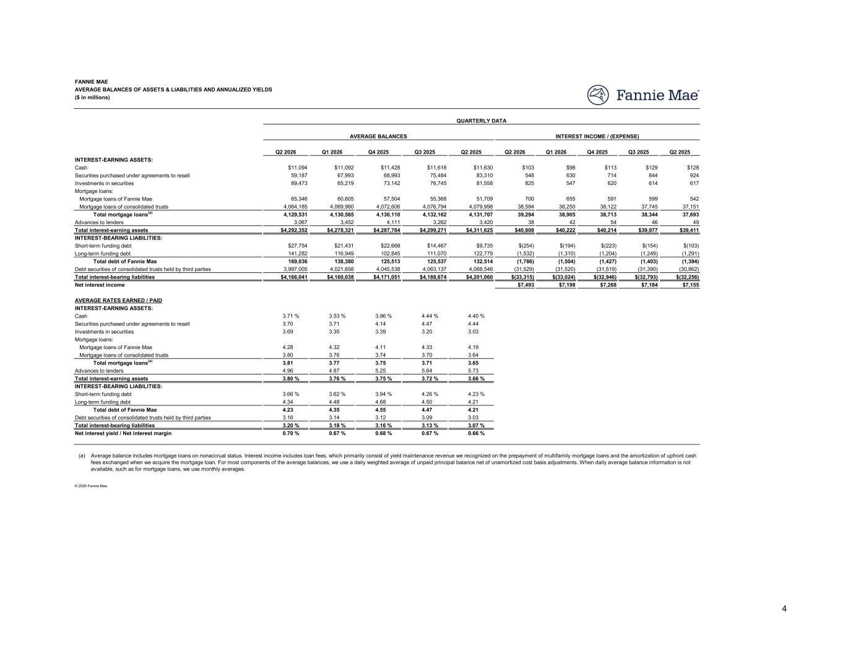
Q2 2026 Q1 2026 Q4 2025 Q3 2025 Q2 2025 Q2 2026 Q1 2026 Q4 2025 Q3 2025 Q2 2025 $11,094 $11,092 $11,428 $11,618 $11,630 $103 $98 $113 $129 $128 59,187 67,993 68,993 75,484 83,310 548 630 714 844 924 89,473 65,219 73,142 76,745 81,558 825 547 620 614 617 65,346 60,605 57,504 55,368 51,709 700 655 591 599 542 4,064,185 4,069,960 4,072,606 4,076,794 4,079,998 38,594 38,250 38,122 37,745 37,151 4,129,531 4,130,565 4,130,110 4,132,162 4,131,707 39,294 38,905 38,713 38,344 37,693 3,067 3,452 4,111 3,262 3,420 38 42 54 46 49 Total interest-earning assets $4,292,352 $4,278,321 $4,287,784 $4,299,271 $4,311,625 $40,808 $40,222 $40,214 $39,977 $39,411 $27,754 $21,431 $22,668 $14,467 $9,735 $(254) $(194) $(223) $(154) $(103) 141,282 116,949 102,845 111,070 122,779 (1,532) (1,310) (1,204) (1,249) (1,291) 169,036 138,380 125,513 125,537 132,514 (1,786) (1,504) (1,427) (1,403) (1,394) 3,997,005 4,021,658 4,045,538 4,063,137 4,068,546 (31,529) (31,520) (31,519) (31,390) (30,862) Total interest-bearing liabilities $4,166,041 $4,160,038 $4,171,051 $4,188,674 $4,201,060 $(33,315) $(33,024) $(32,946) $(32,793) $(32,256) $7,493 $7,198 $7,268 $7,184 $7,155 3.71 % 3.53 % 3.96 % 4.44 % 4.40 % 3.70 3.71 4.14 4.47 4.44 3.69 3.35 3.39 3.20 3.03 4.28 4.32 4.11 4.33 4.19 3.80 3.76 3.74 3.70 3.64 3.81 3.77 3.75 3.71 3.65 4.96 4.87 5.25 5.64 5.73 Total interest-earning assets 3.80 % 3.76 % 3.75 % 3.72 % 3.66 % 3.66 % 3.62 % 3.94 % 4.26 % 4.23 % 4.34 4.48 4.68 4.50 4.21 4.23 4.35 4.55 4.47 4.21 3.16 3.14 3.12 3.09 3.03 Total interest-bearing liabilities 3.20 % 3.18 % 3.16 % 3.13 % 3.07 % 0.70 % 0.67 % 0.68 % 0.67 % 0.66 % (a) Net interest yield / Net interest margin © 2026 Fannie Mae Average balance includes mortgage loans on nonaccrual status. Interest income includes loan fees, which primarily consist of yield maintenance revenue we recognized on the prepayment of multifamily mortgage loans and the amortization of upfront cash fees exchanged when we acquire the mortgage loan. For most components of the average balances, we use a daily weighted average of unpaid principal balance net of unamortized cost basis adjustments. When daily average balance information is not available, such as for mortgage loans, we use monthly averages. INTEREST-BEARING LIABILITIES: Short-term funding debt Long-term funding debt Debt securities of consolidated trusts held by third parties Total debt of Fannie Mae Mortgage loans: Investments in securities Mortgage loans of Fannie Mae Mortgage loans of consolidated trusts Advances to lenders Total mortgage loans(a) AVERAGE RATES EARNED / PAID INTEREST-EARNING ASSETS: Securities purchased under agreements to resell Cash INTEREST INCOME / (EXPENSE) Long-term funding debt Total debt of Fannie Mae Debt securities of consolidated trusts held by third parties Net interest income Mortgage loans of consolidated trusts Total mortgage loans(a) Advances to lenders Short-term funding debt INTEREST-BEARING LIABILITIES: INTEREST-EARNING ASSETS: Cash Investments in securities Securities purchased under agreements to resell Mortgage loans of Fannie Mae Mortgage loans: FANNIE MAE AVERAGE BALANCES OF ASSETS & LIABILITIES AND ANNUALIZED YIELDS ($ in millions) QUARTERLY DATA AVERAGE BALANCES 4

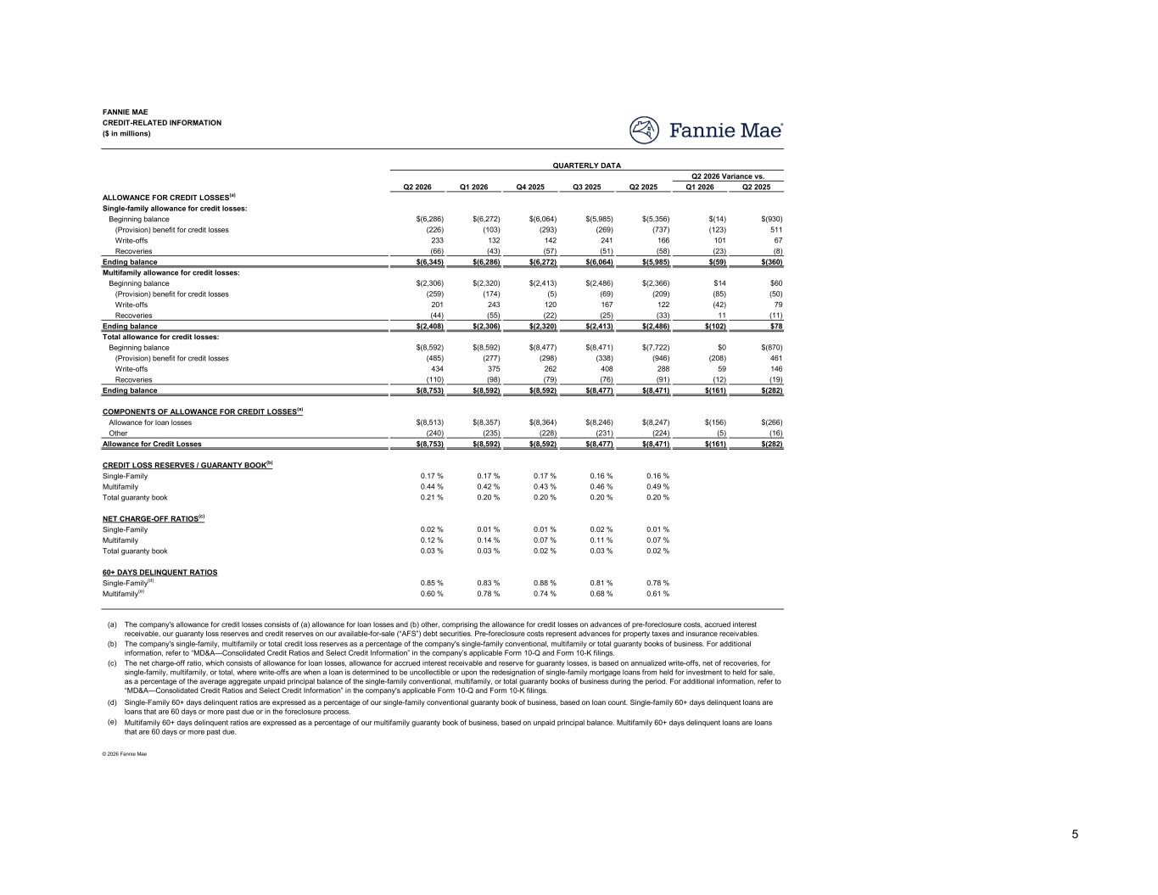
Q2 2026 Q1 2026 Q4 2025 Q3 2025 Q2 2025 Q1 2026 Q2 2025 $(6,286) $(6,272) $(6,064) $(5,985) $(5,356) $(14) $(930) (226) (103) (293) (269) (737) (123) 511 233 132 142 241 166 101 67 (66) (43) (57) (51) (58) (23) (8) $(6,345) $(6,286) $(6,272) $(6,064) $(5,985) $(59) $(360) $(2,306) $(2,320) $(2,413) $(2,486) $(2,366) $14 $60 (259) (174) (5) (69) (209) (85) (50) 201 243 120 167 122 (42) 79 (44) (55) (22) (25) (33) 11 (11) $(2,408) $(2,306) $(2,320) $(2,413) $(2,486) $(102) $78 $(8,592) $(8,592) $(8,477) $(8,471) $(7,722) $0 $(870) (485) (277) (298) (338) (946) (208) 461 434 375 262 408 288 59 146 (110) (98) (79) (76) (91) (12) (19) $(8,753) $(8,592) $(8,592) $(8,477) $(8,471) $(161) $(282) $(8,513) $(8,357) $(8,364) $(8,246) $(8,247) $(156) $(266) (240) (235) (228) (231) (224) (5) (16) $(8,753) $(8,592) $(8,592) $(8,477) $(8,471) $(161) $(282) 0.17 % 0.17 % 0.17 % 0.16 % 0.16 % 0.44 % 0.42 % 0.43 % 0.46 % 0.49 % 0.21 % 0.20 % 0.20 % 0.20 % 0.20 % 0.02 % 0.01 % 0.01 % 0.02 % 0.01 % 0.12 % 0.14 % 0.07 % 0.11 % 0.07 % 0.03 % 0.03 % 0.02 % 0.03 % 0.02 % 0.85 % 0.83 % 0.88 % 0.81 % 0.78 % 0.60 % 0.78 % 0.74 % 0.68 % 0.61 % (a) (b) (c) (d) (e) © 2026 Fannie Mae The company's allowance for credit losses consists of (a) allowance for loan losses and (b) other, comprising the allowance for credit losses on advances of pre-foreclosure costs, accrued interest receivable, our guaranty loss reserves and credit reserves on our available-for-sale (“AFS”) debt securities. Pre-foreclosure costs represent advances for property taxes and insurance receivables. The net charge-off ratio, which consists of allowance for loan losses, allowance for accrued interest receivable and reserve for guaranty losses, is based on annualized write-offs, net of recoveries, for single-family, multifamily, or total, where write-offs are when a loan is determined to be uncollectible or upon the redesignation of single-family mortgage loans from held for investment to held for sale, as a percentage of the average aggregate unpaid principal balance of the single-family conventional, multifamily, or total guaranty books of business during the period. For additional information, refer to “MD&A—Consolidated Credit Ratios and Select Credit Information” in the company's applicable Form 10-Q and Form 10-K filings. The company's single-family, multifamily or total credit loss reserves as a percentage of the company's single-family conventional, multifamily or total guaranty books of business. For additional information, refer to “MD&A—Consolidated Credit Ratios and Select Credit Information” in the company’s applicable Form 10-Q and Form 10-K filings. Multifamily 60+ days delinquent ratios are expressed as a percentage of our multifamily guaranty book of business, based on unpaid principal balance. Multifamily 60+ days delinquent loans are loans that are 60 days or more past due. Single-Family 60+ days delinquent ratios are expressed as a percentage of our single-family conventional guaranty book of business, based on loan count. Single-family 60+ days delinquent loans are loans that are 60 days or more past due or in the foreclosure process. Multifamily Total guaranty book 60+ DAYS DELINQUENT RATIOS Multifamily(e) Single-Family(d) CREDIT LOSS RESERVES / GUARANTY BOOK(b) Single-Family Multifamily Total guaranty book Single-Family NET CHARGE-OFF RATIOS(c) Ending balance COMPONENTS OF ALLOWANCE FOR CREDIT LOSSES(a) Allowance for loan losses Allowance for Credit Losses Other Total allowance for credit losses: Ending balance Beginning balance (Provision) benefit for credit losses Recoveries Write-offs Multifamily allowance for credit losses: Ending balance Beginning balance (Provision) benefit for credit losses Recoveries Write-offs Single-family allowance for credit losses: ALLOWANCE FOR CREDIT LOSSES(a) Beginning balance (Provision) benefit for credit losses Recoveries Write-offs CREDIT-RELATED INFORMATION FANNIE MAE ($ in millions) Q2 2026 Variance vs. QUARTERLY DATA 5

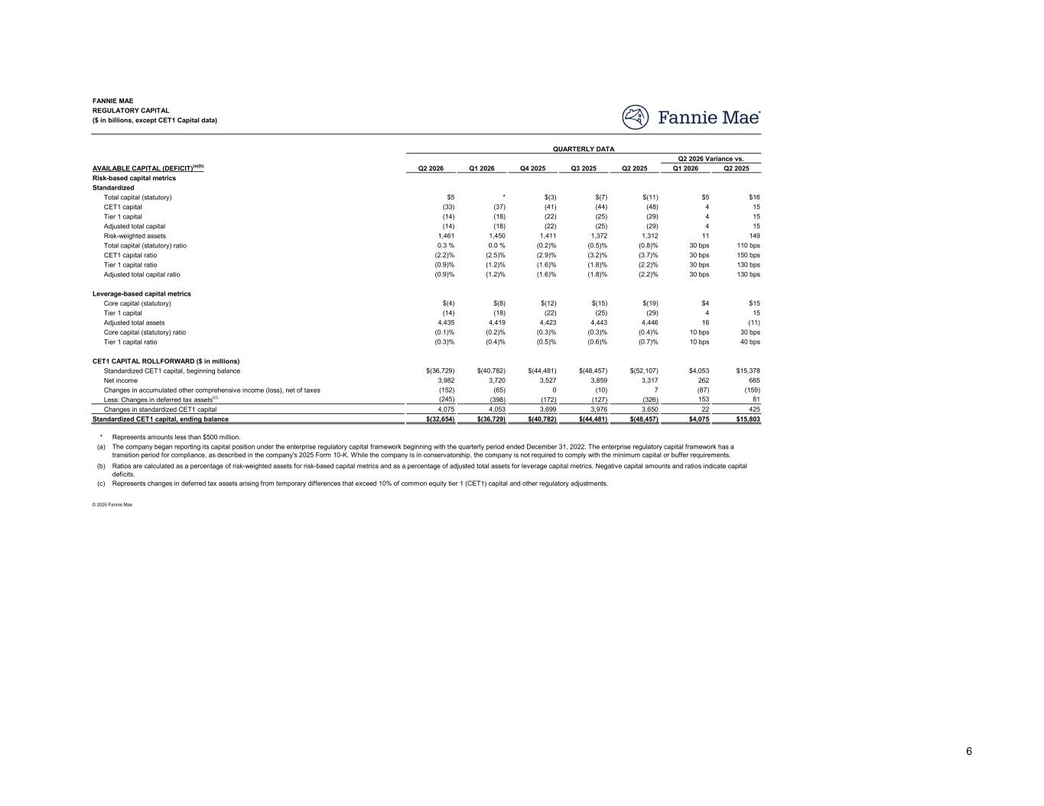
Q2 2026 Q1 2026 Q4 2025 Q3 2025 Q2 2025 Q1 2026 Q2 2025 $5 * $(3) $(7) $(11) $5 $16 (33) (37) (41) (44) (48) 4 15 (14) (18) (22) (25) (29) 4 15 (14) (18) (22) (25) (29) 4 15 1,461 1,450 1,411 1,372 1,312 11 149 0.3 % 0.0 % (0.2)% (0.5)% (0.8)% 30 bps 110 bps (2.2)% (2.5)% (2.9)% (3.2)% (3.7)% 30 bps 150 bps (0.9)% (1.2)% (1.6)% (1.8)% (2.2)% 30 bps 130 bps (0.9)% (1.2)% (1.6)% (1.8)% (2.2)% 30 bps 130 bps $(4) $(8) $(12) $(15) $(19) $4 $15 (14) (18) (22) (25) (29) 4 15 4,435 4,419 4,423 4,443 4,446 16 (11) (0.1)% (0.2)% (0.3)% (0.3)% (0.4)% 10 bps 30 bps (0.3)% (0.4)% (0.5)% (0.6)% (0.7)% 10 bps 40 bps $(36,729) $(40,782) $(44,481) $(48,457) $(52,107) $4,053 $15,378 3,982 3,720 3,527 3,859 3,317 262 665 (152) (65) 0 (10) 7 (87) (159) (245) (398) (172) (127) (326) 153 81 4,075 4,053 3,699 3,976 3,650 22 425 Standardized CET1 capital, ending balance $(32,654) $(36,729) $(40,782) $(44,481) $(48,457) $4,075 $15,803 * Represents amounts less than $500 million. (a) (b) (c) © 2026 Fannie Mae Ratios are calculated as a percentage of risk-weighted assets for risk-based capital metrics and as a percentage of adjusted total assets for leverage capital metrics. Negative capital amounts and ratios indicate capital deficits. The company began reporting its capital position under the enterprise regulatory capital framework beginning with the quarterly period ended December 31, 2022. The enterprise regulatory capital framework has a transition period for compliance, as described in the company's 2025 Form 10-K. While the company is in conservatorship, the company is not required to comply with the minimum capital or buffer requirements. Represents changes in deferred tax assets arising from temporary differences that exceed 10% of common equity tier 1 (CET1) capital and other regulatory adjustments. Changes in standardized CET1 capital CET1 CAPITAL ROLLFORWARD ($ in millions) Standardized CET1 capital, beginning balance Net income Less: Changes in deferred tax assets(c) Changes in accumulated other comprehensive income (loss), net of taxes Core capital (statutory) Leverage-based capital metrics Tier 1 capital Adjusted total assets Tier 1 capital ratio Core capital (statutory) ratio Total capital (statutory) ratio Risk-weighted assets CET1 capital ratio Tier 1 capital ratio Adjusted total capital ratio Standardized Risk-based capital metrics Total capital (statutory) CET1 capital Adjusted total capital Tier 1 capital REGULATORY CAPITAL FANNIE MAE ($ in billions, except CET1 Capital data) AVAILABLE CAPITAL (DEFICIT)(a)(b) Q2 2026 Variance vs. QUARTERLY DATA 6

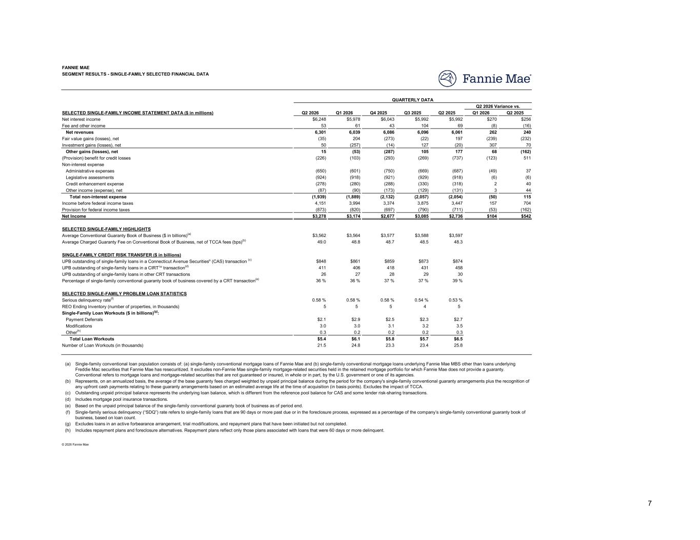
Q2 2026 Q1 2026 Q4 2025 Q3 2025 Q2 2025 Q1 2026 Q2 2025 $6,248 $5,978 $6,043 $5,992 $5,992 $270 $256 53 61 43 104 69 (8) (16) 6,301 6,039 6,086 6,096 6,061 262 240 (35) 204 (273) (22) 197 (239) (232) 50 (257) (14) 127 (20) 307 70 15 (53) (287) 105 177 68 (162) (226) (103) (293) (269) (737) (123) 511 (650) (601) (750) (669) (687) (49) 37 (924) (918) (921) (929) (918) (6) (6) (278) (280) (288) (330) (318) 2 40 (87) (90) (173) (129) (131) 3 44 (1,939) (1,889) (2,132) (2,057) (2,054) (50) 115 4,151 3,994 3,374 3,875 3,447 157 704 (873) (820) (697) (790) (711) (53) (162) $3,278 $3,174 $2,677 $3,085 $2,736 $104 $542 $3,562 $3,564 $3,577 $3,588 $3,597 49.0 48.8 48.7 48.5 48.3 $848 $861 $859 $873 $874 411 406 418 431 458 26 27 28 29 30 36 % 36 % 37 % 37 % 39 % 0.58 % 0.58 % 0.58 % 0.54 % 0.53 % 5 5 5 4 5 $2.1 $2.9 $2.5 $2.3 $2.7 3.0 3.0 3.1 3.2 3.5 0.3 0.2 0.2 0.2 0.3 $5.4 $6.1 $5.8 $5.7 $6.5 21.5 24.8 23.3 23.4 25.8 (a) (b) (c) (d) (e) (f) (g) (h) © 2026 Fannie Mae Outstanding unpaid principal balance represents the underlying loan balance, which is different from the reference pool balance for CAS and some lender risk-sharing transactions. Includes mortgage pool insurance transactions. Single-family serious delinquency (“SDQ”) rate refers to single-family loans that are 90 days or more past due or in the foreclosure process, expressed as a percentage of the company’s single-family conventional guaranty book of business, based on loan count. Based on the unpaid principal balance of the single-family conventional guaranty book of business as of period end. Includes repayment plans and foreclosure alternatives. Repayment plans reflect only those plans associated with loans that were 60 days or more delinquent. Excludes loans in an active forbearance arrangement, trial modifications, and repayment plans that have been initiated but not completed. Represents, on an annualized basis, the average of the base guaranty fees charged weighted by unpaid principal balance during the period for the company's single-family conventional guaranty arrangements plus the recognition of any upfront cash payments relating to these guaranty arrangements based on an estimated average life at the time of acquisition (in basis points). Excludes the impact of TCCA. Single-family conventional loan population consists of: (a) single-family conventional mortgage loans of Fannie Mae and (b) single-family conventional mortgage loans underlying Fannie Mae MBS other than loans underlying Freddie Mac securities that Fannie Mae has resecuritized. It excludes non-Fannie Mae single-family mortgage-related securities held in the retained mortgage portfolio for which Fannie Mae does not provide a guaranty. Conventional refers to mortgage loans and mortgage-related securities that are not guaranteed or insured, in whole or in part, by the U.S. government or one of its agencies. Percentage of single-family conventional guaranty book of business covered by a CRT transaction(e) UPB outstanding of single-family loans in other CRT transactions SELECTED SINGLE-FAMILY PROBLEM LOAN STATISTICS REO Ending Inventory (number of properties, in thousands) Serious delinquency rate(f) Payment Deferrals Single-Family Loan Workouts ($ in billions)(g): Modifications Other(h) Number of Loan Workouts (in thousands) Total Loan Workouts Average Charged Guaranty Fee on Conventional Book of Business, net of TCCA fees (bps)(b) Average Conventional Guaranty Book of Business ($ in billions)(a) SINGLE-FAMILY CREDIT RISK TRANSFER ($ in billions) UPB outstanding of single-family loans in a CIRTTM transaction(d) UPB outstanding of single-family loans in a Connecticut Avenue Securities® (CAS) transaction (c) Income before federal income taxes Total non-interest expense Provision for federal income taxes Net Income SELECTED SINGLE-FAMILY HIGHLIGHTS Non-interest expense (Provision) benefit for credit losses Administrative expenses Legislative assessments Other income (expense), net Credit enhancement expense Fee and other income Net interest income Net revenues Fair value gains (losses), net Other gains (losses), net Investment gains (losses), net SEGMENT RESULTS - SINGLE-FAMILY SELECTED FINANCIAL DATA FANNIE MAE SELECTED SINGLE-FAMILY INCOME STATEMENT DATA ($ in millions) Q2 2026 Variance vs. QUARTERLY DATA 7

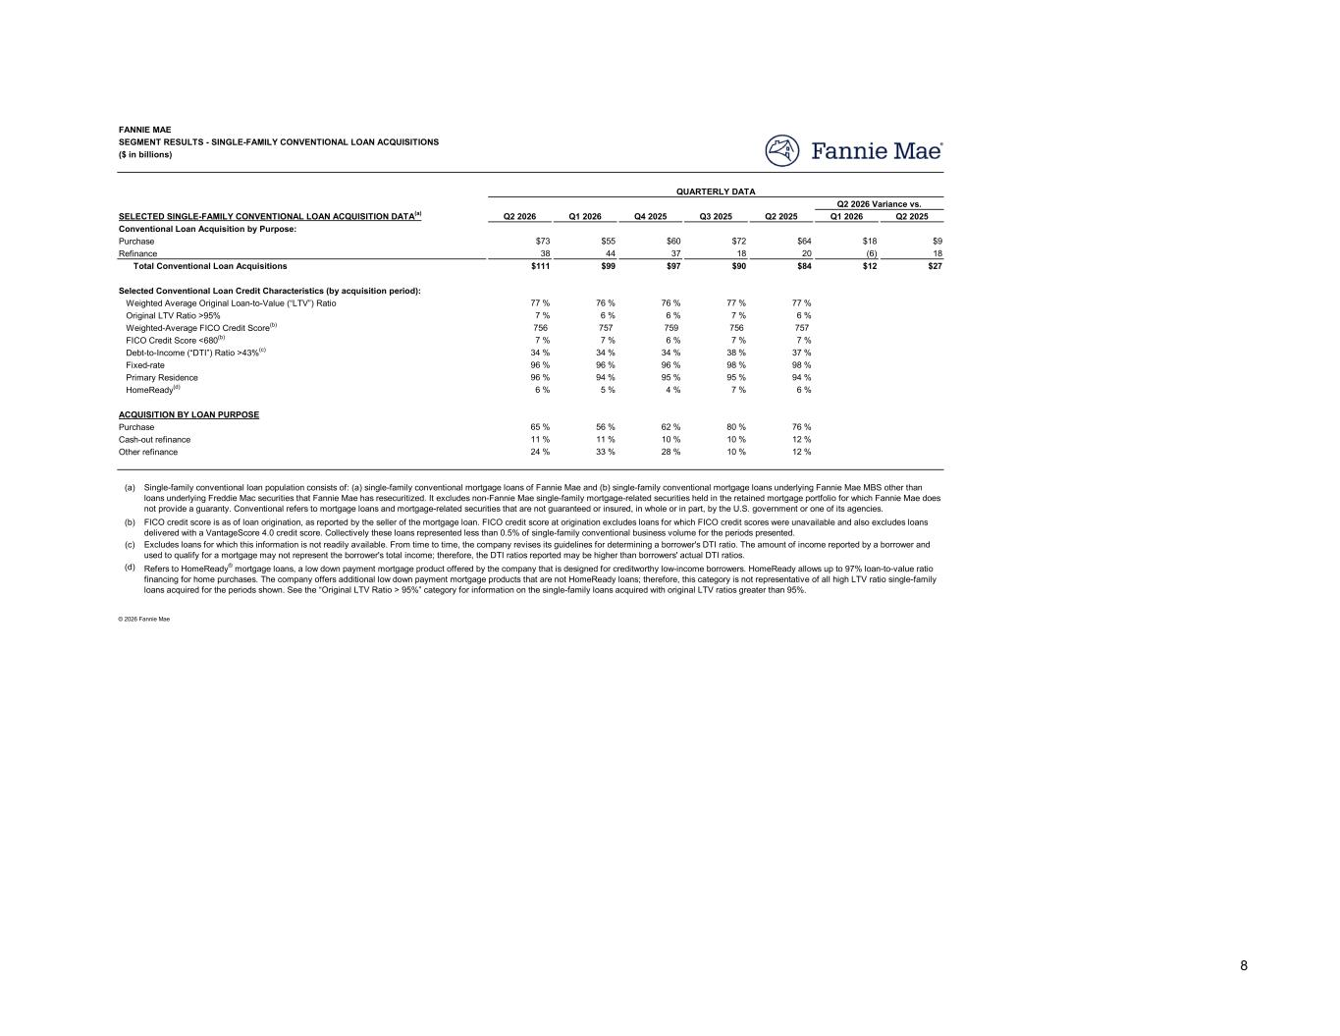
Q2 2026 Q1 2026 Q4 2025 Q3 2025 Q2 2025 Q1 2026 Q2 2025 $73 $55 $60 $72 $64 $18 $9 38 44 37 18 20 (6) 18 $111 $99 $97 $90 $84 $12 $27 77 % 76 % 76 % 77 % 77 % 7 % 6 % 6 % 7 % 6 % 756 757 759 756 757 7 % 7 % 6 % 7 % 7 % 34 % 34 % 34 % 38 % 37 % 96 % 96 % 96 % 98 % 98 % 96 % 94 % 95 % 95 % 94 % 6 % 5 % 4 % 7 % 6 % 65 % 56 % 62 % 80 % 76 % 11 % 11 % 10 % 10 % 12 % 24 % 33 % 28 % 10 % 12 % (a) (b) (c) (d) Excludes loans for which this information is not readily available. From time to time, the company revises its guidelines for determining a borrower's DTI ratio. The amount of income reported by a borrower and used to qualify for a mortgage may not represent the borrower's total income; therefore, the DTI ratios reported may be higher than borrowers' actual DTI ratios. FICO credit score is as of loan origination, as reported by the seller of the mortgage loan. FICO credit score at origination excludes loans for which FICO credit scores were unavailable and also excludes loans delivered with a VantageScore 4.0 credit score. Collectively these loans represented less than 0.5% of single-family conventional business volume for the periods presented. Refers to HomeReady® mortgage loans, a low down payment mortgage product offered by the company that is designed for creditworthy low-income borrowers. HomeReady allows up to 97% loan-to-value ratio financing for home purchases. The company offers additional low down payment mortgage products that are not HomeReady loans; therefore, this category is not representative of all high LTV ratio single-family loans acquired for the periods shown. See the “Original LTV Ratio > 95%” category for information on the single-family loans acquired with original LTV ratios greater than 95%. © 2026 Fannie Mae ACQUISITION BY LOAN PURPOSE Cash-out refinance Purchase Other refinance Single-family conventional loan population consists of: (a) single-family conventional mortgage loans of Fannie Mae and (b) single-family conventional mortgage loans underlying Fannie Mae MBS other than loans underlying Freddie Mac securities that Fannie Mae has resecuritized. It excludes non-Fannie Mae single-family mortgage-related securities held in the retained mortgage portfolio for which Fannie Mae does not provide a guaranty. Conventional refers to mortgage loans and mortgage-related securities that are not guaranteed or insured, in whole or in part, by the U.S. government or one of its agencies. FICO Credit Score <680(b) Fixed-rate Debt-to-Income (“DTI”) Ratio >43%(c) HomeReady(d) Primary Residence Total Conventional Loan Acquisitions Selected Conventional Loan Credit Characteristics (by acquisition period): Original LTV Ratio >95% Weighted Average Original Loan-to-Value (“LTV”) Ratio Weighted-Average FICO Credit Score(b) Q2 2026 Variance vs. QUARTERLY DATA Purchase Conventional Loan Acquisition by Purpose: Refinance SEGMENT RESULTS - SINGLE-FAMILY CONVENTIONAL LOAN ACQUISITIONS FANNIE MAE ($ in billions) SELECTED SINGLE-FAMILY CONVENTIONAL LOAN ACQUISITION DATA(a) 8

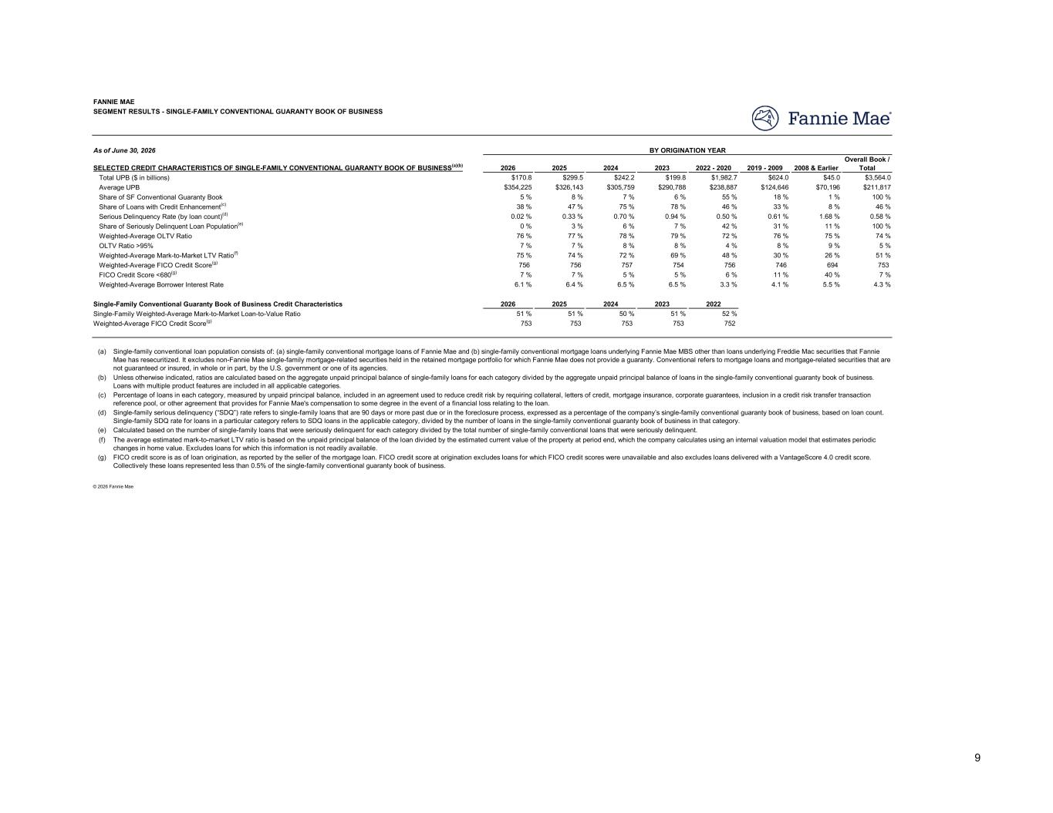
2026 2025 2024 2023 2022 - 2020 2019 - 2009 2008 & Earlier Overall Book / Total $170.8 $299.5 $242.2 $199.8 $1,982.7 $624.0 $45.0 $3,564.0 $354,225 $326,143 $305,759 $290,788 $238,887 $124,646 $70,196 $211,817 5 % 8 % 7 % 6 % 55 % 18 % 1 % 100 % 38 % 47 % 75 % 78 % 46 % 33 % 8 % 46 % 0.02 % 0.33 % 0.70 % 0.94 % 0.50 % 0.61 % 1.68 % 0.58 % 0 % 3 % 6 % 7 % 42 % 31 % 11 % 100 % 76 % 77 % 78 % 79 % 72 % 76 % 75 % 74 % 7 % 7 % 8 % 8 % 4 % 8 % 9 % 5 % 75 % 74 % 72 % 69 % 48 % 30 % 26 % 51 % 756 756 757 754 756 746 694 753 7 % 7 % 5 % 5 % 6 % 11 % 40 % 7 % 6.1 % 6.4 % 6.5 % 6.5 % 3.3 % 4.1 % 5.5 % 4.3 % 2026 2025 2024 2023 2022 51 % 51 % 50 % 51 % 52 % 753 753 753 753 752 (a) (b) (c) (d) (e) (f) (g) Single-family serious delinquency (“SDQ”) rate refers to single-family loans that are 90 days or more past due or in the foreclosure process, expressed as a percentage of the company’s single-family conventional guaranty book of business, based on loan count. Single-family SDQ rate for loans in a particular category refers to SDQ loans in the applicable category, divided by the number of loans in the single-family conventional guaranty book of business in that category. FICO credit score is as of loan origination, as reported by the seller of the mortgage loan. FICO credit score at origination excludes loans for which FICO credit scores were unavailable and also excludes loans delivered with a VantageScore 4.0 credit score. Collectively these loans represented less than 0.5% of the single-family conventional guaranty book of business. The average estimated mark-to-market LTV ratio is based on the unpaid principal balance of the loan divided by the estimated current value of the property at period end, which the company calculates using an internal valuation model that estimates periodic changes in home value. Excludes loans for which this information is not readily available. Calculated based on the number of single-family loans that were seriously delinquent for each category divided by the total number of single-family conventional loans that were seriously delinquent. © 2026 Fannie Mae Weighted-Average FICO Credit Score(g) Single-Family Weighted-Average Mark-to-Market Loan-to-Value Ratio Single-family conventional loan population consists of: (a) single-family conventional mortgage loans of Fannie Mae and (b) single-family conventional mortgage loans underlying Fannie Mae MBS other than loans underlying Freddie Mac securities that Fannie Mae has resecuritized. It excludes non-Fannie Mae single-family mortgage-related securities held in the retained mortgage portfolio for which Fannie Mae does not provide a guaranty. Conventional refers to mortgage loans and mortgage-related securities that are not guaranteed or insured, in whole or in part, by the U.S. government or one of its agencies. Unless otherwise indicated, ratios are calculated based on the aggregate unpaid principal balance of single-family loans for each category divided by the aggregate unpaid principal balance of loans in the single-family conventional guaranty book of business. Loans with multiple product features are included in all applicable categories. Percentage of loans in each category, measured by unpaid principal balance, included in an agreement used to reduce credit risk by requiring collateral, letters of credit, mortgage insurance, corporate guarantees, inclusion in a credit risk transfer transaction reference pool, or other agreement that provides for Fannie Mae's compensation to some degree in the event of a financial loss relating to the loan. Weighted-Average FICO Credit Score(g) Weighted-Average Mark-to-Market LTV Ratio(f) FICO Credit Score <680(g) Weighted-Average Borrower Interest Rate Single-Family Conventional Guaranty Book of Business Credit Characteristics Share of Loans with Credit Enhancement(c) Share of SF Conventional Guaranty Book Serious Delinquency Rate (by loan count)(d) Share of Seriously Delinquent Loan Population(e) OLTV Ratio >95% Weighted-Average OLTV Ratio FANNIE MAE SEGMENT RESULTS - SINGLE-FAMILY CONVENTIONAL GUARANTY BOOK OF BUSINESS As of June 30, 2026 SELECTED CREDIT CHARACTERISTICS OF SINGLE-FAMILY CONVENTIONAL GUARANTY BOOK OF BUSINESS(a)(b) Average UPB Total UPB ($ in billions) BY ORIGINATION YEAR 9

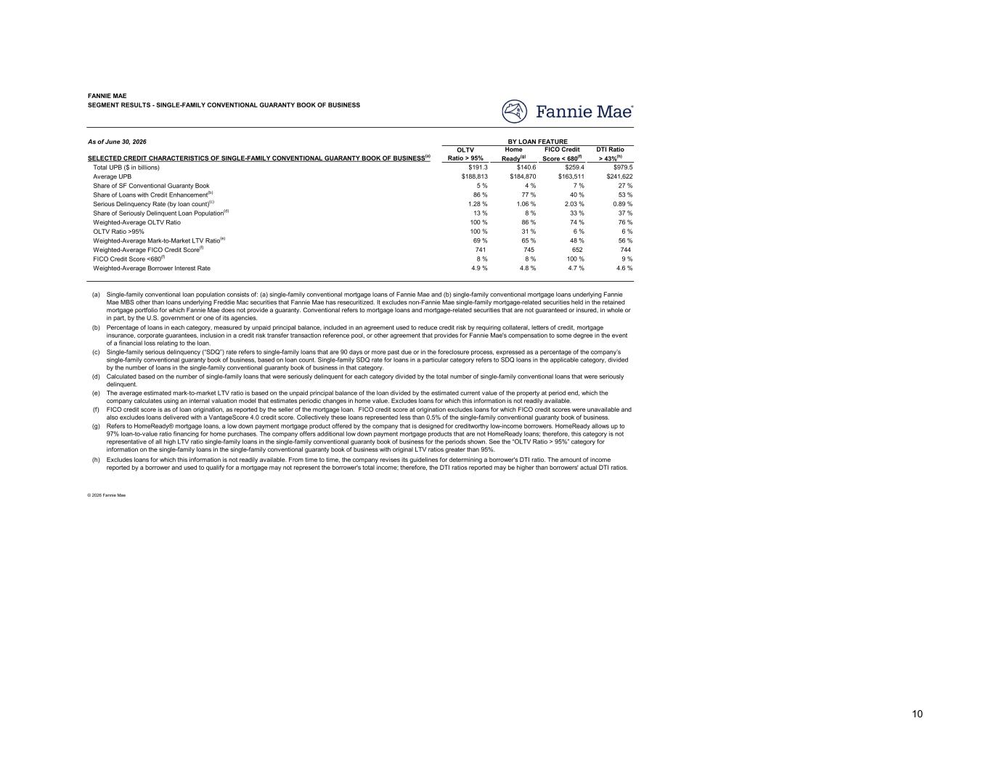
OLTV Ratio > 95% Home Ready(g) FICO Credit Score < 680(f) DTI Ratio > 43%(h) $191.3 $140.6 $259.4 $979.5 $188,813 $184,870 $163,511 $241,622 5 % 4 % 7 % 27 % 86 % 77 % 40 % 53 % 1.28 % 1.06 % 2.03 % 0.89 % 13 % 8 % 33 % 37 % 100 % 86 % 74 % 76 % 100 % 31 % 6 % 6 % 69 % 65 % 48 % 56 % 741 745 652 744 8 % 8 % 100 % 9 % 4.9 % 4.8 % 4.7 % 4.6 % (a) (b) (c) (d) (e) (f) (g) (h) Single-family conventional loan population consists of: (a) single-family conventional mortgage loans of Fannie Mae and (b) single-family conventional mortgage loans underlying Fannie Mae MBS other than loans underlying Freddie Mac securities that Fannie Mae has resecuritized. It excludes non-Fannie Mae single-family mortgage-related securities held in the retained mortgage portfolio for which Fannie Mae does not provide a guaranty. Conventional refers to mortgage loans and mortgage-related securities that are not guaranteed or insured, in whole or in part, by the U.S. government or one of its agencies. Percentage of loans in each category, measured by unpaid principal balance, included in an agreement used to reduce credit risk by requiring collateral, letters of credit, mortgage insurance, corporate guarantees, inclusion in a credit risk transfer transaction reference pool, or other agreement that provides for Fannie Mae's compensation to some degree in the event of a financial loss relating to the loan. Single-family serious delinquency (“SDQ”) rate refers to single-family loans that are 90 days or more past due or in the foreclosure process, expressed as a percentage of the company’s single-family conventional guaranty book of business, based on loan count. Single-family SDQ rate for loans in a particular category refers to SDQ loans in the applicable category, divided by the number of loans in the single-family conventional guaranty book of business in that category. Calculated based on the number of single-family loans that were seriously delinquent for each category divided by the total number of single-family conventional loans that were seriously delinquent. © 2026 Fannie Mae Refers to HomeReady® mortgage loans, a low down payment mortgage product offered by the company that is designed for creditworthy low-income borrowers. HomeReady allows up to 97% loan-to-value ratio financing for home purchases. The company offers additional low down payment mortgage products that are not HomeReady loans; therefore, this category is not representative of all high LTV ratio single-family loans in the single-family conventional guaranty book of business for the periods shown. See the “OLTV Ratio > 95%” category for information on the single-family loans in the single-family conventional guaranty book of business with original LTV ratios greater than 95%. Excludes loans for which this information is not readily available. From time to time, the company revises its guidelines for determining a borrower's DTI ratio. The amount of income reported by a borrower and used to qualify for a mortgage may not represent the borrower's total income; therefore, the DTI ratios reported may be higher than borrowers' actual DTI ratios. The average estimated mark-to-market LTV ratio is based on the unpaid principal balance of the loan divided by the estimated current value of the property at period end, which the company calculates using an internal valuation model that estimates periodic changes in home value. Excludes loans for which this information is not readily available. FICO credit score is as of loan origination, as reported by the seller of the mortgage loan. FICO credit score at origination excludes loans for which FICO credit scores were unavailable and also excludes loans delivered with a VantageScore 4.0 credit score. Collectively these loans represented less than 0.5% of the single-family conventional guaranty book of business. Weighted-Average FICO Credit Score(f) Weighted-Average Mark-to-Market LTV Ratio(e) FICO Credit Score <680(f) Weighted-Average Borrower Interest Rate Share of Loans with Credit Enhancement(b) Share of SF Conventional Guaranty Book Serious Delinquency Rate (by loan count)(c) Share of Seriously Delinquent Loan Population(d) OLTV Ratio >95% Weighted-Average OLTV Ratio FANNIE MAE SEGMENT RESULTS - SINGLE-FAMILY CONVENTIONAL GUARANTY BOOK OF BUSINESS As of June 30, 2026 SELECTED CREDIT CHARACTERISTICS OF SINGLE-FAMILY CONVENTIONAL GUARANTY BOOK OF BUSINESS(a) Average UPB Total UPB ($ in billions) BY LOAN FEATURE 10

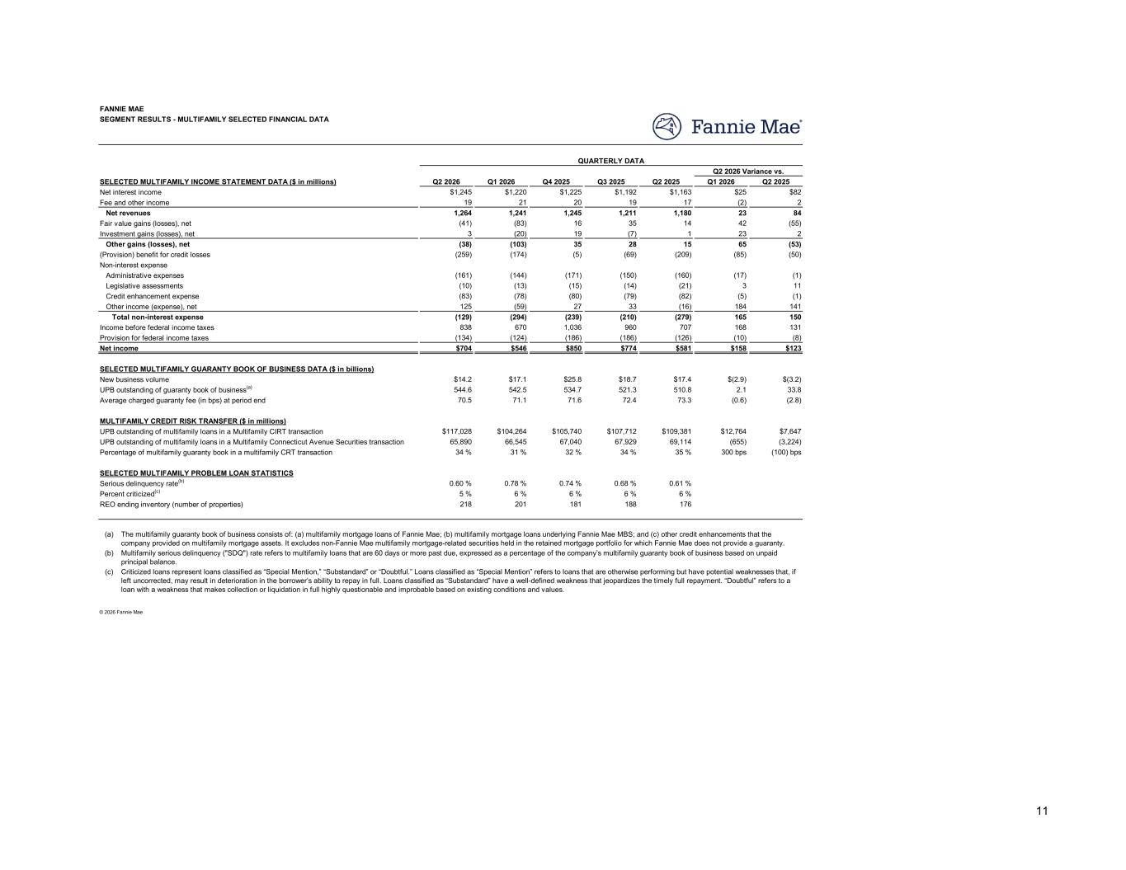
Q2 2026 Q1 2026 Q4 2025 Q3 2025 Q2 2025 Q1 2026 Q2 2025 $1,245 $1,220 $1,225 $1,192 $1,163 $25 $82 19 21 20 19 17 (2) 2 1,264 1,241 1,245 1,211 1,180 23 84 (41) (83) 16 35 14 42 (55) 3 (20) 19 (7) 1 23 2 (38) (103) 35 28 15 65 (53) (259) (174) (5) (69) (209) (85) (50) (161) (144) (171) (150) (160) (17) (1) (10) (13) (15) (14) (21) 3 11 (83) (78) (80) (79) (82) (5) (1) 125 (59) 27 33 (16) 184 141 (129) (294) (239) (210) (279) 165 150 838 670 1,036 960 707 168 131 (134) (124) (186) (186) (126) (10) (8) $704 $546 $850 $774 $581 $158 $123 $14.2 $17.1 $25.8 $18.7 $17.4 $(2.9) $(3.2) 544.6 542.5 534.7 521.3 510.8 2.1 33.8 70.5 71.1 71.6 72.4 73.3 (0.6) (2.8) $117,028 $104,264 $105,740 $107,712 $109,381 $12,764 $7,647 65,890 66,545 67,040 67,929 69,114 (655) (3,224) 34 % 31 % 32 % 34 % 35 % 300 bps (100) bps 0.60 % 0.78 % 0.74 % 0.68 % 0.61 % 5 % 6 % 6 % 6 % 6 % 218 201 181 188 176 (a) (b) (c) © 2026 Fannie Mae Criticized loans represent loans classified as “Special Mention,” “Substandard” or “Doubtful.” Loans classified as “Special Mention” refers to loans that are otherwise performing but have potential weaknesses that, if left uncorrected, may result in deterioration in the borrower’s ability to repay in full. Loans classified as “Substandard” have a well-defined weakness that jeopardizes the timely full repayment. “Doubtful” refers to a loan with a weakness that makes collection or liquidation in full highly questionable and improbable based on existing conditions and values. Multifamily serious delinquency ("SDQ") rate refers to multifamily loans that are 60 days or more past due, expressed as a percentage of the company’s multifamily guaranty book of business based on unpaid principal balance. The multifamily guaranty book of business consists of: (a) multifamily mortgage loans of Fannie Mae; (b) multifamily mortgage loans underlying Fannie Mae MBS; and (c) other credit enhancements that the company provided on multifamily mortgage assets. It excludes non-Fannie Mae multifamily mortgage-related securities held in the retained mortgage portfolio for which Fannie Mae does not provide a guaranty. Percentage of multifamily guaranty book in a multifamily CRT transaction UPB outstanding of multifamily loans in a Multifamily Connecticut Avenue Securities transaction SELECTED MULTIFAMILY PROBLEM LOAN STATISTICS Percent criticized(c) Serious delinquency rate(b) REO ending inventory (number of properties) UPB outstanding of guaranty book of business(a) New business volume Average charged guaranty fee (in bps) at period end UPB outstanding of multifamily loans in a Multifamily CIRT transaction MULTIFAMILY CREDIT RISK TRANSFER ($ in millions) Income before federal income taxes Total non-interest expense Provision for federal income taxes Net income SELECTED MULTIFAMILY GUARANTY BOOK OF BUSINESS DATA ($ in billions) Non-interest expense (Provision) benefit for credit losses Administrative expenses Legislative assessments Other income (expense), net Credit enhancement expense Fee and other income Net interest income Net revenues Fair value gains (losses), net Other gains (losses), net Investment gains (losses), net SEGMENT RESULTS - MULTIFAMILY SELECTED FINANCIAL DATA FANNIE MAE SELECTED MULTIFAMILY INCOME STATEMENT DATA ($ in millions) Q2 2026 Variance vs. QUARTERLY DATA 11

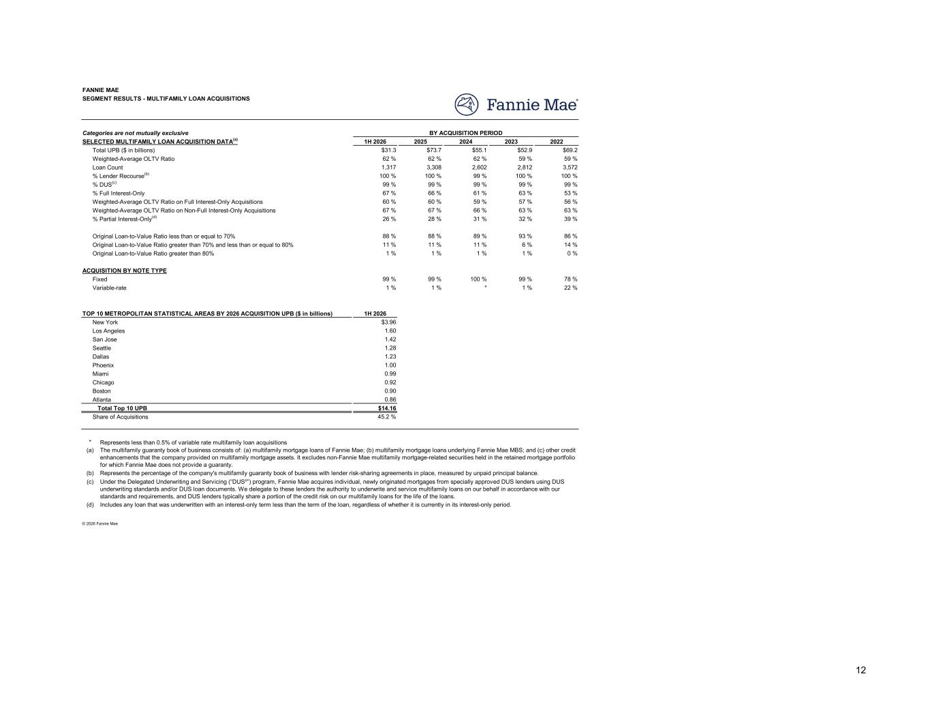
1H 2026 2025 2024 2023 2022 $31.3 $73.7 $55.1 $52.9 $69.2 62 % 62 % 62 % 59 % 59 % 1,317 3,308 2,602 2,812 3,572 100 % 100 % 99 % 100 % 100 % 99 % 99 % 99 % 99 % 99 % 67 % 66 % 61 % 63 % 53 % 60 % 60 % 59 % 57 % 56 % 67 % 67 % 66 % 63 % 63 % 26 % 28 % 31 % 32 % 39 % 88 % 88 % 89 % 93 % 86 % 11 % 11 % 11 % 6 % 14 % 1 % 1 % 1 % 1 % 0 % 99 % 99 % 100 % 99 % 78 % 1 % 1 % * 1 % 22 % 1H 2026 $3.96 1.60 1.42 1.28 1.23 1.00 0.99 0.92 0.90 0.86 $14.16 45.2 % * Represents less than 0.5% of variable rate multifamily loan acquisitions (a) (b) (c) (d) Includes any loan that was underwritten with an interest-only term less than the term of the loan, regardless of whether it is currently in its interest-only period. © 2026 Fannie Mae The multifamily guaranty book of business consists of: (a) multifamily mortgage loans of Fannie Mae; (b) multifamily mortgage loans underlying Fannie Mae MBS; and (c) other credit enhancements that the company provided on multifamily mortgage assets. It excludes non-Fannie Mae multifamily mortgage-related securities held in the retained mortgage portfolio for which Fannie Mae does not provide a guaranty. Represents the percentage of the company's multifamily guaranty book of business with lender risk-sharing agreements in place, measured by unpaid principal balance. Under the Delegated Underwriting and Servicing (“DUS®”) program, Fannie Mae acquires individual, newly originated mortgages from specially approved DUS lenders using DUS underwriting standards and/or DUS loan documents. We delegate to these lenders the authority to underwrite and service multifamily loans on our behalf in accordance with our standards and requirements, and DUS lenders typically share a portion of the credit risk on our multifamily loans for the life of the loans. Chicago Miami Boston Atlanta Share of Acquisitions Total Top 10 UPB Los Angeles New York San Jose Seattle Phoenix Dallas Original Loan-to-Value Ratio greater than 80% Fixed ACQUISITION BY NOTE TYPE Variable-rate TOP 10 METROPOLITAN STATISTICAL AREAS BY 2026 ACQUISITION UPB ($ in billions) Weighted-Average OLTV Ratio on Non-Full Interest-Only Acquisitions Weighted-Average OLTV Ratio on Full Interest-Only Acquisitions % Partial Interest-Only(d) Original Loan-to-Value Ratio less than or equal to 70% Original Loan-to-Value Ratio greater than 70% and less than or equal to 80% BY ACQUISITION PERIOD % Lender Recourse(b) Loan Count % DUS(c) % Full Interest-Only SEGMENT RESULTS - MULTIFAMILY LOAN ACQUISITIONS FANNIE MAE Categories are not mutually exclusive SELECTED MULTIFAMILY LOAN ACQUISITION DATA(a) Weighted-Average OLTV Ratio Total UPB ($ in billions) 12

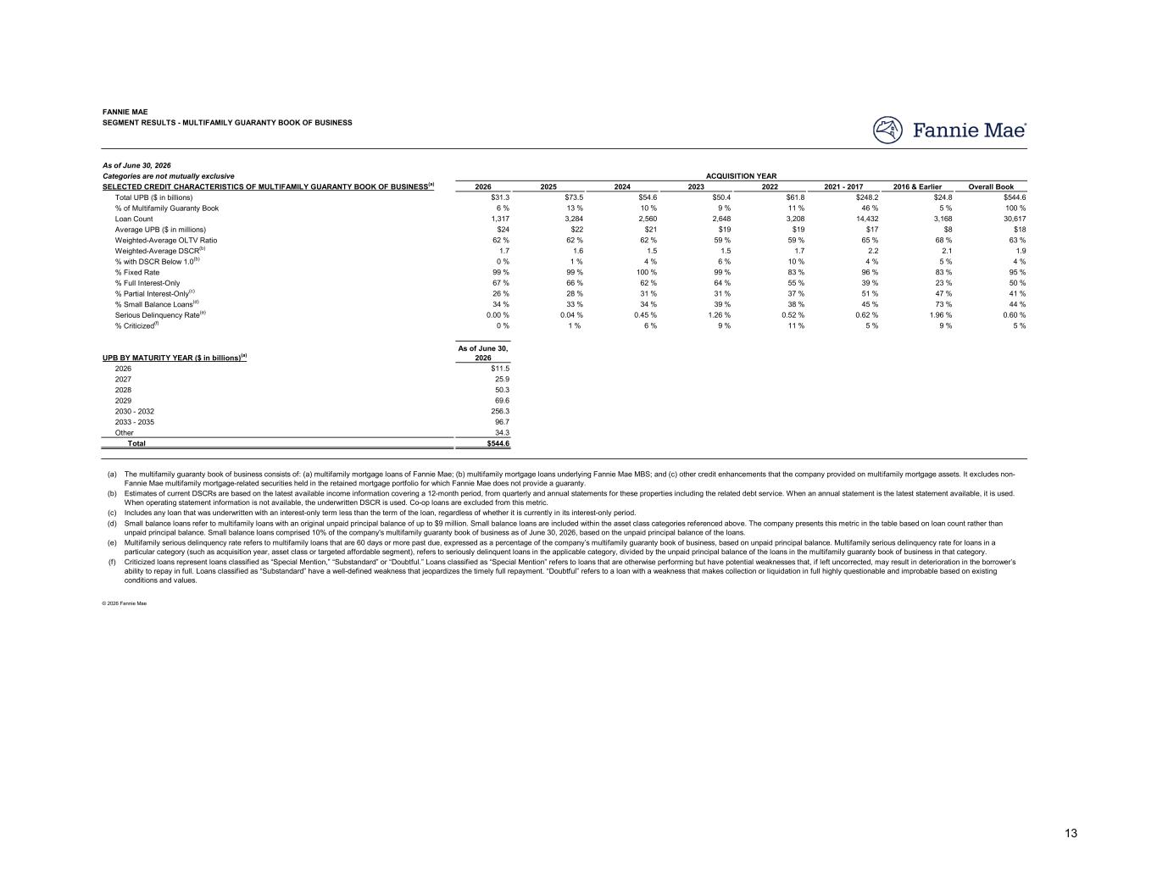
2026 2025 2024 2023 2022 2021 - 2017 2016 & Earlier Overall Book $31.3 $73.5 $54.6 $50.4 $61.8 $248.2 $24.8 $544.6 6 % 13 % 10 % 9 % 11 % 46 % 5 % 100 % 1,317 3,284 2,560 2,648 3,208 14,432 3,168 30,617 $24 $22 $21 $19 $19 $17 $8 $18 62 % 62 % 62 % 59 % 59 % 65 % 68 % 63 % 1.7 1.6 1.5 1.5 1.7 2.2 2.1 1.9 0 % 1 % 4 % 6 % 10 % 4 % 5 % 4 % 99 % 99 % 100 % 99 % 83 % 96 % 83 % 95 % 67 % 66 % 62 % 64 % 55 % 39 % 23 % 50 % 26 % 28 % 31 % 31 % 37 % 51 % 47 % 41 % 34 % 33 % 34 % 39 % 38 % 45 % 73 % 44 % 0.00 % 0.04 % 0.45 % 1.26 % 0.52 % 0.62 % 1.96 % 0.60 % 0 % 1 % 6 % 9 % 11 % 5 % 9 % 5 % As of June 30, 2026 $11.5 25.9 50.3 69.6 256.3 96.7 34.3 $544.6 (a) (b) (c) (d) (e) (f) Small balance loans refer to multifamily loans with an original unpaid principal balance of up to $9 million. Small balance loans are included within the asset class categories referenced above. The company presents this metric in the table based on loan count rather than unpaid principal balance. Small balance loans comprised 10% of the company's multifamily guaranty book of business as of June 30, 2026, based on the unpaid principal balance of the loans. Multifamily serious delinquency rate refers to multifamily loans that are 60 days or more past due, expressed as a percentage of the company’s multifamily guaranty book of business, based on unpaid principal balance. Multifamily serious delinquency rate for loans in a particular category (such as acquisition year, asset class or targeted affordable segment), refers to seriously delinquent loans in the applicable category, divided by the unpaid principal balance of the loans in the multifamily guaranty book of business in that category. Criticized loans represent loans classified as “Special Mention,” “Substandard” or “Doubtful.” Loans classified as “Special Mention” refers to loans that are otherwise performing but have potential weaknesses that, if left uncorrected, may result in deterioration in the borrower’s ability to repay in full. Loans classified as “Substandard” have a well-defined weakness that jeopardizes the timely full repayment. “Doubtful” refers to a loan with a weakness that makes collection or liquidation in full highly questionable and improbable based on existing conditions and values. © 2026 Fannie Mae Other Total Includes any loan that was underwritten with an interest-only term less than the term of the loan, regardless of whether it is currently in its interest-only period. Estimates of current DSCRs are based on the latest available income information covering a 12-month period, from quarterly and annual statements for these properties including the related debt service. When an annual statement is the latest statement available, it is used. When operating statement information is not available, the underwritten DSCR is used. Co-op loans are excluded from this metric. The multifamily guaranty book of business consists of: (a) multifamily mortgage loans of Fannie Mae; (b) multifamily mortgage loans underlying Fannie Mae MBS; and (c) other credit enhancements that the company provided on multifamily mortgage assets. It excludes non- Fannie Mae multifamily mortgage-related securities held in the retained mortgage portfolio for which Fannie Mae does not provide a guaranty. 2027 2029 2028 2033 - 2035 2030 - 2032 % Small Balance Loans(d) % Criticized(f) Serious Delinquency Rate(e) UPB BY MATURITY YEAR ($ in billions)(a) 2026 % with DSCR Below 1.0(b) Weighted-Average DSCR(b) % Full Interest-Only % Fixed Rate % Partial Interest-Only(c) ACQUISITION YEAR Loan Count % of Multifamily Guaranty Book Average UPB ($ in millions) Weighted-Average OLTV Ratio SEGMENT RESULTS - MULTIFAMILY GUARANTY BOOK OF BUSINESS FANNIE MAE As of June 30, 2026 Categories are not mutually exclusive Total UPB ($ in billions) SELECTED CREDIT CHARACTERISTICS OF MULTIFAMILY GUARANTY BOOK OF BUSINESS(a) 13

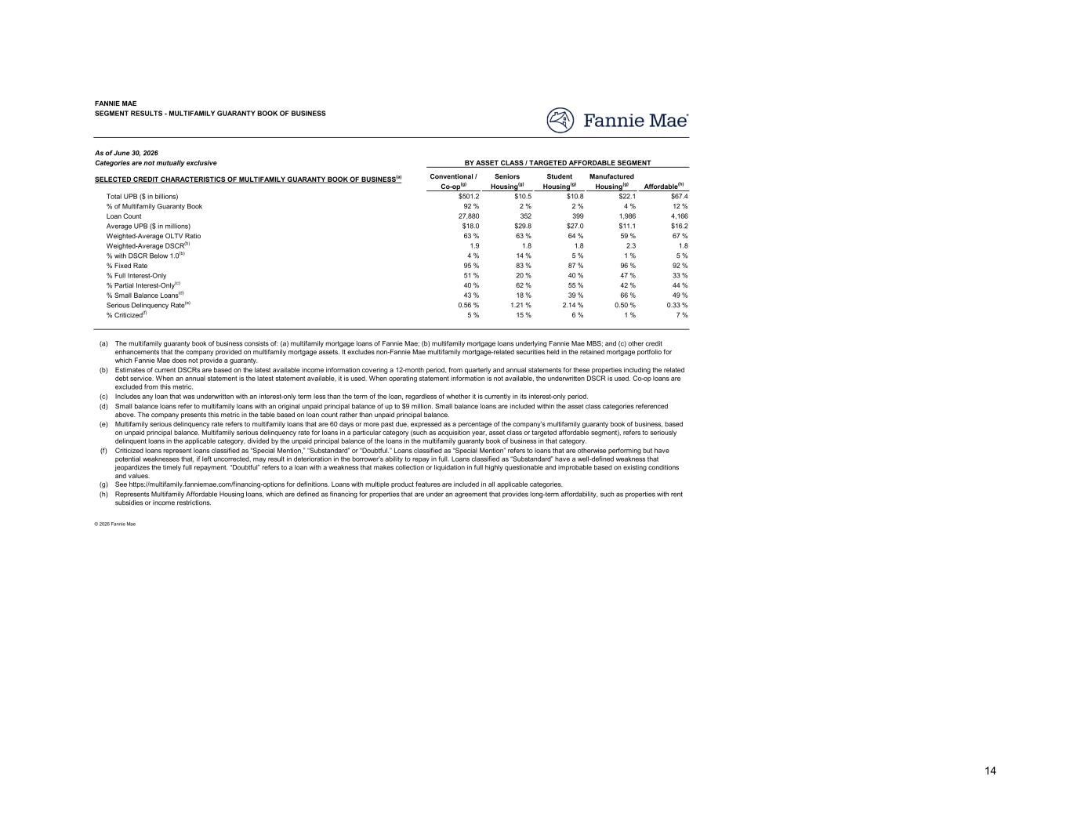
Conventional / Co-op(g) Seniors Housing(g) Student Housing(g) Manufactured Housing(g) Affordable(h) $501.2 $10.5 $10.8 $22.1 $67.4 92 % 2 % 2 % 4 % 12 % 27,880 352 399 1,986 4,166 $18.0 $29.8 $27.0 $11.1 $16.2 63 % 63 % 64 % 59 % 67 % 1.9 1.8 1.8 2.3 1.8 4 % 14 % 5 % 1 % 5 % 95 % 83 % 87 % 96 % 92 % 51 % 20 % 40 % 47 % 33 % 40 % 62 % 55 % 42 % 44 % 43 % 18 % 39 % 66 % 49 % 0.56 % 1.21 % 2.14 % 0.50 % 0.33 % 5 % 15 % 6 % 1 % 7 % (a) (b) (c) (d) (e) (f) (g) (h) Estimates of current DSCRs are based on the latest available income information covering a 12-month period, from quarterly and annual statements for these properties including the related debt service. When an annual statement is the latest statement available, it is used. When operating statement information is not available, the underwritten DSCR is used. Co-op loans are excluded from this metric. © 2026 Fannie Mae Represents Multifamily Affordable Housing loans, which are defined as financing for properties that are under an agreement that provides long-term affordability, such as properties with rent subsidies or income restrictions. See https://multifamily.fanniemae.com/financing-options for definitions. Loans with multiple product features are included in all applicable categories. Criticized loans represent loans classified as “Special Mention,” “Substandard” or “Doubtful.” Loans classified as “Special Mention” refers to loans that are otherwise performing but have potential weaknesses that, if left uncorrected, may result in deterioration in the borrower’s ability to repay in full. Loans classified as “Substandard” have a well-defined weakness that jeopardizes the timely full repayment. “Doubtful” refers to a loan with a weakness that makes collection or liquidation in full highly questionable and improbable based on existing conditions and values. Multifamily serious delinquency rate refers to multifamily loans that are 60 days or more past due, expressed as a percentage of the company’s multifamily guaranty book of business, based on unpaid principal balance. Multifamily serious delinquency rate for loans in a particular category (such as acquisition year, asset class or targeted affordable segment), refers to seriously delinquent loans in the applicable category, divided by the unpaid principal balance of the loans in the multifamily guaranty book of business in that category. Small balance loans refer to multifamily loans with an original unpaid principal balance of up to $9 million. Small balance loans are included within the asset class categories referenced above. The company presents this metric in the table based on loan count rather than unpaid principal balance. Includes any loan that was underwritten with an interest-only term less than the term of the loan, regardless of whether it is currently in its interest-only period. % Partial Interest-Only(c) % Small Balance Loans(d) % Criticized(f) Serious Delinquency Rate(e) The multifamily guaranty book of business consists of: (a) multifamily mortgage loans of Fannie Mae; (b) multifamily mortgage loans underlying Fannie Mae MBS; and (c) other credit enhancements that the company provided on multifamily mortgage assets. It excludes non-Fannie Mae multifamily mortgage-related securities held in the retained mortgage portfolio for which Fannie Mae does not provide a guaranty. Average UPB ($ in millions) Weighted-Average OLTV Ratio % with DSCR Below 1.0(b) Weighted-Average DSCR(b) % Full Interest-Only % Fixed Rate Total UPB ($ in billions) SELECTED CREDIT CHARACTERISTICS OF MULTIFAMILY GUARANTY BOOK OF BUSINESS(a) BY ASSET CLASS / TARGETED AFFORDABLE SEGMENT Loan Count % of Multifamily Guaranty Book SEGMENT RESULTS - MULTIFAMILY GUARANTY BOOK OF BUSINESS FANNIE MAE As of June 30, 2026 Categories are not mutually exclusive 14

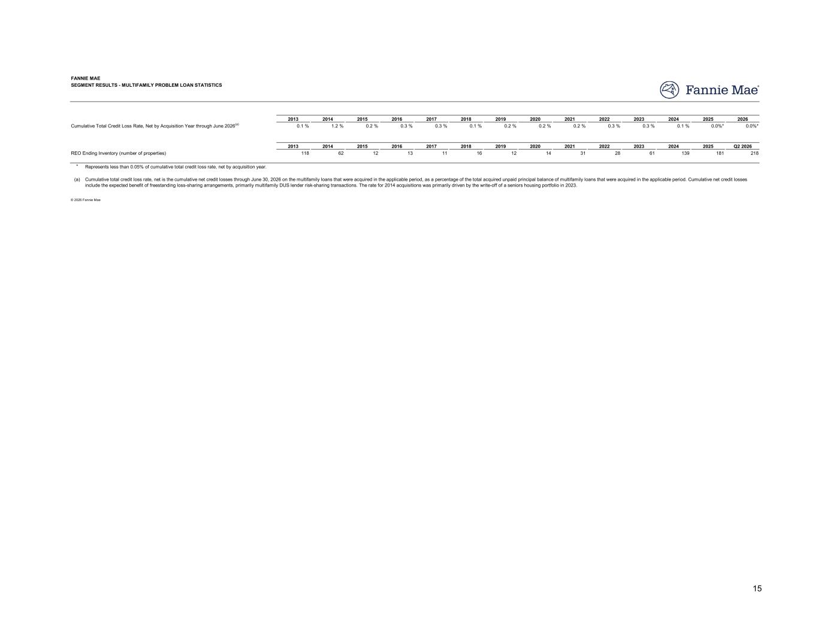
2013 2014 2015 2016 2017 2018 2019 2020 2021 2022 2023 2024 2025 2026 0.1 % 1.2 % 0.2 % 0.3 % 0.3 % 0.1 % 0.2 % 0.2 % 0.2 % 0.3 % 0.3 % 0.1 % 0.0%* 0.0%* 2013 2014 2015 2016 2017 2018 2019 2020 2021 2022 2023 2024 2025 Q2 2026 118 62 12 13 11 16 12 14 31 28 61 139 181 218 * Represents less than 0.05% of cumulative total credit loss rate, net by acquisition year. (a) © 2026 Fannie Mae Cumulative total credit loss rate, net is the cumulative net credit losses through June 30, 2026 on the multifamily loans that were acquired in the applicable period, as a percentage of the total acquired unpaid principal balance of multifamily loans that were acquired in the applicable period. Cumulative net credit losses include the expected benefit of freestanding loss-sharing arrangements, primarily multifamily DUS lender risk-sharing transactions. The rate for 2014 acquisitions was primarily driven by the write-off of a seniors housing portfolio in 2023. Cumulative Total Credit Loss Rate, Net by Acquisition Year through June 2026(a) REO Ending Inventory (number of properties) SEGMENT RESULTS - MULTIFAMILY PROBLEM LOAN STATISTICS FANNIE MAE 15

